

**MINISTRY OF**

**EDUCATION AND TRAINING**

**FPT UNIVERSITY**

Capstone Project Document

**Travel and Ship**

|  |  |
| --- | --- |
| **GROUP 6** | |
| **Group members** | Nguyễn Quốc Bảo – SE61774 (Leader)  Nguyễn Duy Hùng – SE61819  Trịnh Thanh Vũ – SE60983 |
| **Supervisor** | Nguyễn Huy Hùng |
| **Ext. Supervisor** | N/A |
| **Capstone Project code** | TAS |

- Ho Chi Minh City, ***23rd May, 2018*** –

*This page is intentionally left blank*

# Table of Content

Table of Content 3

List of Table 9

List of Figure 12

Definitions, Acronyms, and Abbreviations 15

A. Introduction 16

1. Project Information 16

2. Introduction 16

3. Current Situation 16

4. Problem Definition 16

5. Proposed Solution 17

5.1 Feature functions 17

5.2 Advantages and Disadvantages 17

6. Functional Requirements 18

7. Role and Responsibility 19

B. Software Project Management Plan 19

1. Problem Definition 19

1.1 Name of this Capstone Project 19

1.2 Problem Abstract 19

1.3 Project Overview 19

1.3.1 Current Situation 19

1.3.2 The Proposed System 20

1.3.2.1 Mobile Application 20

1.3.2.2 Web Application 20

1.3.3 Boundaries of the System 21

1.3.4 Future Plan 21

1.3.5 Development Environment 21

1.3.5.1 Hardware requirements 21

1.3.5.2 Software requirements 22

2. Project Organization 22

2.1 Software Process Model 22

2.2 Roles and Responsibilities 23

2.3 Tools and Techniques 23

3. Project Management Plan 24

3.1 Product Backlog 24

3.2 Sprint Backlog 24

3.3 Meeting Minutes 24

4. Coding Convention 24

C. Software Requirement Specification 25

1. User Requirement Specification 25

1.1 Unauthorized User Requirement 25

1.2 Authorized User Requirement 25

1.3 Traveler Requirement 25

1.4 Buyer Requirement 26

1.5 Admin Requirement 26

2. System Requirement Specification 26

2.1 External Interface Requirement 26

2.1.1 User Interface 26

2.1.2 Hardware Interface. 26

2.1.3 Software Interface 26

2.1.4 Communication Protocol 27

2.2 System Overview Use Case 27

2.3 List of Use Case 28

2.3.1 <Unauthorized User> Overview Use Case 28

2.3.1.1 <Unauthorized User> Login 28

2.3.1.2 <Unauthorized User> Login Via Google 30

2.3.1.3 <Unauthorized User> Login Via Facebook 31

2.3.2 <Authorized User> Overview Use Case 32

2.3.2.1 <Authorized User> Logout 33

2.3.2.2 <Authorized User> Send Message 34

2.3.2.3 <Authorized User> Video Call 35

2.3.2.4 <Authorized User> Update Info 37

2.3.2.5 <Authorized User> Withdraw 39

2.3.2.6 <Authorized User> Deposit 40

2.3.2.7 <Authorized User> View History 42

2.3.3 <Traveler> Overview Use Case 43

2.3.3.1 <Traveler> Make Offer 44

2.3.3.2 <Traveler> Create Trip 45

2.3.3.3 <Traveler> View Suggest Order 47

2.3.3.4 <Traveler> Manage Trip 48

2.3.3.5 <Traveler> Delete Trip 49

2.3.3.6 <Traveler> Tracking Order 51

2.3.3.7 <Traveler> View Timeline 52

2.3.3.8 <Traveler> Share Location Information 54

2.3.4 <Buyer> Overview Use Case 56

2.3.4.1 <Buyer> Create Order 56

2.3.4.2 <Buyer> Create Order With Url 59

2.3.4.3 <Buyer> View Suggest Trip 61

2.3.4.4 <Buyer> Delete Order 63

2.3.4.5 <Buyer> Update Order 65

2.3.4.6 <Buyer> View Offer 67

2.3.4.7 <Buyer> Accept Offer 69

2.3.4.8 <Buyer> Confirm Complete 71

2.3.4.9 <Buyer> Rate 73

2.3.5 <Admin> Overview Use Case 74

2.3.5.1 <Admin> Login 75

2.3.5.2 <Admin> Logout 77

2.3.5.3 <Admin> View User 78

2.3.5.4 <Admin> Manage Order 79

2.3.5.5 <Admin> Update Status 80

2.3.5.6 <Admin> View Detail 81

2.3.5.7 <Admin> View Transaction 83

2.3.5.8 <Admin> Confirm Order Complete 84

3. Software System Attribute 85

3.1 Usability 85

3.1.1 Graphic User Interface 85

3.1.2 Usability 85

3.2 Reliability 86

3.3 Availability 86

3.4 Security 86

3.5 Maintainability 86

3.6 Portability 86

3.7 Performance 86

4. Conceptual diagram 87

D. Software Design Description 88

1. Design Overview 88

2. System Architecture Design 88

2.1 Web service Application Architecture Description 88

2.2 Mobile Application Architecture Description 89

3. Component Diagram 90

3.1 Web Application 90

3.2 Mobile Application 91

4. Detail Description 92

4.1 Class Diagram 92

4.2 Class Diagram Explanation 93

4.2.1 AspNetRole 93

4.2.2 AspNetUserRole 93

4.2.3 AspNetUser 93

4.2.4 Trips 94

4.2.5 TrackingOrder 94

4.2.6 Order 95

4.2.7 Offer 95

4.2.8 City 96

4.2.9 Country 96

4.2.10 Transactions 97

4.2.11 Bill 97

4.2.12 EcommerceWebsite 98

4.2.13 Image 98

4.2.14 Rating 98

4.2.15 Notification 99

4.2.16 Dialog 99

4.2.17 Message 99

4.3 Interactive diagram 100

4.3.1 Sequence Diagram 100

4.3.1.1 Accept Offer 100

4.3.1.2 Complete Bill 101

4.3.1.3 Create Order 102

4.3.1.4 Create Trip 103

4.3.1.5 Login Via Form 104

4.3.1.6 Make Offer 105

4.3.1.7 Deposit 106

4.3.1.8 Update Order 107

4.3.1.9 Order Detail 108

4.3.1.10 View Suggested Order 109

5. Interface 110

5.1 Admin Interface Design 110

5.1.1 Login 110

5.1.2 Manage User 111

5.1.3 View Order List 112

5.1.4 Tranfer Money To Traveler 113

5.1.5 Notification Of Order 115

5.2 Unauthorized User Interface Design 116

5.2.1 Login 116

5.3 Authorized User Interface Design 117

5.3.1 View Setting 117

5.3.2 Chat 118

5.3.3 Video Call 119

5.3.4 Update User Information 120

5.3.5 Withdraw/Deposit 121

5.3.6 View Transaction History 122

5.4 Traveler Interface Design 123

5.4.1 View Suggest Order 123

5.4.2 Create Trip 124

5.4.3 View Trip 125

5.4.4 Make Offer 126

5.4.5 Tracking Order 128

5.5 Buyer Interface Design 129

5.5.1 View Suggest Trip 129

5.5.2 Create Order 130

5.5.3 View Order 132

5.5.4 Accept Offer 133

5.5.5 Rate 135

6. Database Design 136

6.1 Entity relationship diagram (ERD) 136

6.2 Entity dictionary 136

7. Algorithms 137

7.1 Definition 137

7.2 Define Problem 137

7.3 Solution 137

7.4 Flowchart 139

E. System Implementation & Test 140

1. Introduction 140

1.1 Overview 140

1.2 Test approach 140

2. Database Relationship Diagram 140

2.1 Physical diagram 140

2.2 Data dictionary 142

3. Performance Measure 147

3.1 Show list result of offers performance 147

3.2 Show list result of orders performance 147

3.3 Show lists result of trips performance 147

3.4 Add new trip performance 147

3.5 Add new order performance 148

3.6 Get bill GPS tracking performance 148

3.7 Notifications performance 148

4. Test Plan 148

4.1 Features to be tested 148

4.2 Features not to be tested 148

5. System Testing Test Case 148

5.1 Test case 148

5.1.1 <Unauthorized User> Login 148

5.1.2 <Authorized User> Chat 149

5.1.3 <Authorized User> Update User Information 150

5.1.4 <Traveler> Make Offer 150

5.1.5 <Traveler> View Suggest Order 151

5.1.6 <Traveler> Create Trip 151

5.1.7 <Buyer> Create Order 152

5.1.8 <Buyer> View Suggest Trip 153

5.1.9 <Buyer> Accept Offer 154

5.1.10 <Buyer> Rate 154

5.1.11 <Buyer> Confirm Complete 154

5.1.12 <Admin> View User 155

5.1.13 <Admin> View Order 155

F. Software User’s Manual 155

1. Installation Guide 155

1.1 Setting up environment at server side 155

1.1.1 Hardware Requirement 155

1.1.2 Software Requirement 155

1.2 Deployment at server side 156

1.2.1 Check Environment 156

1.2.2 Import Database 156

1.2.3 Build Project 156

1.2.4 Deploy Project To IIS 156

2. User Manual 157

2.1 Unauthorized User 157

2.1.1 Login 157

2.2 Authorized User 158

2.2.1 Message 158

2.2.2 Video Call 159

2.2.3 Update User Information 162

2.2.4 Withdraw 163

2.2.5 Deposit 164

2.3 Admin 165

2.3.1 Login 165

2.3.2 Manage User 166

2.3.3 View Order 167

2.3.4 Tranfer Money To Traveler 167

2.4 Traveler 168

2.4.1 Create Trip 168

2.4.2 Make Offer 170

2.4.3 Share Location Information 171

2.5 Buyer 174

2.5.1 View Suggest Trip 174

2.5.2 Create Order 175

2.5.3 Create Order With Url 176

2.5.4 Accept Offer 180

2.5.5 Tracking Order 182

2.5.6 Confirm Complete 184

2.5.7 Rate for Traveler 186

G. Acknowledge 187

H. Appendix 187

# List of Table

Table 1: Roles and Responsibilities 19

Table 2: Hardware Requirements for Server 21

Table 3: Hardware Requirement for Mobile 22

Table 4: Software Requirements 22

Table 5: Roles and Responsibilities 23

Table 6: Tools and Techniques 24

Table 7: <Unauthorized User> Login specification 30

Table 8: <Unauthorized User> Login via Google specification 31

Table 9: Login via Facebook Specification 32

Table 10: <Authorized User> Logout specification 34

Table 11: <Authorized User> Send Message specification 35

Table 12: <Authorized User> Video Call specification 36

Table 13: <Authorized User> Update Information specification 39

Table 14: <Authorized User> Withdraw specification 40

Table 15: <Authorized User> Deposit specification 42

Table 16: <Authorized User> View History specification 43

Table 17: <Traveler> Make Offer specification 45

Table 20: <Traveler> Create Trip specification 47

Table 21: <Traveler> View Suggest Order specification 48

Table 22: <Traveler> Manage Trip specification 49

Table 23: <Traveler> Delete Trip 50

Table 24: <Traveler> Tracking Order specification 52

Table 25: <Traveler> View Timeline specification 54

Table 26: <Traveler> Share Location Information specification 55

Table 27: <Buyer> Create Order specification 59

Table 28: <Buyer> Create Order with Url specification 61

Table 29: <Buyer> View Suggest Trip specification 62

Table 30: <Buyer> Delete Order 64

Table 31: <Buyer> Update Order specification 67

Table 32: <Buyer> View Offer specification 69

Table 33: <Buyer> Accept Offer specification 71

Table 34: <Buyer> Confirm Complete specification 73

Table 35: <Buyer> Rate specification 74

Table 36: <Admin> Login specification 76

Table 37: <Admin> Logout specification 78

Table 38: <Admin> View User specification 79

Table 39: <Admin> Manage Order specification 80

Table 40: <Admin> Update Status specification 81

Table 41: <Admin> View Detail specification 82

Table 42: <Admin> View Transaction specification 84

Table 43: <Admin> Confirm Order Complete specification 85

Table 44: Conceptual Diagram Dictionary 87

Table 45: Component Diagram Dictionary of Web Application 90

Table 46: Component Diagram Dictionary of Mobile Application 91

Table 47: Class Diagram Explanation 93

Table 48: AspNetRoles attribute 93

Table 49: AspNetUserRoles attribute 93

Table 50: AspNetUsers attribute 94

Table 51: Trips attribute 94

Table 52: TrackingOrders attribute 94

Table 53: Order attribute 95

Table 54: Offers attribute 96

Table 55: Cities attribute 96

Table 56: Countries attribute 96

Table 57: Transactions attribute 97

Table 58: Bill attribute 97

Table 59: EcommerceWebsite attribute 98

Table 60: Images attribute 98

Table 61: Rating attribute 98

Table 62: Notification attribute 99

Table 63: Dialog attribute 99

Table 64: Message attribute 99

Table 65: Admin login - Field, Buttons, Hyperlinks 110

Table 66: Admin Manage User - Field, Buttons, Hyperlinks 112

Table 67: Admin View Order List - Field, Buttons, Hyperlinks 113

Table 68: Admin Tranfer Money to Traveler - Field, Buttons, Hyperlinks 114

Table 69: Admin View Notification - Field, Buttons, Hyperlinks 115

Table 70: Login - Field, Buttons, Hyperlinks 116

Table 71: View Setting - Field, Buttons, Hyperlinks 117

Table 72: Chat - Field, Buttons, Hyperlinks 119

Table 73: Video Call - Field, Buttons, Hyperlinks 120

Table 74: Update User Information - Field, Buttons, Hyperlinks 121

Table 75: Withdraw/Deposit - Field, Buttons, Hyperlinks 121

Table 76: View Transaction History - Field, Buttons, Hyperlinks 122

Table 77: View Suggest Order - Field, Buttons, Hyperlinks 124

Table 78: Create Trip - Field, Buttons, Hyperlinks 125

Table 79: View Trip - Field, Buttons, Hyperlinks 126

Table 80: Make Offer - Field, Buttons, Hyperlinks 127

Table 81: Tracking Order - Field, Buttons, Hyperlinks 129

Table 82: View Suggest Trip - Field, Buttons, Hyperlinks 130

Table 83: Create Order - Field, Buttons, Hyperlinks 132

Table 84: View Order - Field, Buttons, Hyperlinks 133

Table 85: Accept Offer - Field, Buttons, Hyperlinks 135

Table 86: Rate - Field, Buttons, Hyperlinks 136

Table 87: Entity Data dictionary 137

Table 88: Data dictionary 142

Table 89: Data Table description 147

Table 90: Test case <Unauthorized User> Login 149

Table 91: Test case <Authorized User> Chat 149

Table 92: Test case <Authorized User> Update USer Information 150

Table 93: Test case <Traveler> Make Offer 151

Table 94: Test case <Traveler> View Suggest Order 151

Table 95: Test case <Traveler> Create Trip 152

Table 96: Test case <Buyer> Create Order 153

Table 97: Test case <Buyer> View Suggest Trip 153

Table 98: Test case <Buyer> Accept Offer 154

Table 99: Test case <Buyer> Rate 154

Table 100: Test case <Buyer> Confirm Complete 154

Table 101: Test case <Admin> Manage User 155

Table 102: Test case <Admin> Manage Order 155

Table 103: Hardware Requirement for Server 155

Table 104: Software Requirement for Server 155

Table 105: User manual – Login 157

Table 106: User manual - Message 159

Table 107: User manual - Video Call 161

Table 108: User manual - Update User Information 163

Table 109: User manual - Withdraw 164

Table 110: User manual - Deposit 165

Table 111: User manual - Admin Login 166

Table 112: User manual - Admin Manage User 167

Table 113: User manual - Admin View Order 167

Table 114: User manual - Admin Tranfer Money to Traveler 168

Table 115: User manual - Create Trip 169

Table 116: User manual - Make Offer 171

Table 117: User manual - Share Location Information 174

Table 118: User manual - View Suggest Trip 174

Table 119: User manual - Create Order 176

Table 120: User manual - Create Order with Url 179

Table 121: User manual - Accept Offer 181

Table 122: User manual - Tracking Order 184

Table 123: User manual - Confirm Complete 185

Table 124: User manual - Rate for Traveler 187

# List of Figure

Figure 1: Agile Methodology 22

Figure 2: System Overview Use Case (1) 27

Figure 3: System Overview Use Case (2) 28

Figure 4: <Unauthorized User> Overview Use Case 28

Figure 5: <Unauthorized User> Login Use Case 28

Figure 6: <Unauthorized User> Login via Google Use case 30

Figure 7: <Unauthorized User> Login via Facebook Use Case 31

Figure 8: <Authorized User> Overview Use Case 32

Figure 9: <Authorized User> Logout Use Case 33

Figure 10: <Authorized User> Send Message Use Case 34

Figure 11: <Authorized User> Video Call Use Case 35

Figure 12: <Authorized User> Update Information Use Case 37

Figure 13: <Authorized User> Withdraw Use Case 39

Figure 14: <Authorized User> Deposit 40

Figure 15: <Authorized User> View History Use Case 42

Figure 16: <Traveler> Overview Use CaseFigure 17 43

Figure 18: <Traveler> Make Offer Use Case 44

Figure 21: <Traveler> Create Trip Use Case 46

Figure 22: <Traveler> View Suggest Order Use Case 47

Figure 23: <Traveler> Manage Trip Use Case 48

Figure 24: <Traveler> Delete Trip Use Case 49

Figure 25: <Traveler> Tracking Order Use Case 51

Figure 26: <Traveler> View Timeline Use Case 52

Figure 27: <Traveler> Share Location Information Use Case 54

Figure 28: <Buyer> Overview Use Case 56

Figure 29: <Buyer> Create Order Use Case 57

Figure 30: <Buyer> Create Order with Url Use Case 59

Figure 31: <Buyer> View Suggest Trip Use Case 61

Figure 32: <Buyer> Delete Order Use Case 63

Figure 33: <Buyer> Update Order Use Case 65

Figure 34: <Buyer> View Offer Use Case 67

Figure 35: <Buyer> Accept Offer Use Case 69

Figure 36: <Buyer> Confirm Complete Use Case 71

Figure 37: <Buyer> Rate Use Case 73

Figure 38: <Admin> Overview Use Case 75

Figure 39: <Admin> Login Use Case 75

Figure 40: <Admin> Logout Use Case 77

Figure 41: <Admin> View User Use Case 78

Figure 42: <Admin> Manage Order Use Case 79

Figure 43: <Admin> Update Status Use Case 80

Figure 44: <Admin> View Detail Use Case 81

Figure 45: <Admin> View Transaction Use Case 83

Figure 46: <Admin> Confirm Order Complete Use Case 84

Figure 47: Conceptual Diagram 87

Figure 48: Web Server Application Architure Design 88

Figure 49: Mobile Application Architecture Design 89

Figure 50: Component Diagram - Web Application 90

Figure 51: Component Diagram - Mobile Application 91

Figure 52: Class Diagram 92

Figure 53: Sequence Diagram - <Buyer> Accept Offer 100

Figure 54: Sequence Diagram - <Buyer> Complete Bill 101

Figure 55: Sequence Diagram - <Buyer> Create Order 102

Figure 56: Sequence Diagram - <Traveler> Create Trip 103

Figure 57: Sequence Diagram - <Unauthorized User> Login via Form 104

Figure 58: Sequence Diagram - <Traveler> Make Offer 105

Figure 59: Sequence Diagram - <Authorized User> Deposit 106

Figure 60: Sequence Diagram - <Buyer> Update Order 107

Figure 61: Sequence Diagram - <Buyer> Order Detail 108

Figure 62: Sequence Diagram - <Buyer> View Suggest Order 109

Figure 63: <Admin> Login Interface 110

Figure 64: <Admin> Manage User Interface 111

Figure 65: <Admin> View Order List Interface 112

Figure 66: <Admin> Tranfer Money to Traveler Interface 113

Figure 67: <Admin> View Notification 115

Figure 68: <Unauthorized User> Login Interface 116

Figure 69: <Authorized User> View Setting Interface 117

Figure 70: <Authorized User> Chat Interface (1) 118

Figure 71: <Authorized User> Chat Interface (2) 118

Figure 72: <Authorized User> Video Call Interface 119

Figure 73: <Authorized User> Update Information Interface (1) 120

Figure 74: <Authorized User> Update Information Interface (2) 120

Figure 75: <Authorized User> Withdraw/Deposit Interface 121

Figure 76: <Authorized User> View Transaction History Interface 122

Figure 77: <Traveler> View Suggested Order 123

Figure 78: <Traveler> Create Trip Interface 124

Figure 79: <Traveler> View Trip Interface 125

Figure 80: <Traveler> Make Offer Interface (1) 126

Figure 81: <Traveler> Make Offer Interface (2) 126

Figure 82: <Traveler> Tracking Order Interface 128

Figure 83: <Buyer> View Suggest Trip Inteface 129

Figure 84: <Buyer> Create Order Interface (1) 130

Figure 85: <Buyer> Create Order Interface (2) 131

Figure 86: <Buyer> View Order Interface 132

Figure 87: <Buyer> Accept Offer Interface (1) 133

Figure 88: <Buyer> Accept Offer Interface (2) 134

Figure 89: <Buyer> Rate Interface 135

Figure 90: Entity Relationship diagram 136

Figure 91: Flowchart 139

Figure 92: Physical diagram 141

Figure 93: User manual - Login Interface 157

Figure 94: User manual - Message Interface (1) 158

Figure 95: User manual - Message Interface (2) 158

Figure 96: User manual - Video Call Interface (1) 159

Figure 97: User manual - Video Call Interface (2) 160

Figure 98: User manual - Video Call (3) 160

Figure 99: User manual - Video Call Interface (4) 161

Figure 100: User manual - Update User Information Interface (1) 162

Figure 101: User manual - Update User Information Interface (2) 162

Figure 102: User manual - Update User Information Interface (3) 162

Figure 103: User manual - Withdraw Interface (1) 163

Figure 104: User manual - Withdraw Interface (2) 163

Figure 105: User manual - Withdraw Interface (3) 164

Figure 106: User manual - Deposit Interface (1) 164

Figure 107: User manual -Deposit Interface (2) 165

Figure 108: User manual - Deposit Interface (3) 165

Figure 109: User manual - Admin Login Interface 166

Figure 110: User manual - Admin Manage User Interface (1) 166

Figure 111: User manual - Admin Manage User Interface (2) 166

Figure 112: User manual - Admin View Order Interface 167

Figure 113: User manual - Admin Tranfer Money to Traveler Interface (1) 167

Figure 114: User manual - Admin Tranfer Money to Traveler Interface (2) 168

Figure 115: User manual - Create Trip Interface (1) 168

Figure 116: User manual - Create Trip Interface (2) 169

Figure 117: User manual - Make Offer Interface (1) 170

Figure 118: User manual - Make Offer Interface (2) 170

Figure 119: User manual - Make Offer Interface (3) 171

Figure 120: User manual - Share Location Information Interface (1) 171

Figure 121: User manual - Share Location Information Interface (2) 172

Figure 122: User manual - Share Location Information Interface (3) 172

Figure 123: User manual - Share Location Information Interface (4) 173

Figure 124: User manual - Share Location Information Interface (5) 173

Figure 125: User manual - View Suggested Trip Interface 174

Figure 126: User manual - Create Order Interface (1) 175

Figure 127: User manual - Create Order Interface (2) 175

Figure 128: User manual - Create Order Interface (3) 176

Figure 129: User manual - Create Order with Url Interface (1) 177

Figure 130: User manual - Create Order with Url Interface (2) 177

Figure 131: User manual - Create Order with Url Interface (3) 178

Figure 132: User manual - Create Order with Url Interface (4) 178

Figure 133: User manual - Create Order with Url Interface (5) 179

Figure 134: User manual - Accept Offer Interface (1) 180

Figure 135: User manual - Accept Offer Interface (2) 181

Figure 136: User manual - Tracking Order Interface (1) 182

Figure 137: User manual - Tracking Order Interface (2) 183

Figure 138: User manual - Tracking Order Interface (3) 184

Figure 139: User manual - Confirm Complete Interface (1) 184

Figure 140: User manual - Confirm Complete Interface (2) 185

Figure 141: User manual - Rate for Traveler Interface (1) 186

Figure 142: User manual - Rate for Traveler Interface (2) 186

# Definitions, Acronyms, and Abbreviations

|  |  |
| --- | --- |
| Name | Definition |
| TAS | Travel and Ship |
| Url | Uniform Resource Locator |

# A. Introduction

## Project Information

* Project Name: **Travel and Ship**
* Project Code: **TAS**
* Project Type: **Mobile Application**
* Start Date: **23rd May, 2018**
* End Date: **24st August, 2018**

## Introduction

In the new era of Globalization, e-commerce is playing an important role in the world’s economy. E-commerce becomes one of the catalysts that can promotes the way for better trading. It helps connecting customers and dealers closer together.

The potential of e-commerce is undeniable. However, there is a fact that there are difficulties in online transactions across borders. One of them is the cost of shipping. The cost of shipping of a certain product from overseas countries to Vietnam is expensive. The cost would be much more expensive than the purchased items.

Customer, who live in Vietnam, wants to own a specific product from overseas, it will be difficult because the cost of shipping a certain product from abroad to VN is expensive.

Meanwhile, everyday there are many people moving around the world for various purposes such as tourism, business. Besides the main purpose, they want to earn more income.

We can customer buys an item from abroad to Vietnam with the best shipping cost and can help those who frequently move can earn extra income.

That has brought us to the ideal of building up an application with the name: “Travel and Ship”. The Travel and Ship application is an application that connects travelers who wants to earn extra money with people who wants to buy something abroad, in order to make it easy for them to find the application. The goods are in line with the best shipping costs.

## Current Situation

Currently, the cost of shipping a certain product from overseas countries to Vietnam is very expensive. The cost would be much more expensive than the purchased items.

Buyers have difficulty purchasing, paying and ship a certain product from overseas to Vietnam.

Travelers can earn more money due to empty luggage.

## Problem Definition

Below are disadvantages of the current situation:

* The cost: cost of shipping a certain product is very expensive and often fixed. Buyers can’t negotiate the cost to suit themselves.
* The Information: Lack of information on Buyer and Traveler to find and match them together.
* Trust and Safety: Too much false information in the exchange leads to a lack of trust between Buyer and Traveler, reducing the development of e-commerce.

## Proposed Solution

Our proposed solution is to build a system named “TAS”. User can add information about their requests in system. The system processes the requests and matches the Buyer with the Traveler appropriately. Through chat function, Buyer can connect, exchange, negotiate with Traveler. Payment will be made via a reputable international payment gateway. Besides that, Buyer and Traveler can rate together about their service.

TAS system includes a mobile application for Traveler and Buyer and a web application for administrator.

### Feature functions

* Mobile application
* User can register a new account to order information about product they want to buy or make offer with buyer to deal about purchase fee of product.
* User can manage their own wallet.
* User can create and manage their own trip.
* Purchase fee can pay and withdraw on nganluong.vn.
* System matching traveler with order and suggest appropriate order for traveler.
* Buyer can view timeline of traveler and view location what traveler share.
* Buyer and traveler can negotiate with message feature to send text or image of product.
* Web application (for admin)
* Manage users.
* View and complete bill.
* View transaction.

### Advantages and Disadvantages

* Advantages:
* Traveler can earn more money during work or vacation.
* Buyer can own high quality good with cheap price and don’t have to travel abroad to look for it.
* Disadvantages:
* Trust issues is top priority problem.

## Functional Requirements

Function requirement of the system are listed at below:

* Mobile application (for unauthorized user)
* Login form.
* Login via Google.
* Login via Facebook.
* Register.
* Mobile application (for authorized user)
* Chat. (send text and image message)
* Video call.
* View and manage information.
* Manage wallet (deposit, withdraw, pay)
* Notification.
* Logout.
* Mobile application (for buyer)
* View suggest trip.
* Manage order.
* View offer.
* Accept offer.
* View trip.
* Deposit bill or complete bill
* Rate for traveler.
* View timeline on order.
* View location of traveler.
* Mobile application (for traveler)
* View suggest order.
* View order.
* Make offer.
* Manage offer.
* View bill.
* Manage trip.
* Rate for buyer.
* Tracking order.
* Share location.
* Web application (for admin)
* View and manage user.
* View and manage order.
* View bill.
* View transaction.
* Complete bill (transfer money for traveler)

## Role and Responsibility

|  |  |  |  |  |
| --- | --- | --- | --- | --- |
| **No** | **Full name** | **Role** | **Position** | **Contact** |
| 1 | Nguyễn Huy Hùng | Project Manager | Supervisor | Hungnh@fpt.edu.vn |
| 2 | Nguyễn Quốc Bảo | Developer | Leader | Baonqse61774@fpt.edu.vn |
| 3 | Nguyễn Duy Hùng | Developer | Member | Hungndse61819@fpt.edu.vn |
| 5 | Trịnh Thanh Vũ | Developer | Member | Vuttse60983@fpt.edu.vn |

Table 1: Roles and Responsibilities

# B. Software Project Management Plan

## Problem Definition

### Name of this Capstone Project

* Official name: Travel and Ship
* Vietnamese name: Ứng dụng hỗ trợ giao hàng khi đi du lịch
* Abbreviation: TAS

### Problem Abstract

First, Vietnam is currently in the integration and development process, so developed countries are always focus on this potential market. Foreign companies invest a lot in Vietnam and it always have number of employee working onsite.

Second, young generation love traveling abroad, they focus and follow the trends of the word. Traveling is one of the most popular in their mind right now.

Third, Vietnamese attach special importance to both the quality and the price of the product they get. This show us from some company always bring foreign good from another country to Vietnam to sale with the price of the inland Vietnam to get attention from customer. Vietnamese usually ask oversea relatives to bring stuffs from oversea to Vietnam for presents.

From the above, we can see moving between Vietnam and other countries is a necessity and this is of course a potential market if you can invest its good side. So we have been thinking about an idea about an application can help people who always travel abroad or onsite can earn some cash and people inland Vietnam can still have chance to own good quality product from oversea.

### Project Overview

#### Current Situation

Below are some problems that we encountered in this project:

* **Business logic:** Some scopes of this project are not clear in early stage of development. For example, buyer and traveler share the same interface because users can be different roles in different situations. Payment method is not clear and we should solve that problem by how the buyer and traveler can still do the trade.
* **Scheduler of team members:** Team members can have conflicts in meeting schedule because of sick, study and work schedule, etc.
* **Framework study:** Team members have a problem when applying the play framework into project. The team needs an amount of time to get familiar new techniques.
* **Lack of UI and UX design skill:** Our team members all study IS major, and no one has studied UI, UX design. Therefore, that some UI may misunderstand or hard to use with normal user.

#### The Proposed System

The system contains a web application for admin and a mobile application for traveler, buyer.

##### Mobile Application

**- Traveler:**

* Traveler can create new trip for buyer to know which one they should contact.
* Traveler can manage their own information, offer they have made, their bill after they complete the negotiate with buyer.
* They can rate for buyer after complete bill for different traveler can make a better deal with them without hestitate.

**- Buyer:**

* Buyer can create order and system can match their order with location traveler go to make a deal.
* Buyer can manage their own information, their order, the offer traveler had decided to make with them.
* They can rate for traveler after complete bill for another buyer can choose which one they should believe in.

##### Web Application

**- Admin:**

* Admin manages user information, orders, bills.
* Admin view transaction.

#### Boundaries of the System

This section supposes that users of the system have stable internet connection while using.

Language of application is Vietnamese.

* **The system can:**
* Allow buyer search for trip and make offer with them.
* Allow traveler search for order.
* Matching order and trip and suggest to user.
* Allow buyer track the bill so they know is their bill will complete or not.
* **The system cannot:**
* The application can not run in another platform except android OS.
* The application can not scrap data from all e-commerce website.
* Can not match order and trip if their location close to each other.

#### Future Plan

The current system only support for android OS, we recommend some features for future plan:

* Mobile application will be available on iOS.
* Application can scrap data from more e-commerce website.
* Application can match order and trip with their location close to each other.

#### Development Environment

##### Hardware requirements

**For Server**

|  |  |  |
| --- | --- | --- |
| Windows | Minimum Requirements | Recommend Requirements |
| OS | Window Server 2008 | Window Server 2012 |
| Internet Connection | Cable, Wifi (8 Mbps) | Cable, Wifi (16 Mbps) |
| Processor | Intel® Xeon ® 1.4GHz | Intel® Xeon ® Quad-Core (12M Cache, 2.50 GHz) |
| RAM | 1GB | 2GB |
| I/O Speed | 120MB/s | 350MB/s |

Table 2: Hardware Requirements for Server

**For Mobile**

|  |  |  |
| --- | --- | --- |
| Mobile | Minimum Requirements | Recommend Requirements |
| OS | Android 4.1 | Android 5.0 |
| Internet Connection | 2 Mbps | 4 Mbps |
| Memory | 100MB | 150Mb or more |

Table 3: Hardware Requirement for Mobile

##### Software requirements

|  |  |  |
| --- | --- | --- |
| Software | Name/Version | Description |
| Environment | Windows 7 or above | Window 10 |
| Modeling Tool | StarUML v2.0 |  |
| IDE | Visual studio, android studio |  |
| DBMS | Microsoft SQL Server 2014 |  |
| Source Control | TortoiseSVN 1.10.0 |  |
| Web Browser | Chrome |  |

Table 4: Software Requirements

## Project Organization

### Software Process Model

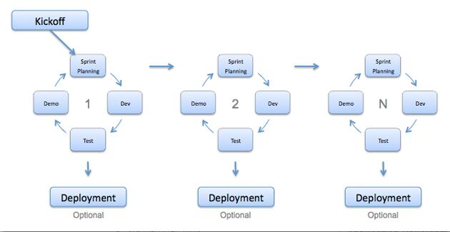

Figure 1: Agile Methodology

For more information: <http://agilemodeling.com/>

This project is developed under Agile model. We apply Agile model to capable with current situation of our team. We choose this model due to following reasons:

* **Greater flexibility:** Though traditional methodologies require the customer to provide detail idea requirements, agile software developers are more flexible because of their iterative style of work.
* **Quick responding to changing needs:** Since agile software development goes through multiple rollout cycles, it has a better chance of providing exactly what the customers need at any given point in time. These cycles are designed not only to add new features but also to make adjustments to what has already been deployed.
* **Continuous feedback and easy to track:** It allow continuous feedbacks in bill to shape the final design.

### Roles and Responsibilities

|  |  |  |  |
| --- | --- | --- | --- |
| **No** | **Full name** | **Role** | **Responsibilities** |
| 1 | Nguyễn Huy Hùng | Project Manager | - Specify user requirement  - Control development process  - Give out technique and business analysis support  - Review document and product |
| 2 | Nguyễn Quốc Bảo | Team Leader, BA, Developer, Tester | - Managing process  - Planning project  - Distribute Tasks  - Designing database  - Clarifying requirements  - Prepare document  - GUI design  - Create test plan  - Coding  - Testing  - Deploy product |
| 3 | Nguyễn Duy Hùng | Team Member, BA, Developer, Tester | - Designing database  - Clarifying requirements  - Prepare document  - GUI design  - Create test plan  - Coding  - Testing |
| 4 | Trịnh Thanh Vũ | Team Member, BA, Developer, Tester | - Designing database  - Clarifying requirements  - Prepare document  - GUI design  - Create test plan  - Coding  - Testing |

Table 5: Roles and Responsibilities

### Tools and Techniques

|  |  |  |
| --- | --- | --- |
|  | **Tools** | **Techniques** |
| Front-end | Visual studio | HTML5, CSS3, JavaScript, jQuery, Bootstrap |
| Back-end | Visual studio | .Net 4.5, entity framework 6, asp.NET MVC 5, web API 2.0, Jwt authentication, Autofac (configure dependency injection), SignalR 2. |
| Web server | IIS 10 |  |
| Application | Android Studio | Mvvm data binding, dagger2 ( configure dependency injection), Rx2androidnetworking, Signal R 2. |
| DBMS | SQL server 2014, Sqlite |  |
| Source control | TortoiseSVN 1.10.0 |  |
| Modeling tool | StarUML v2.0 |  |
| Document tool | Microsoft Word 2016 |  |

Table 6: Tools and Techniques

## Project Management Plan

### Product Backlog

All product backlogs could be found here:

CP\Document\Develop\BaoNQ

### Sprint Backlog

All print backlogs could be found here:

CP\Document\Develop\BaoNQ

### Meeting Minutes

All meeting documents could be found here:

CP\Document\Develop

## Coding Convention

We use followings naming convention from the reference to capable with the current situation in our team:

* Naming Convention:
* Follows camelcase syntax for naming the class, interface, method and variable.
* Method names should be verbs.
* Class names should be nouns, in mixed case with first letter of each internal word capitalized.
* Constant names should be all uppercase with words separated by underscore.
* Comment:
* Using /* */ for block comments.
* Using // for line comments.
* Follow Field Naming Conventions
* Other fields start with a lowercase letter.
* Public static final fields (constants) are ALL_CAPS_WITH_UNDERSCORES.

Using Java coding convention from:

<http://www.oracle.com/technetwork/java/codeconvtoc-136057.html>

Using .NET coding convention from:

<https://docs.microsoft.com/en-us/dotnet/csharp/programming->guide/inside-a-program/coding-conventions

# C. Software Requirement Specification

## User Requirement Specification

### Unauthorized User Requirement

Unauthorized user is a person who doesn’t access to the system. Unauthorized user can use some functions in the system, to use all functions, they must login. These are one function they can use:

* Login
* Login via Facebook
* Login via Google
* Register

### Authorized User Requirement

Authorized user is a person after they login in the system and they will separate into buyer or traveler depend on what they want to do in our application. Authorized user can do some functions, such as:

* Chat
* Video call
* Manage wallet
* Manage their information
* Receive notification
* Logout

### Traveler Requirement

Traveler is authorized user which want to post their trip in order to looking for suitable orders and make offers with buyer. Traveler can do following functions:

* View suggested order
* View offer
* Make offer
* Manage offer
* View bill
* View trip
* Manage trip
* Create trip
* Rate for buyer

### Buyer Requirement

Buyer is authorized user which want to order their offer and try to look for people who travel abroad to make deal with them. Buyer can do following functions:

* Create order
* View suggested trip
* Manage order
* Send order to traveler
* View offer
* Accept offer
* View bill
* Confirm complete
* View trip
* Rating

### Admin Requirement

Admin is a completely different role form another. Admin only can manage information and tracking is system work efficiently or not. Admin can do following functions:

* Manage user
* Manage order
* View bill
* View transaction
* Logout

## System Requirement Specification

### External Interface Requirement

#### User Interface

* The user interface use Vietnamese.
* Use the consistent palette of colors between the text and the background.
* General requirement for graphical user interface of application on the mobile device is the GUI should be simple, reminiscent.

#### Hardware Interface.

* Smartphone.

#### Software Interface

* Mobile application: Android operating system (android 4.1 or above).

#### Communication Protocol

* Using Http protocol.

### System Overview Use Case

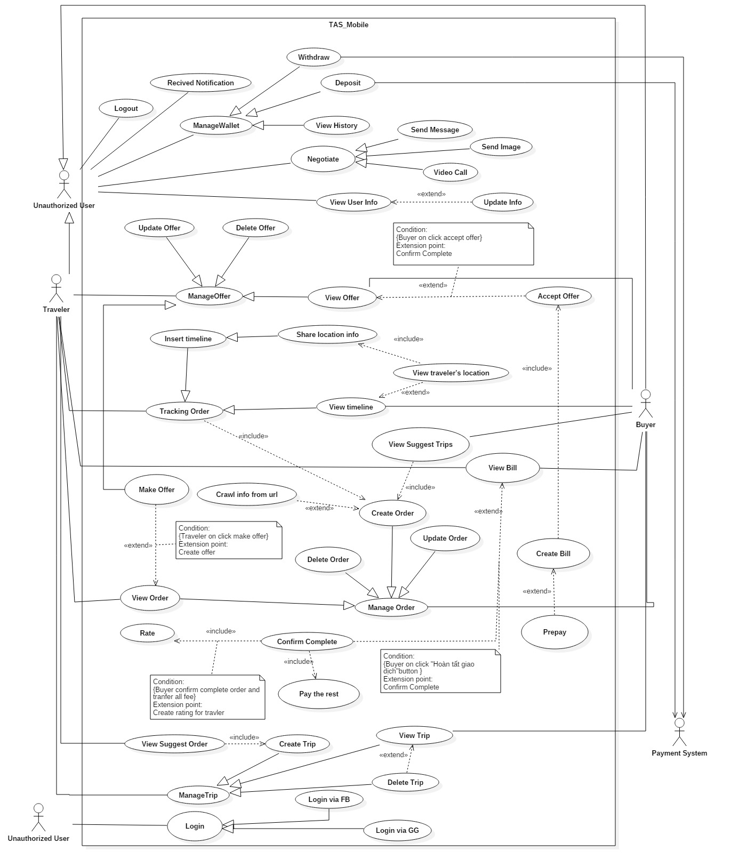

Figure 2: System Overview Use Case (1)

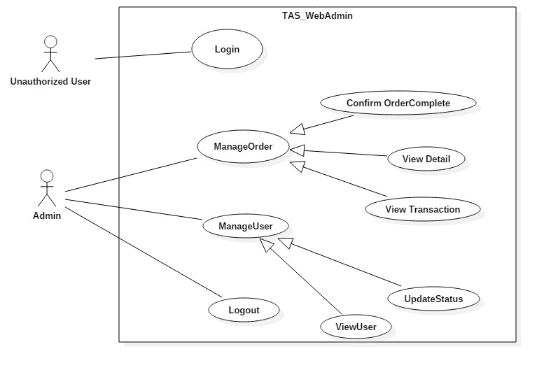

Figure 3: System Overview Use Case (2)

### List of Use Case

#### <Unauthorized User> Overview Use Case

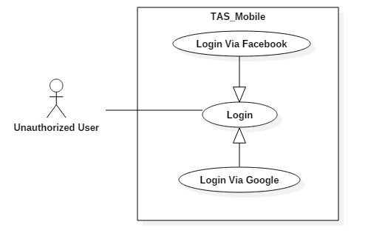

Figure 4: <Unauthorized User> Overview Use Case

##### <Unauthorized User> Login



Figure 5: <Unauthorized User> Login Use Case

|  |  |  |  |
| --- | --- | --- | --- |
| **USE CASE – UC_ TAS1** | | | |
| **Use Case No.** | UC_ TAS1 | **Use Case Version** | 0.2 |
| **Use Case Name** | Login | | |
| **Author** | Trịnh Thanh Vũ | | |
| **Date** | 15/6/2018 | **Priority** | High |
| **Actor:**   * Unauthorized User   **Summary:**   * This use case allows unauthorized user to login to system with email and password.   **Goal:**   * To login to the system.   **Triggers:**   * Actor sends login command.   **Preconditions:** N/A  **Post conditions:**   * Success: Actor accesses to system successfully. * Fail: System shows error messages.   **Main Success Scenario:**   |  |  |  | | --- | --- | --- | | **Step** | **Actor Action** | **System Response** | | 1 | Actor goes to login page | System requires information:   * “Email”: Text input * “Password”: Text input * Login button. * Google button. * Facebook button. | | 2 | Actor inputs information  (Email and password) |  | | 3 | Actor sends command to login  (Click “Login” button after input login form). | [Exception no.1]  [Exception no.2]  System navigates to home page. |   **Alternative Scenario:** N/A  **Exceptions:**   |  |  |  | | --- | --- | --- | | **No** | **Cause** | **System Response** | | 1 | Actor inputs wrong information. | System shows message:“Thông tin đăng nhập không hợp lệ” | | 2 | Actor left blank to required fields. | System shows message: “Vui lòng điền đầy đủ thông tin”. |   **Relationships:** N/A  **Business Rules:**   * User have not logged in to system. * Username must be in range of 5-35 characters * Password must be in range of 4-30 characters. * Password must be encrypted before being sent to server. | | | |

Table 7: <Unauthorized User> Login specification

##### <Unauthorized User> Login Via Google

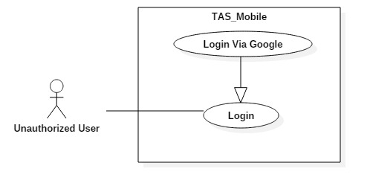

Figure 6: <Unauthorized User> Login via Google Use case

|  |  |  |  |
| --- | --- | --- | --- |
| **USE CASE – UC_ TAS2** | | | |
| **Use Case No.** | UC_ TAS2 | **Use Case Version** | 0.2 |
| **Use Case Name** | Login Via Google | | |
| **Author** | Trịnh Thanh Vũ | | |
| **Date** | 15/6/2018 | **Priority** | High |
| **Actor:**   * Unauthorized User   **Summary:**   * This use case allows unauthorized user to login to system with Google account.   **Goal:**   * To login to the system.   **Triggers:**   * Actor sends login command.   **Preconditions:** N/A  **Post conditions:**   * Success: Actor accesses to system successfully. * Fail: System shows error messages.   **Main Success Scenario:**   |  |  |  | | --- | --- | --- | | **Step** | **Actor Action** | **System Response** | | 1 | Actor goes to login page | System displays requires information:   * “Email”: Text input * “Password”: Text input * Login button. * Google button. * Facebook button. | | 2 | Actor clicks on Google button. | System sends request to Google and pops up modal with all Google account on device. | | 3 | Actor clicks on certain account. | System shows message: “Đang xử lý”.  System navigates to home page. |   **Alternative Scenario:** N/A  **Exceptions:** N/A  **Relationships:** N/A  **Business Rules:**   * User have not logged in to system. | | | |

Table 8: <Unauthorized User> Login via Google specification

##### <Unauthorized User> Login Via Facebook

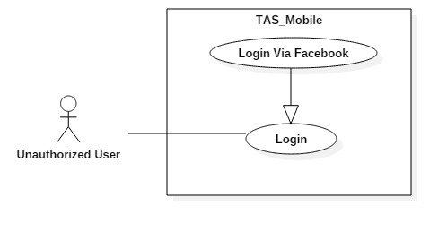

Figure 7: <Unauthorized User> Login via Facebook Use Case

|  |  |  |  |
| --- | --- | --- | --- |
| **USE CASE – UC_ TAS3** | | | |
| **Use Case No.** | UC_ TAS3 | **Use Case Version** | 0.2 |
| **Use Case Name** | Login Via Facebook | | |
| **Author** | Trịnh Thanh Vũ | | |
| **Date** | 15/6/2018 | **Priority** | High |
| **Actor:**   * Unauthorized User   **Summary:**   * This use case allows unauthorized user to login to system Facebook account.   **Goal:**   * To login to the system.   **Triggers:**   * Actor sends login command.   **Preconditions:** N/A  **Post conditions:**   * Success: Actor accesses to system successfully. * Fail: System shows error messages.   **Main Success Scenario:**   |  |  |  | | --- | --- | --- | | **Step** | **Actor Action** | **System Response** | | 1 | Actor goes to login page | System requires information:   * “Email”: Text input * “Password”: Text input * Login button. * Google button. * Facebook button. | | 2 | Actor clicks on Google button. | System sends request to Facebook and pops up modal show ask for user’s facebook permission. | | 3 | Actor clicks “OK” button. | System shows message: “Đang xử lý”.  System navigates to home page. |   **Alternative Scenario:** N/A  **Exceptions:** N/A  **Relationships:** N/A  **Business Rules:**   * User have not logged in to system. | | | |

Table 9: Login via Facebook Specification

#### <Authorized User> Overview Use Case

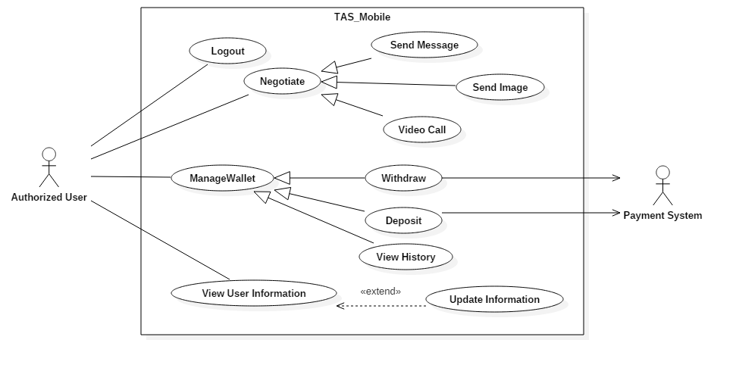

Figure 8: <Authorized User> Overview Use Case

##### <Authorized User> Logout

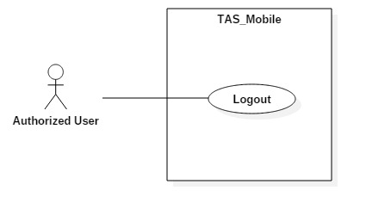

Figure 9: <Authorized User> Logout Use Case

|  |  |  |  |
| --- | --- | --- | --- |
| **USE CASE – UC_ TAS4** | | | |
| **Use Case No.** | UC_ TAS4 | **Use Case Version** | 0.2 |
| **Use Case Name** | Logout | | |
| **Author** | Trịnh Thanh Vũ | | |
| **Date** | 22/7/2018 | **Priority** | High |
| **Actor:**   * Authorized User   **Summary:**   * This use case allows authorized user signs out from the system.   **Goal:**   * Authenticated user stops accessing to the system. * User’s session is removed from the system.   **Triggers:**   * Actor sends signs out command.   **Preconditions:**   * User logged in the system.   **Post conditions:**   * Success: User session is removed, and system displays login page. * Fail: System displays error messages.   **Main Success Scenario:**   |  |  |  | | --- | --- | --- | | **Step** | **Actor Action** | **System Response** | | 1 | Actor clicks “Cài Đặt” button. | User navigated to setting page | | 2 | Actor clicks “Đăng xuất” button. | User session is removed, and system displays login page. |   **Alternative Scenario:**N/A  **Exceptions:** N/A  **Relationships:** N/A  **Business Rules:**   * Actor has already accessed to the system. * After signing out, Authorized User will become “Unauthorized User” | | | |

Table 10: <Authorized User> Logout specification

##### <Authorized User> Send Message

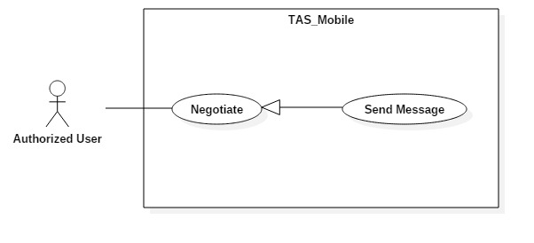

Figure 10: <Authorized User> Send Message Use Case

|  |  |  |  |
| --- | --- | --- | --- |
| **USE CASE – UC_ TAS5** | | | |
| **Use Case No.** | UC_ TAS5 | **Use Case Version** | 0.2 |
| **Use Case Name** | Send Message | | |
| **Author** | Trịnh Thanh Vũ | | |
| **Date** | 22/7/2018 | **Priority** | High |
| **Actor:**   * Authorized User   **Summary:**   * This use case allows user to communicate with other users in the system by message.   **Goal:**   * To communicate between users by message.   **Triggers:**   * Actor sends message command.   **Preconditions:**   * User logged in the system.   **Post conditions:**   * Success: System displays chat page. * Fail: System displays error messages.   **Main Success Scenario:**   |  |  |  | | --- | --- | --- | | **Step** | **Actor Action** | **System Response** | | 1 | Actor clicks “Tin nhắn” button. | System navigates to messages page | | 2 | Actor input user name field. |  | | 3 | Actor clicks “Tìm” button. | [Exception 1]  System shows result with user name. | | 4 | Actor clicks on certain user name. |  | | 5 | Actor types message. |  | | 6 | Actor clicks on “Gửi” button. | System shows new chat box on screen. |   **Alternative Scenario:**N/A  **Exceptions:**   |  |  |  | | --- | --- | --- | | **Step** | **Cause** | **System Response** | | 1 | User doesn’t exist in database. | System displays blank page with “Không tìm thấy người dùng” message. |   **Relationships:** N/A  **Business Rules:**   * Actor already accessed to the system. * If user wants to connect with another user, current user have to inputs the correct other user’s name. | | | |

Table 11: <Authorized User> Send Message specification

##### <Authorized User> Video Call

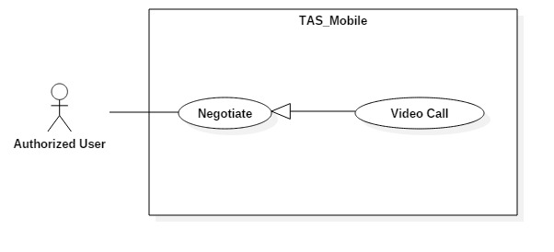

Figure 11: <Authorized User> Video Call Use Case

|  |  |  |  |
| --- | --- | --- | --- |
| **USE CASE – UC_ TAS6** | | | |
| **Use Case No.** | UC_ TAS6 | **Use Case Version** | 0.2 |
| **Use Case Name** | Video Call | | |
| **Author** | Trịnh Thanh Vũ | | |
| **Date** | 22/7/2018 | **Priority** | High |
| **Actor:**   * Authorized User   **Summary:**   * This use case allows user to communicate with other users in the system by video.   **Goal:**   * To communicate between users by video.   **Triggers:**   * Actor sends video command.   **Preconditions:**   * User logged in the system.   **Post conditions:**   * Success: System displays chat page. * Fail: System displays error messages.   **Main Success Scenario:**   |  |  |  | | --- | --- | --- | | **Step** | **Actor Action** | **System Response** | | 1 | Actor clicks “Tin nhắn” button. | System navigates to messages page | | 2 | Actor input user name field. |  | | 3 | Actor clicks “Tìm” button. | [Exception 1]  System shows result with user name. | | 4 | Actor clicks on certain user name. |  | | 5 | Actor clicks on “Video” button. | System opens video call with:  - Current user camera point of view.  - Other user camera point of view. |   **Alternative Scenario:**N/A  **Exceptions:**   |  |  |  | | --- | --- | --- | | **Step** | **Cause** | **System Response** | | 1 | User doesn’t exist in database. | System displays blank page with “Không tìm thấy người dùng” message. |   **Relationships:** N/A  **Business Rules:**   * Actor already accessed to the system. * If user wants to connect with another user, current user have to inputs the correct other user’s name. | | | |

Table 12: <Authorized User> Video Call specification

##### <Authorized User> Update Info

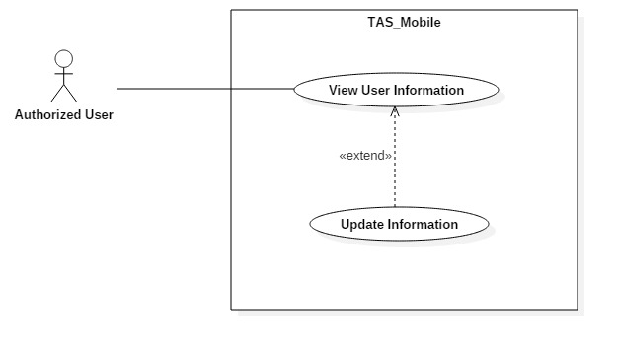

Figure 12: <Authorized User> Update Information Use Case

|  |  |  |  |
| --- | --- | --- | --- |
| **USE CASE – UC_ TAS7** | | | |
| **Use Case No.** | UC_ TAS7 | **Use Case Version** | 0.2 |
| **Use Case Name** | Update User Info | | |
| **Author** | Trịnh Thanh Vũ | | |
| **Date** | 22/7/2018 | **Priority** | High |
| **Actor:**   * Authorized User   **Summary:**   * This use case allows authorized user to update their own information.   **Goal:**   * To update information of user.   **Triggers:**   * Actor sends update user info command.   **Preconditions:**   * User logged in the system.   **Post conditions:**   * Success: System navigates back to user information page and displays new information of the current user. * Fail: System displays error messages.   **Main Success Scenario:**   |  |  |  | | --- | --- | --- | | **Step** | **Actor Action** | **System Response** | | 1 | Actor clicks “Cài đặt” button. | System navigates to setting page. | | 2 | Actor clicks on current user name section. | System displays profile page with:   * “Ảnh đại diện”: Image Upload * “Họ và tên”: Text input * “Email”: Text input * “Tài khoản Ngân lượng”: Text input * “Số điện thoại”: Text input * “Địa chỉ”: Text input * “Giới thiệu bản thân”: Text input | | 3 | Actor clicks “Cập nhật” button. | [Exception no.1]  [Exception no.2]  User info is updated successfully and system refreshes the profile page with new information. |   **Alternative Scenario:***N/A*  **Exceptions:**   |  |  |  | | --- | --- | --- | | **No** | **Cause** | **System Response** | | 1 | User does not input required fields. | System notices that user need to input all these field:  - “Họ và tên”: System displays warning message: “Họ và tên không được để trống”.  - “Tài khoản Ngân lượng”: System displays warning message: “Tài khoản Ngân lượng không được để trống”.  - “Số điện thoại”: System displays warning message: “Số điện thoại không được để trống”. | | 2 | Learner input wrong some fields with requirement. | System notices that guest need to re-input all these field:  - “Họ và tên”: System displays warning message: “Không được sử dụng ký tự đặc biệt !@#$%^&*()-=_+...”.  - “Tài khoản Ngân lượng”: System displays warning message: “Sai định dạng, thiếu @”  - “Số điện thoại”: System displays warning message: “Không được sử dụng chữ hoặc ký tự đặc biệt !@#$%^&*()-=_+...”. |   **Relationships:**   * Extend from: View User Info.   **Business Rules:**   * Actor has already accessed to the system. * Name is not null and do not use special character. * Payment email can not input wrong format or not contain @ character. * Phone can not input alphabet character. | | | |

Table 13: <Authorized User> Update Information specification

##### <Authorized User> Withdraw

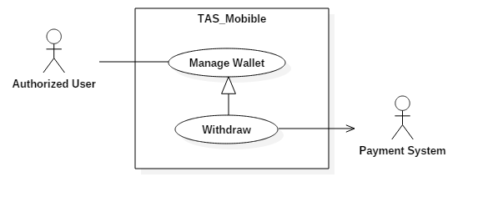

Figure 13: <Authorized User> Withdraw Use Case

|  |  |  |  |
| --- | --- | --- | --- |
| **USE CASE – UC_ TAS8** | | | |
| **Use Case No.** | UC_ TAS8 | **Use Case Version** | 0.2 |
| **Use Case Name** | Withdraw | | |
| **Author** | Trịnh Thanh Vũ | | |
| **Date** | 22/7/2018 | **Priority** | High |
| **Actor:**   * Authorized User   **Summary:**   * This use case allows user to withdraw money from system.   **Goal:**   * To withdraw money.   **Triggers:**   * Actor sends withdraw command.   **Preconditions:**   * User logged in the system.   **Post conditions:**   * Success: User get money back from TAS system. * Fail: System displays error messages.   **Main Success Scenario:**   |  |  |  | | --- | --- | --- | | **Step** | **Actor Action** | **System Response** | | 1 | Actor clicks on “Cài đặt” button. | System navigates to setting page. | | 2 | Actor clicks on “Ví của tôi” button. | System displays wallet page with:   * “Số dư trong ví” * “Nạp tiền”: Button * “Rút tiền”: Button * “Lịch sử giao dịch” | | 3 | Actor clicks on “Rút tiền” button. | System navigates to withdraw screen with:   * “Tài khoản Ngân lượng” * “Tổng số tiền”: Text input * “Gửi yêu cầu”: Button | | 4 | Actor inputs “Tổng số tiền” |  | | 5 | Actor clicks on “Gửi yêu cầu” button. | System sends withdraw request to Nganluong.vn system |   **Alternative Scenario:**N/A  **Exceptions:** N/A  **Relationships:** N/A  **Business Rules:**   * Actor has already accessed to the system. * Actor have money left in system. | | | |

Table 14: <Authorized User> Withdraw specification

##### <Authorized User> Deposit

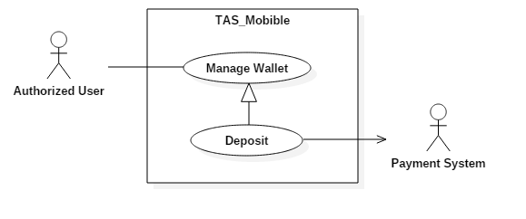

Figure 14: <Authorized User> Deposit

|  |  |  |  |
| --- | --- | --- | --- |
| **USE CASE – UC_ TA9** | | | |
| **Use Case No.** | UC_ TAS9 | **Use Case Version** | 0.2 |
| **Use Case Name** | Deposit | | |
| **Author** | Trịnh Thanh Vũ | | |
| **Date** | 22/7/2018 | **Priority** | High |
| **Actor:**   * Authorized User   **Summary:**   * This use case allows user to deposit money to TAS system.   **Goal:**   * To deposit money.   **Triggers:**   * Actor sends deposit command.   **Preconditions:**   * User logged in the system.   **Post conditions:**   * Success: User get money back from TAS system. * Fail: System displays error messages.   **Main Success Scenario:**   |  |  |  | | --- | --- | --- | | **Step** | **Actor Action** | **System Response** | | 1 | Actor clicks on “Cài đặt” button. | System navigates to setting page. | | 2 | Actor clicks on “Ví của tôi” button. | System displays wallet page with:   * “Số dư trong ví” * “Nạp tiền”: Button * “Rút tiền”: Button * “Lịch sử giao dịch” | | 3 | Actor clicks on “Nạp tiền” button. | System navigates to deposit screen with:   * “Tài khoản Ngân lượng” * “Tổng số tiền”: Text input * “Gửi yêu cầu”: Button | | 4 | Actor inputs “Tổng số tiền” |  | | 5 | Actor clicks on “Gửi yêu cầu” button. | System sends deposit request to Nganluong.vn system |   **Alternative Scenario:**N/A  **Exceptions:** N/A  **Relationships:** N/A  **Business Rules:**   * Actor has already accessed to the system. | | | |

Table 15: <Authorized User> Deposit specification

##### <Authorized User> View History

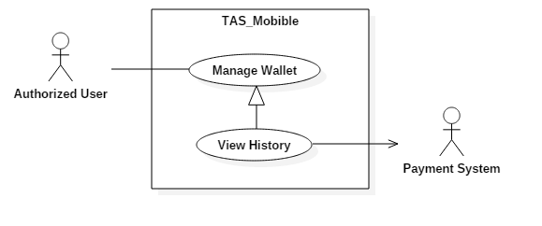

Figure 15: <Authorized User> View History Use Case

|  |  |  |  |
| --- | --- | --- | --- |
| **USE CASE – UC_ TA9** | | | |
| **Use Case No.** | UC_ TAS9 | **Use Case Version** | 0.2 |
| **Use Case Name** | Deposit | | |
| **Author** | Trịnh Thanh Vũ | | |
| **Date** | 22/7/2018 | **Priority** | High |
| **Actor:**   * Authorized User   **Summary:**   * This use case allows user to deposit money to TAS system.   **Goal:**   * To deposit money.   **Triggers:**   * Actor sends deposit command.   **Preconditions:**   * User logged in the system.   **Post conditions:**   * Success: User get money back from TAS system. * Fail: System displays error messages.   **Main Success Scenario:**   |  |  |  | | --- | --- | --- | | **Step** | **Actor Action** | **System Response** | | 1 | Actor clicks on “Cài đặt” button. | System navigates to setting page. | | 2 | Actor clicks on “Ví của tôi” button. | System displays wallet page with:   * “Số dư trong ví” * “Nạp tiền”: Button * “Rút tiền”: Button * “Lịch sử giao dịch” |   **Alternative Scenario:**N/A  **Exceptions:** N/A  **Relationships:** N/A  **Business Rules:**   * Actor has already accessed to the system. | | | |

Table 16: <Authorized User> View History specification

#### <Traveler> Overview Use Case

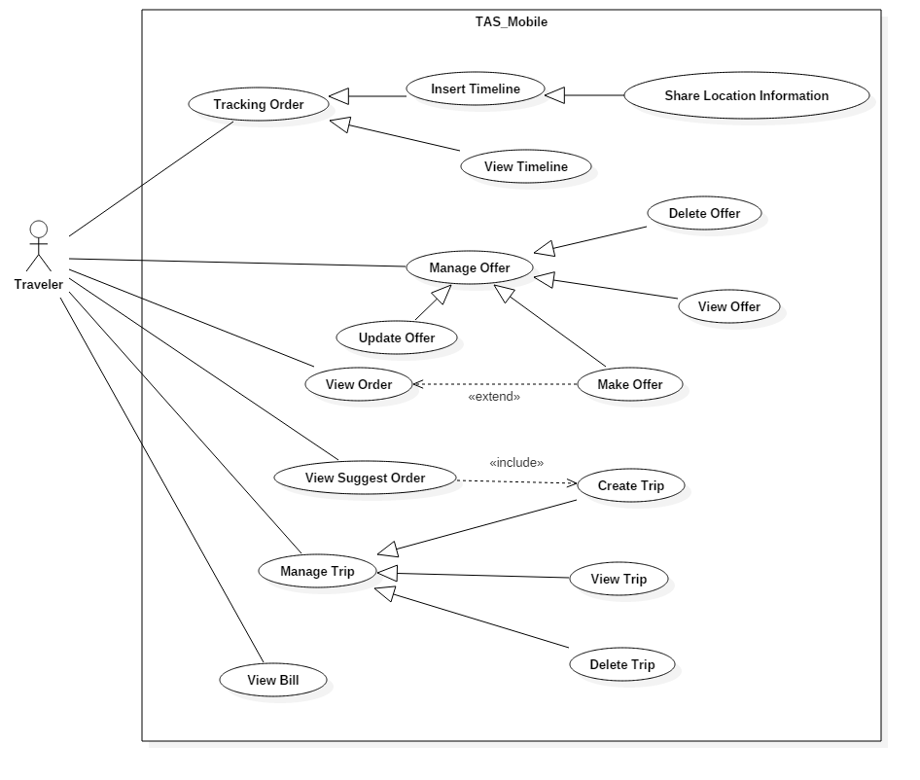

Figure 16: <Traveler> Overview Use CaseFigure 17

##### <Traveler> Make Offer

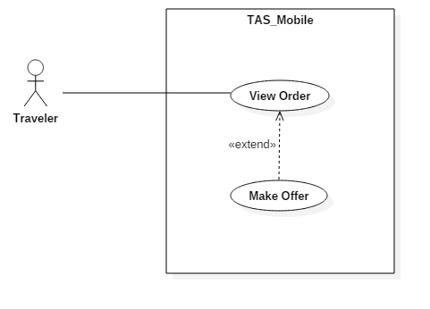

Figure 18: <Traveler> Make Offer Use Case

|  |  |  |  |
| --- | --- | --- | --- |
| **USE CASE – UC_ TAS10** | | | |
| **Use Case No.** | UC_ TAS10 | **Use Case Version** | 0.2 |
| **Use Case Name** | Make Offer | | |
| **Author** | Trịnh Thanh Vũ | | |
| **Date** | 22/7/2018 | **Priority** | High |
| **Actor:**   * Traveler   **Summary:**   * This use case allows traveler to make offer with buyer.   **Goal:**   * To make offer.   **Triggers:**   * Actor sends make offer command.   **Preconditions:**   * User logged in the system. * User created trip. * Buyer created order.   **Post conditions:**   * Success: User can make offer with other user. * Fail: System shows error messages.   **Main Success Scenario:**   |  |  |  | | --- | --- | --- | | **Step** | **Actor Action** | **System Response** | | 1 | Actor clicks on certain product | System navigate to product detail screen. | | 2 | Actor chooses product and clicks “Thỏa thuận” button. | System displays make offer screen | | 3 | Actor chooses trip. | System navigates to make offer screen. | | 4 | Actor clicks “Gửi đề nghị” button. | [Exception no.1]  System navigates back to main screen. |   **Alternative Scenario:** N/A  **Exceptions:**   |  |  |  | | --- | --- | --- | | **No** | **Cause** | **System Response** | | 1 | User does not input required fields. | System notices that user need to input all these field:  - “Phí vận chuyển”: System displays warning message: “Phí vận chuyển không được để trống”.  - “Ngày giao hàng”: System displays warning message: “Ngày giao hàng không được để trống”. |   **Relationships:**   * Extends form: View Order   **Business Rules:**   * User already logged in the system. * Traveler created trip. * Transport fee is not null. * Delivery date is not null. | | | |

Table 17: <Traveler> Make Offer specification

##### <Traveler> Create Trip

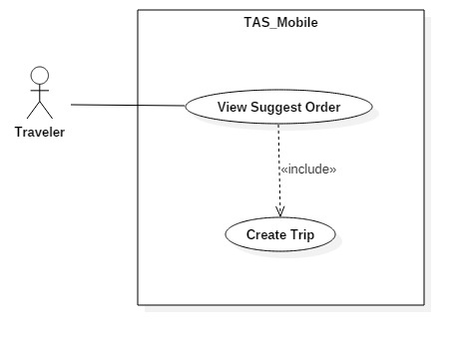

Figure 21: <Traveler> Create Trip Use Case

|  |  |  |  |
| --- | --- | --- | --- |
| **USE CASE – UC_ TAS13** | | | |
| **Use Case No.** | UC_ TAS13 | **Use Case Version** | 0.2 |
| **Use Case Name** | Create Trip | | |
| **Author** | Trịnh Thanh Vũ | | |
| **Date** | 22/7/2018 | **Priority** | High |
| **Actor:**   * Traveler   **Summary:**   * This use case allows traveler to create new trip.   **Goal:**   * To create new trip.   **Triggers:**   * Actor sends create trip command.   **Preconditions:**   * User logged in the system.   **Post conditions:**   * Success: User can see new trip created. * Fail: System shows error messages.   **Main Success Scenario:**   |  |  |  | | --- | --- | --- | | **Step** | **Actor Action** | **System Response** | | 1 | Actor clicks on “ Chuyến Đi” button. | System navigates to trip page. | | 2 | Actor clicks on “Thêm Chuyến Đi” button. | System navigates to create trip page.  System displays create trip page with:  - “Nơi bạn đi”: Text input.  - “Nơi bạn đến”: Text input.  - “Ngày bạn đi”: Date Time picker.  - “Nhận thông báo”: Switch. | | 3 | Actor clicks on “Xác nhận” button. | [Exception no.1]  System creates trip successfully and navigate User back to trip page.  System will display “Thêm Chuyến Đi” button and information about lastest created trip. |   **Alternative Scenario:** N/A  **Exceptions:**   |  |  |  | | --- | --- | --- | | **No** | **Cause** | **System Response** | | 1 | User does not input required fields. | System notices that user need to input all these field:  - “Nơi bạn đi”: System displays warning message: “Nơi bạn đi không được để trống”.  - “Nơi bạn đến”: System displays warning message: “Nơi bạn đến không được để trống”.  - “Ngày bạn đi”: System displays warning message: “Phải lựa chọn ngày bạn đi”. |   **Relationships:**   * Include from: View suggest Order.   **Business Rules:**   * User already logged in the system. | | | |

Table 20: <Traveler> Create Trip specification

##### <Traveler> View Suggest Order



Figure 22: <Traveler> View Suggest Order Use Case

|  |  |  |  |
| --- | --- | --- | --- |
| **USE CASE – UC_ TAS14** | | | |
| **Use Case No.** | UC_ TAS14 | **Use Case Version** | 0.2 |
| **Use Case Name** | View Suggest Order | | |
| **Author** | Trịnh Thanh Vũ | | |
| **Date** | 22/7/2018 | **Priority** | High |
| **Actor:**   * Traveler   **Summary:**   * This use case allows traveler to view suggest orders.   **Goal:**   * To view all suggest orders.   **Triggers:**   * Actor sends view suggest orders command.   **Preconditions:**   * User logged in the system. * User created trip.   **Post conditions:**   * Success: Traveler can see all orders matching with their trip. * Fail: System shows error messages.   **Main Success Scenario:**   |  |  |  | | --- | --- | --- | | **Step** | **Actor Action** | **System Response** | | 1 | Actor clicks on “Trang chủ” tab. | System navigate main page. | | 2 | Actor clicks on “Bạn đi du lịch” tab. | System will automatically display all suggest orders. |   **Alternative Scenario:** N/A  **Exceptions:** N/A  **Relationships:**   * Include from: Create Trip.   **Business Rules:**   * User already logged in the system. * Traveler already created trip. * Buyer already created order. | | | |

Table 21: <Traveler> View Suggest Order specification

##### <Traveler> Manage Trip

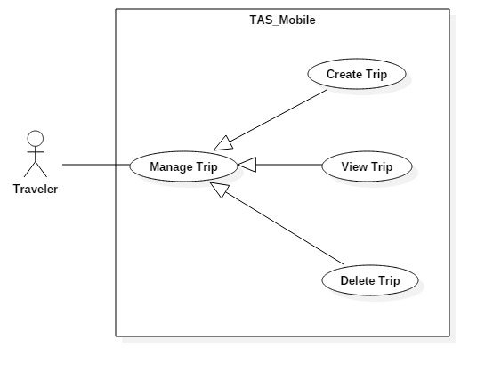

Figure 23: <Traveler> Manage Trip Use Case

|  |  |  |  |
| --- | --- | --- | --- |
| **USE CASE – UC_ TAS15** | | | |
| **Use Case No.** | UC_ TAS15 | **Use Case Version** | 0.2 |
| **Use Case Name** | Manage Trip | | |
| **Author** | Trịnh Thanh Vũ | | |
| **Date** | 22/7/2018 | **Priority** | High |
| **Actor:**   * Traveler   **Summary:**   * This use case allows traveler to manage all trips.   **Goal:**   * To manage all trips.   **Triggers:**   * Actor sends mange trip command.   **Preconditions:**   * User logged in the system. * Traveler created trip.   **Post conditions:**   * Success: Traveler can manage all trip. * Fail: System shows error messages.   **Main Success Scenario:**   |  |  |  | | --- | --- | --- | | **Step** | **Actor Action** | **System Response** | | 1 | Actor clicks on “ Chuyến đi” button. | System navigates to trip page.  System displays all trips user have created. |   **Alternative Scenario:** N/A  **Exceptions:** N/A  **Relationships:** N/A  **Business Rules:**   * User already logged in the system. * User already create trip. | | | |

Table 22: <Traveler> Manage Trip specification

##### <Traveler> Delete Trip

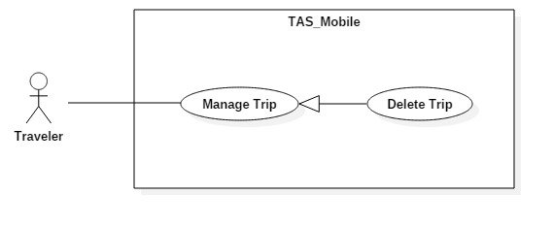

Figure 24: <Traveler> Delete Trip Use Case

|  |  |  |  |
| --- | --- | --- | --- |
| **USE CASE – UC_ TAS16** | | | |
| **Use Case No.** | UC_ TAS16 | **Use Case Version** | 0.2 |
| **Use Case Name** | Delete Trip | | |
| **Author** | Trịnh Thanh Vũ | | |
| **Date** | 22/7/2018 | **Priority** | High |
| **Actor:**   * Traveler   **Summary:**   * This use case allows traveler delete trip.   **Goal:**   * To delete trip.   **Triggers:**   * Actor sends delete trip command.   **Preconditions:**   * User logged in the system. * Traveler already created trip.   **Post conditions:**   * Success: User can delete trip. * Fail: System shows error messages.   **Main Success Scenario:**   |  |  |  | | --- | --- | --- | | **Step** | **Actor Action** | **System Response** | | 1 | Actor clicks on “Chuyến Đi” tab. | System navigates to trip page. | | 2 | Actor clicks on certain trip section. | System navigates to selected trip page. | | 3 | Actor clicks on “Xóa” button. | System displays message:”Bạn có chắc chắn ?”. | | 4 | Actor clicks on “Chắc chắn” button. | System deletes successfully and navigate back to trip page. |   **Alternative Scenario:** N/A  **Exceptions:** N/A  **Relationships:** N/A  **Business Rules:**   * User already logged in the system. * User already created trip. | | | |

Table 23: <Traveler> Delete Trip

##### <Traveler> Tracking Order

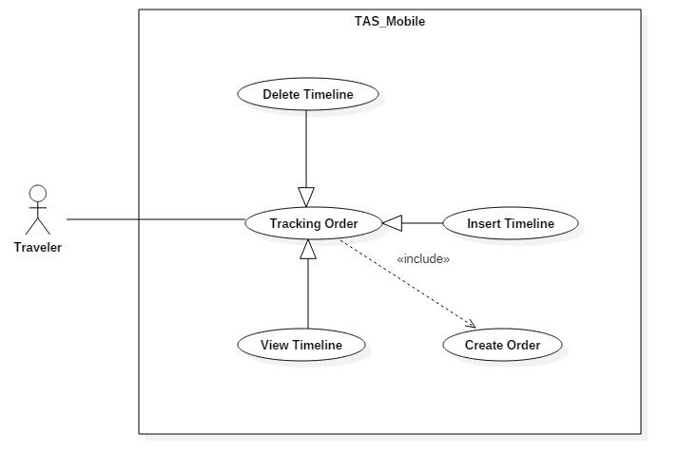

Figure 25: <Traveler> Tracking Order Use Case

|  |  |  |  |
| --- | --- | --- | --- |
| **USE CASE – UC_ TAS17** | | | |
| **Use Case No.** | UC_ TAS17 | **Use Case Version** | 0.2 |
| **Use Case Name** | Tracking Order | | |
| **Author** | Trịnh Thanh Vũ | | |
| **Date** | 22/7/2018 | **Priority** | High |
| **Actor:**   * Traveler   **Summary:**   * This use case allows user track order.   **Goal:**   * To track order.   **Triggers:**   * Actor sends track order command.   **Preconditions:**   * User logged in the system. * User already created trip. * Offer had been made. * Order progressing.   **Post conditions:**   * Success: User can track order. * Fail: System shows error messages.   **Main Success Scenario:**   |  |  |  | | --- | --- | --- | | **Step** | **Actor Action** | **System Response** | | 1 | Actor clicks on “Chuyến Đi” tab. | System navigates to trip page. | | 2 | Actor clicks on certain trip section. | System navigates to selected trip page. | | 3 | Actor clicks on “Đang vận chuyển” tab. | System navigates to transit page.  System show bill transition. |   **Alternative Scenario:** N/A  **Exceptions:** N/A  **Relationships:**   * Extend: Create Trip.   **Business Rules:**   * User already logged in the system. * User already created trip. * Offer had been made. * Order progressing. | | | |

Table 24: <Traveler> Tracking Order specification

##### <Traveler> View Timeline

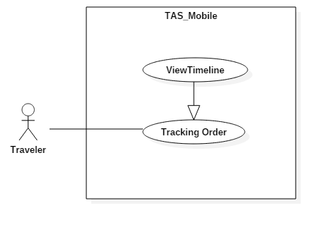

Figure 26: <Traveler> View Timeline Use Case

|  |  |  |  |
| --- | --- | --- | --- |
| **USE CASE – UC_ TAS18** | | | |
| **Use Case No.** | UC_ TAS18 | **Use Case Version** | 0.2 |
| **Use Case Name** | View Timeline | | |
| **Author** | Trịnh Thanh Vũ | | |
| **Date** | 22/7/2018 | **Priority** | High |
| **Actor:**   * Traveler   **Summary:**   * This use case allows user track certain order.   **Goal:**   * To track certain order.   **Triggers:**   * Actor sends track certain order command.   **Preconditions:**   * User logged in the system. * User already created trip. * Offer had been made. * Order progressing.   **Post conditions:**   * Success: User can track certain order. * Fail: System shows error messages.   **Main Success Scenario:**   |  |  |  | | --- | --- | --- | | **Step** | **Actor Action** | **System Response** | | 1 | Actor clicks on “Chuyến Đi” tab. | System navigates to trip page. | | 2 | Actor clicks on certain trip section. | System navigates to selected trip page. | | 3 | Actor clicks on “Đang vận chuyển” tab. | System navigates to transit page.  System show bill transition. | | 4 | Actor clicks on certain order. | System show order detail with:  - “Hình ảnh”  - “Tên món hàng”  - “Mua từ”  - “Gửi đển”  - “Chi tiết vận chuyển”  - “Giá sản phẩm”  - “Chi phí vận chuyển”  - “Tổng cộng”  - “Ngày giao hàng”  - “Đã thanh toán”  - “Còn lại”  - “Gửi tin nhắn” button.  - “Hoàn tất giao dịch” button. | | 5 | Actor clicks on “Chi tiết vận chuyển”. | System will navigate to tracking page. |   **Alternative Scenario:** N/A  **Exceptions:** N/A  **Relationships:** N/A  **Business Rules:**   * User already logged in the system. * User already created trip. * User have to turn on location in android setting. | | | |

Table 25: <Traveler> View Timeline specification

##### <Traveler> Share Location Information

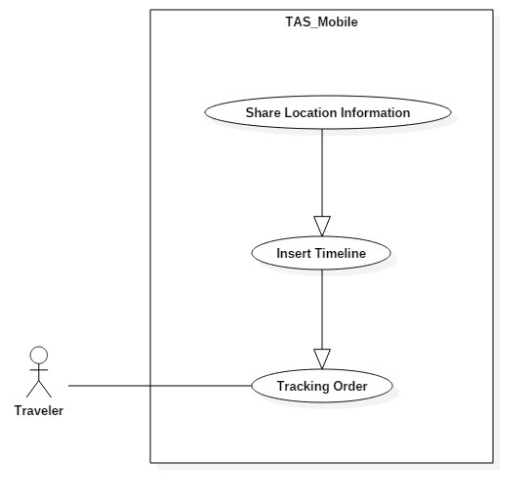

Figure 27: <Traveler> Share Location Information Use Case

|  |  |  |  |
| --- | --- | --- | --- |
| **USE CASE – UC_ TAS19** | | | |
| **Use Case No.** | UC_ TAS19 | **Use Case Version** | 0.2 |
| **Use Case Name** | Share Location Information | | |
| **Author** | Trịnh Thanh Vũ | | |
| **Date** | 22/7/2018 | **Priority** | High |
| **Actor:**   * Traveler   **Summary:**   * This use case allows user share location information.   **Goal:**   * To share location information.   **Triggers:**   * Actor sends share location information command.   **Preconditions:**   * User logged in the system. * User already created trip. * Offer had been made. * Bill progressing.   **Post conditions:**   * Success: User can share location information. * Fail: System shows error messages.   **Main Success Scenario:**   |  |  |  | | --- | --- | --- | | **Step** | **Actor Action** | **System Response** | | 1 | Actor clicks on “Chuyến Đi” tab. | System navigates to trip page. | | 2 | Actor clicks on certain trip section. | System navigates to selected trip page. | | 3 | Actor clicks on “Đang vận chuyển” tab. | System navigates to transit page.  System show bill transition. | | 4 | Actor clicks on certain order. | System show order detail with:  - “Hình ảnh”  - “Tên món hàng”  - “Mua từ”  - “Gửi đển”  - “Chi tiết vận chuyển”  - “Giá sản phẩm”  - “Chi phí vận chuyển”  - “Tổng cộng”  - “Ngày giao hàng”  - “Đã thanh toán”  - “Còn lại”  - “Gửi tin nhắn” button.  - “Hoàn tất giao dịch” button. | | 5 | Actor clicks on “Chi tiết vận chuyển”. | System will navigate to tracking page. | | 6 | Actor clicks on “Chia sẻ” button. | Systim will send current transition to buyer. |   **Alternative Scenario:** N/A  **Exceptions:** N/A  **Relationships:** N/A  **Business Rules:**   * User already logged in the system. * User already created trip. * User have to turn on location in android setting. | | | |

Table 26: <Traveler> Share Location Information specification

#### <Buyer> Overview Use Case

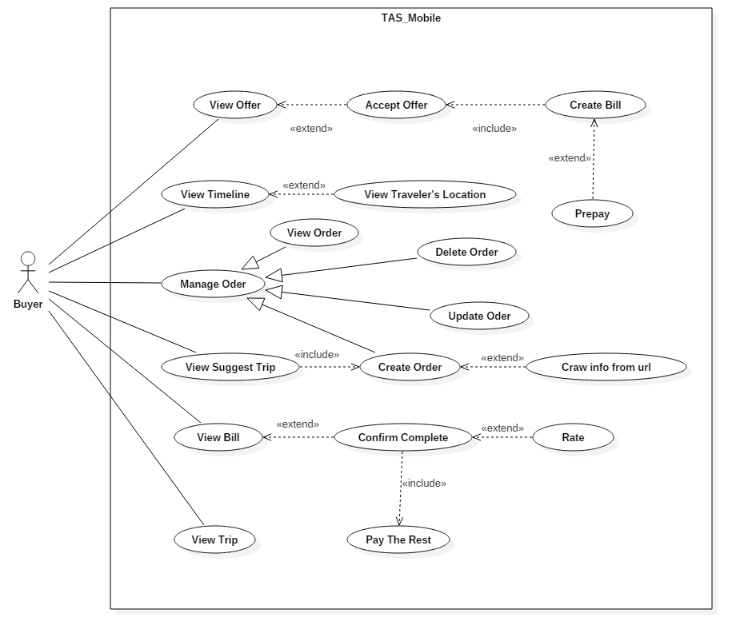

Figure 28: <Buyer> Overview Use Case

##### <Buyer> Create Order

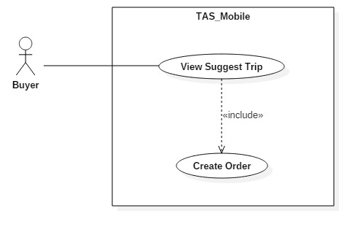

Figure 29: <Buyer> Create Order Use Case

|  |  |  |  |
| --- | --- | --- | --- |
| **USE CASE – UC_ TAS20** | | | |
| **Use Case No.** | UC_ TAS20 | **Use Case Version** | 0.2 |
| **Use Case Name** | Create Order | | |
| **Author** | Trịnh Thanh Vũ | | |
| **Date** | 22/7/2018 | **Priority** | High |
| **Actor:**   * Buyer   **Summary:**   * This use case allows traveler to create new order.   **Goal:**   * To create new order.   **Triggers:**   * Actor sends create order command.   **Preconditions:**   * User logged in the system.   **Post conditions:**   * Success: User can create new order. * Fail: System shows error messages.   **Main Success Scenario:**   |  |  |  | | --- | --- | --- | | **Step** | **Actor Action** | **System Response** | | 1 | Actors clicks on “Đơn hàng” button. | System navigates to order screen | | 1 | Actor clicks on “+” icon. | System navigates to create order screen.  System displays create order screen with:  - “Mua hàng từ”: Text input.  - “Tên sản phẩm”: Text input.  - “Giá sản phẩm”: Text input.  - “Số lượng”: Text input.  - “Mô tả thêm”: Text input. | | 2 | Actor clicks on “Kế tiếp” button. | [Exception no.1]  System navigates to next page.  System displays next page with:  - “Nơi mua”: Text input.  - “Nơi nhận”: Text input. - “Ngày nhận mong muốn”: Datetime picker.  - “Phí vận chuyển đề nghị”: Text input.  - “Thanh toán trước”: Switch button.  - “Số tiền trả trước”: Text input. | | 3 | Actor clicks on “Kế tiếp” button. | [Exception no.2]  System creates order successfully and navigate user back to home screen.  System will display latest information. |   **Alternative Scenario:** N/A  **Exceptions:**   |  |  |  | | --- | --- | --- | | **No** | **Cause** | **System Response** | | 1 | User does not input required fields. | System notices that user need to input all these field:  - “Tên sản phẩm”: System displays warning message: “Tên sản phẩm không được để trống”.  - “Giá sản phẩm”: System displays warning message: “Giá sản phẩm không được để trống”.  - “Số lượng”: System displays warning message: “Số lượng không được để trống”. | | 2 | User does not input required fields. | System notices that user need to input all these field:  - “Nơi mua”: System displays warning message: “Nơi mua không được để trống”.  - “Nơi nhận”: System displays warning message: “Nơi nhận không được để trống”.  - “Ngày nhận mong muốn”: System displays warning message: “Ngày nhận mong muốn không được để trống”.  - “Phí vận chuyển đề nghị”: System displays warning message: “Phí vận chuyển đề nghị không được để trống”. |   **Relationships:**   * Include by: View suggest Trip.   **Business Rules:**   * User already logged in the system. * Order name is not null. * Order price is not null. * Quantity is not null. * Buy from is not null. * Buy to is not null. * Delivery date is not null. * Shipping fee is not null. | | | |

Table 27: <Buyer> Create Order specification

##### <Buyer> Create Order With Url

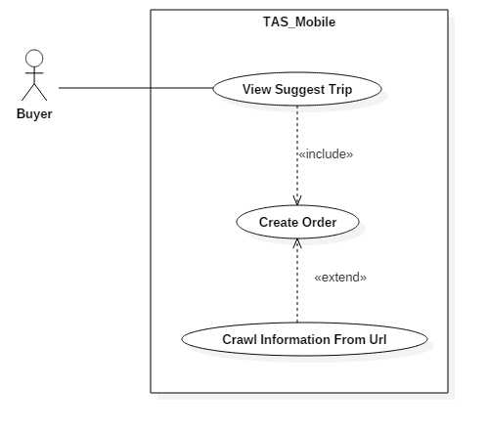

Figure 30: <Buyer> Create Order with Url Use Case

|  |  |  |  |
| --- | --- | --- | --- |
| **USE CASE – UC_ TAS21** | | | |
| **Use Case No.** | UC_ TAS21 | **Use Case Version** | 0.2 |
| **Use Case Name** | Create Order | | |
| **Author** | Trịnh Thanh Vũ | | |
| **Date** | 22/7/2018 | **Priority** | High |
| **Actor:**   * Buyer   **Summary:**   * This use case allows traveler to create new order.   **Goal:**   * To create new order.   **Triggers:**   * Actor sends create order command.   **Preconditions:**   * User logged in the system.   **Post conditions:**   * Success: User can create new order. * Fail: System shows error messages.   **Main Success Scenario:**   |  |  |  | | --- | --- | --- | | **Step** | **Actor Action** | **System Response** | | 1 | Actors clicks on “Đơn hàng” button. | System navigates to order screen | | 1 | Actor clicks on “+” icon. | System navigates to create order screen.  System displays create order screen with:  - “Mua hàng từ”: Text input.  - “Tên sản phẩm”: Text input.  - “Giá sản phẩm”: Text input.  - “Số lượng”: Text input.  - “Mô tả thêm”: Text input. | | 2 | Actor pastes hyper link copy from e-commerce website into “Mua hàng từ” field. | [Exception no.1]  System navigates to next page.  System displays next page with:  - “Nơi mua”: Text input.  - “Nơi nhận”: Text input. - “Ngày nhận mong muốn”: Datetime picker.  - “Phí vận chuyển đề nghị”: Text input.  - “Thanh toán trước”: Switch button.  - “Số tiền trả trước”: Text input. | | 3 | Actor clicks on “Kế tiếp” button. | [Exception no.2]  System creates order successfully and navigate user back to home screen.  System will display latest information. |   **Alternative Scenario:** N/A  **Exceptions:**   |  |  |  | | --- | --- | --- | | **No** | **Cause** | **System Response** | | 1 | User does not input required fields. | System notices that user need to input all these field:  - “Số lượng”: System displays warning message: “Số lượng không được để trống”. | | 2 | User does not input required fields. | System notices that user need to input all these field:  - “Nơi nhận”: System displays warning message: “Nơi nhận không được để trống”.  - “Ngày nhận mong muốn”: System displays warning message: “Ngày nhận mong muốn không được để trống”.  - “Phí vận chuyển đề nghị”: System displays warning message: “Phí vận chuyển đề nghị không được để trống”. |   **Relationships:**   * Include by: View suggest Trip. * Extend by: Crawl Information From Url.   **Business Rules:**   * User already logged in the system. * Quantity is not null. * Buy to is not null. * Delivery date is not null. * Shipping fee is not null. | | | |

Table 28: <Buyer> Create Order with Url specification

##### <Buyer> View Suggest Trip



Figure 31: <Buyer> View Suggest Trip Use Case

|  |  |  |  |
| --- | --- | --- | --- |
| **USE CASE – UC_ TAS22** | | | |
| **Use Case No.** | UC_ TAS22 | **Use Case Version** | 0.2 |
| **Use Case Name** | View Suggest Trips | | |
| **Author** | Trịnh Thanh Vũ | | |
| **Date** | 22/7/2018 | **Priority** | High |
| **Actor:**   * Buyer   **Summary:**   * This use case allows traveler to view suggest trips.   **Goal:**   * To view all suggest trips.   **Triggers:**   * Actor sends view suggest trips command.   **Preconditions:**   * User logged in the system. * User had created order. * Traveler had created trip.   **Post conditions:**   * Success: Traveler can see all trips matching with order. * Fail: System shows error messages.   **Main Success Scenario:**   |  |  |  | | --- | --- | --- | | **Step** | **Actor Action** | **System Response** | | 1 | Actor clicks on “Trang chủ” tab. | System navigate main screen. | | 2 | Actor clicks on “Bạn muốn mua” tab. | System will automatically display all suggest trips. |   **Alternative Scenario:** N/A  **Exceptions:** N/A  **Relationships:**   * Include from: Create Order.   **Business Rules:**   * User already logged in the system. * User already created order. * Travelers already created trips. | | | |

Table 29: <Buyer> View Suggest Trip specification

##### <Buyer> Delete Order

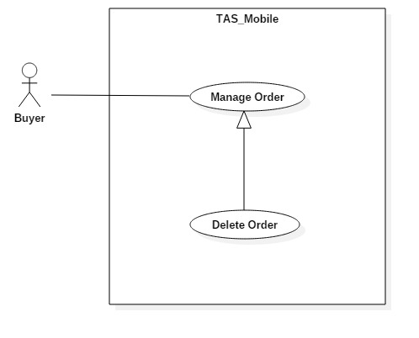

Figure 32: <Buyer> Delete Order Use Case

|  |  |  |  |
| --- | --- | --- | --- |
| **USE CASE – UC_ TAS23** | | | |
| **Use Case No.** | UC_ TAS23 | **Use Case Version** | 0.2 |
| **Use Case Name** | Delete Order | | |
| **Author** | Trịnh Thanh Vũ | | |
| **Date** | 22/7/2018 | **Priority** | High |
| **Actor:**   * Buyer   **Summary:**   * This use case allows buyer delete order.   **Goal:**   * To delete order.   **Triggers:**   * Actor sends delete order command.   **Preconditions:**   * User logged in the system.   **Post conditions:**   * Success: User can delete order. * Fail: System shows error messages.   **Main Success Scenario:**   |  |  |  | | --- | --- | --- | | **Step** | **Actor Action** | **System Response** | | 1 | Actor clicks “Đơn hàng” tab. | System navigates to “Đơn hàng” page.  System displays “Đơn hàng” page with:  - “Đã đăng” tab.  - “Đang vận chuyển” tab.  - “Đã nhận” tab. | | 2 | Actor clicks on certain order. | System will navigate to this order page with common detail.  - “Hình ảnh”  - “Tên vật phẩm”  - “Số tiền đề nghị”  - “Thời gian”  - “Giá tốt nhất” | | 3 | Actor click on this order again. | System will navigate to this order page with common detail.  - “Hình ảnh”  - “Tên vật phẩm”  - “Số đề nghị”  - “Thời gian”  - “Giá tốt nhất”  - “Chi tiết đơn hàng”  - “Yêu cầu nhận mua” button.  - Information of traveler want to make offer with current buyer.  - “Chỉnh sửa” button  - “Xóa” button | | 4 | Actor clicks on “Xóa” button. | System shows message: “Bạn có chắc chắn ?“ | | 5 | Actor clicks “Đồng ý” button. | System will refresh and show the new “Đã đăng” page. |   **Alternative Scenario:** N/A  **Exceptions:** N/A  **Relationships:** N/A  **Business Rules:**   * User already logged in the system. * Traveler already created trip. * User already created order. | | | |

Table 30: <Buyer> Delete Order

##### <Buyer> Update Order

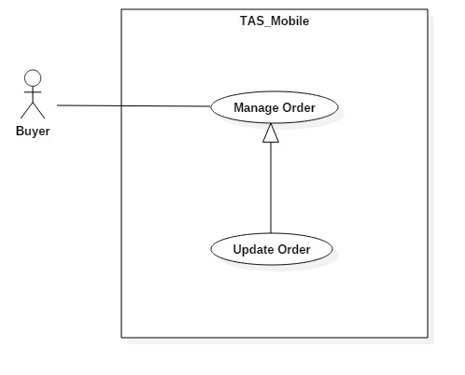

Figure 33: <Buyer> Update Order Use Case

|  |  |  |  |
| --- | --- | --- | --- |
| **USE CASE – UC_ TAS24** | | | |
| **Use Case No.** | UC_ TAS24 | **Use Case Version** | 0.2 |
| **Use Case Name** | Update Order | | |
| **Author** | Trịnh Thanh Vũ | | |
| **Date** | 22/7/2018 | **Priority** | High |
| **Actor:**   * Buyer   **Summary:**   * This use case allows buyer update order.   **Goal:**   * To update order.   **Triggers:**   * Actor sends update order command.   **Preconditions:**   * User logged in the system.   **Post conditions:**   * Success: User can update new information to order. * Fail: System shows error messages.   **Main Success Scenario:**   |  |  |  | | --- | --- | --- | | **Step** | **Actor Action** | **System Response** | | 1 | Actor clicks “Đơn hàng” tab. | System navigates to “Đơn hàng” page.  System displays “Đơn hàng” page with:  - “Đã đăng” tab.  - “Đang vận chuyển” tab.  - “Đã nhận” tab. | | 2 | Actor clicks on certain order. | System will navigate to this order page with common detail.  - “Hình ảnh”  - “Tên vật phẩm”  - “Số đề nghị”  - “Thời gian”  - “Giá tốt nhất” | | 3 | Actor click on this order again. | System will navigate to this order page with common detail.  - “Hình ảnh”  - “Tên vật phẩm”  - “Số đề nghị”  - “Thời gian”  - “Giá tốt nhất”  - “Chi tiết đơn hàng”  - “Yêu cầu nhận mua” button.  - Information of traveler want to make offer with current buyer.  - “Chỉnh sửa” button  - “Xóa” button | | 5 | Actor clicks on “Cập nhật” button. | Systems navigate to update order page.  System displays update page with:  - “Tên sản phẩm”: Text input.  - “Giá sản phẩm”: Text input.  - “Số lượng”: Text input.  - “Nơi mua”: Text input.  - “Nơi nhận:” Text input. | | 6 | Actor clicks on “Đồng ý” button. | [Exception no.1]  Order info is updated successfully and system refreshes the “Đã đăng” page with new information. |   **Alternative Scenario:** N/A  **Exceptions:**   |  |  |  | | --- | --- | --- | | **No** | **Cause** | **System Response** | | 1 | User does not input required fields. | System notices that user need to re-input all these fields:  - “Tên sản phẩm”: System displays warning message: “Tên sản phẩm không được để trống”.  - “Giá sản phẩm”: System displays warning message: “Giá sản phẩm không được để trống”.  - “Số lượng”: System displays warning message: “Số lượng không được để trống”.  - “Nơi mua”: System displays warning message: “Nơi mua không được để trống”.  - “Nơi nhận”: System displays warning message: “Nơi nhận không được để trống”. |   **Relationships:** N/A  **Business Rules:**   * User already logged in the system. * User already created order. * Image of order is not null. * Order name is not null. * Price is not null. * Quantity is not null. * Buy from is not null. * Buy to is not null. | | | |

Table 31: <Buyer> Update Order specification

##### <Buyer> View Offer

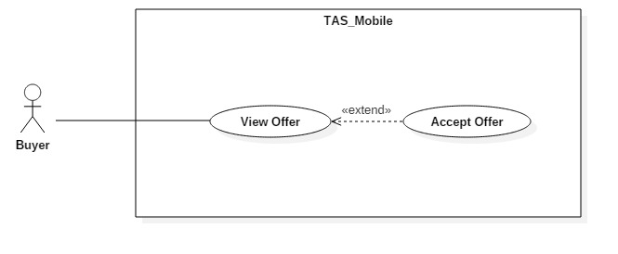

Figure 34: <Buyer> View Offer Use Case

|  |  |  |  |
| --- | --- | --- | --- |
| **USE CASE – UC_ TAS25** | | | |
| **Use Case No.** | UC_ TAS25 | **Use Case Version** | 0.2 |
| **Use Case Name** | View Offer | | |
| **Author** | Trịnh Thanh Vũ | | |
| **Date** | 22/7/2018 | **Priority** | High |
| **Actor:**   * Buyer   **Summary:**   * This use case allows buyer to view offer.   **Goal:**   * To view all offers.   **Triggers:**   * Actor sends view offer command.   **Preconditions:**   * User logged in the system.   **Post conditions:**   * Success: User can see all offers. * Fail: System shows error messages.   **Main Success Scenario:**   |  |  |  | | --- | --- | --- | | **Step** | **Actor Action** | **System Response** | | 1 | Actor clicks “Đơn hàng” tab. | System navigates to “Đơn hàng” page.  System displays “Đơn hàng” page with:  - “Đã đăng” tab.  - “Đang vận chuyển” tab.  - “Đã nhận” tab. | | 2 | Actor clicks on certain order. | System will navigate to this order page with common detail.  - “Hình ảnh”  - “Tên vật phẩm”  - “Số đề nghị”  - “Thời gian”  - “Giá tốt nhất” | | 3 | Actor click on this order again. | System will navigate to this order page with common detail.  - “Hình ảnh”  - “Tên vật phẩm”  - “Số đề nghị”  - “Thời gian”  - “Giá tốt nhất”  - “Chi tiết đơn hàng”  - “Yêu cầu nhận mua” button.  - Information of traveler want to make offer with current buyer. | | 4 | Actor clicks on “Chi tiết đơn hàng” | System navigate to order detail page.  System show order detail with:  - “Hình ảnh”  - “Tên vật phẩm”  - “Nhận được từ”  - “Giá sản phẩm”  - “Mô tả”  - “Hình ảnh” (traveler avatar)  - “Tên”  - “Ngày yêu cầu mua”  - “Gửi tin nhắn” button.  - “Gửi đến”  - “Mua từ”  - “Giao trước ngày”  - “Số lương”  - “Chỉnh sửa” button  - “Xóa” button |   **Alternative Scenario:** N/A  **Exceptions:** N/A  **Relationships:** N/A  **Business Rules:**   * User already logged in the system. * User already created trip. * Traveler have made offer with user. | | | |

Table 32: <Buyer> View Offer specification

##### <Buyer> Accept Offer

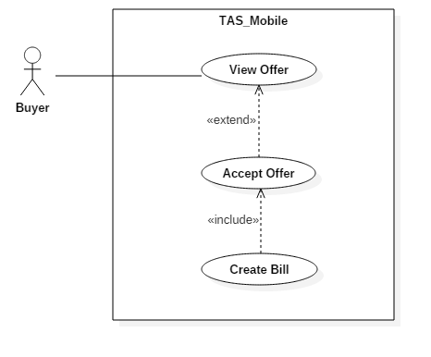

Figure 35: <Buyer> Accept Offer Use Case

|  |  |  |  |
| --- | --- | --- | --- |
| **USE CASE – UC_ TAS26** | | | |
| **Use Case No.** | UC_ TAS26 | **Use Case Version** | 0.2 |
| **Use Case Name** | Accept Offer | | |
| **Author** | Trịnh Thanh Vũ | | |
| **Date** | 22/7/2018 | **Priority** | High |
| **Actor:**   * Buyer   **Summary:**   * This use case allows buyer to accept offer.   **Goal:**   * To accept offer.   **Triggers:**   * Actor sends accept offer command.   **Preconditions:**   * User logged in the system.   **Post conditions:**   * Success: User can accept offer. * Fail: System shows error messages.   **Main Success Scenario:**   |  |  |  | | --- | --- | --- | | **Step** | **Actor Action** | **System Response** | | 1 | Actor clicks “Đơn hàng” tab. | System navigates to “Đơn hàng” page.  System displays “Đơn hàng” page with:  - “Đã đăng” tab.  - “Đang vận chuyển” tab.  - “Đã nhận” tab. | | 2 | Actor clicks on “Đã đăng” tab. | System navigates to “Đã đăng” page.  System displays “Đã đăng” page with:  - “Order detail”. | | 3 | Actor clicks on certain order. | System shows offer detail:  - Traveler’s avatar.  - Traveler’s star.  - Time offer was made.  - “Giá sản phẩm”  - “Phí vận chuyển”  - “Tổng cộng”  - “Đi đến”  - “Ngày giao hàng”  - “Gửi tin nhắn” button.  - “Chấp nhận yêu cầu” button. | | 4 | Actor clicks on “Chấp nhận yêu cầu” button. | System navigates to payment method page. |   **Alternative Scenario:** N/A  **Exceptions:** N/A  **Relationships:**   * Include by: Create Bill. * Extend from: View Offer.   **Business Rules:**   * User already logged in the system. * User already created order. * Traveler already created trip. * Traveler send make offer command to buyer. | | | |

Table 33: <Buyer> Accept Offer specification

##### <Buyer> Confirm Complete

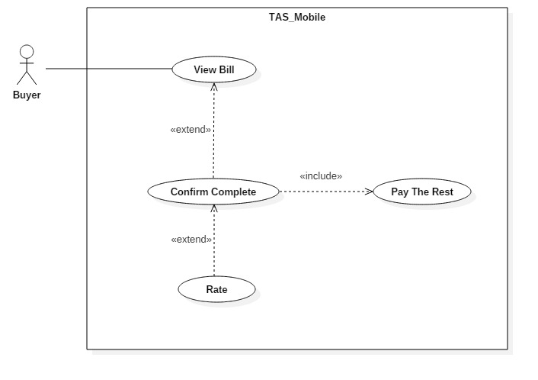

Figure 36: <Buyer> Confirm Complete Use Case

|  |  |  |  |
| --- | --- | --- | --- |
| **USE CASE – UC_ TAS27** | | | |
| **Use Case No.** | UC_ TAS27 | **Use Case Version** | 0.2 |
| **Use Case Name** | Confirm Complete | | |
| **Author** | Trịnh Thanh Vũ | | |
| **Date** | 22/7/2018 | **Priority** | High |
| **Actor:**   * Buyer   **Summary:**   * This use case allows buyer to confirm complete bill.   **Goal:**   * To confirm order complete.   **Triggers:**   * Actor sends confirm command.   **Preconditions:**   * User logged in the system.   **Post conditions:**   * Success: User can confirm order complete. * Fail: System shows error messages.   **Main Success Scenario:**   |  |  |  | | --- | --- | --- | | **Step** | **Actor Action** | **System Response** | | 1 | Actor clicks on “Chuyến Đi” tab. | System navigates to trip page. | | 2 | Actor clicks on certain trip section. | System navigates to selected trip page. | | 3 | Actor clicks on “Đang vận chuyển” tab. | System navigates to transit page.  System show bill transition. | | 4 | Actor clicks on certain bill. | System navigates to bill detail page with:  - “Hình ảnh”  - “Yêu cầu từ”  - “Tên vật phẩm”  - “Mua từ”  - “Gửi đến”  - “Chi tiết vận chuyển”  - “Giá sản phẩm”  - “Phí vận chuyển”  - “Tổng cộng”  - “Ngày giao hàng”  - “Đã thanh toán”  - “Còn lại”  - “Gửi tin nhắn” button  - “Hoàn tất giao dịch” button | | 5 | Actor click on “Hoàn tất giao dịch” button. | System sends notification to traveler.  System sends bill to “Đã nhận” tab. |   **Alternative Scenario:** N/A  **Exceptions:** N/A  **Relationships:**   * Extend by: Rate. * Extend from: View Bill. * Include from: Pay The Rest.   **Business Rules:**   * User already logged in the system. * User already created trip. * User already make offer with another users. | | | |

Table 34: <Buyer> Confirm Complete specification

##### <Buyer> Rate

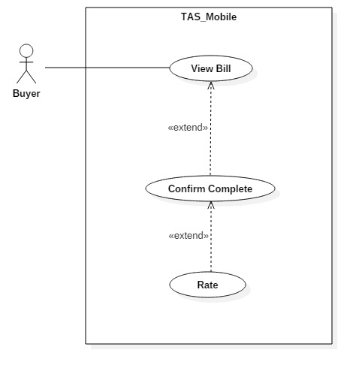

Figure 37: <Buyer> Rate Use Case

|  |  |  |  |
| --- | --- | --- | --- |
| **USE CASE – UC_ TAS28** | | | |
| **Use Case No.** | UC_ TAS28 | **Use Case Version** | 0.2 |
| **Use Case Name** | Rate | | |
| **Author** | Trịnh Thanh Vũ | | |
| **Date** | 22/7/2018 | **Priority** | High |
| **Actor:**   * Buyer   **Summary:**   * This use case allows buyer to rate for traveler.   **Goal:**   * To rate for traveler.   **Triggers:**   * Actor sends rate command.   **Preconditions:**   * User logged in the system.   **Post conditions:**   * Success: User can rate for traveler. * Fail: System shows error messages.   **Main Success Scenario:**   |  |  |  | | --- | --- | --- | | **Step** | **Actor Action** | **System Response** | | 1 | Actor clicks on “Đơn Hàng” tab. | System navigates to order page. | | 2 | Actor clicks on “Đang vận chuyển” tab. | System navigates to transit page.  System show bill information. | | 3 | Actor clicks on certain bill. | System navigates to bill detail page. | | 4 | Actor click on “Hoàn tất giao dịch” button. | System sends notification to traveler.  System sends bill to “Đã nhận” tab.  System navigates to “Đã nhận” screen. | | 5 | Actor clicks on Traveler avatar. | System pops up rating screen. | | 6 | Actor clicks on number of stars. |  | | 7 | Actor clicks on “Xác nhận” button. | System sends notification to Traveler.  System refresh received screen with new information. |   **Alternative Scenario:** N/A  **Exceptions:** N/A  **Relationships:**   * Extend by: Confirm Complete.   **Business Rules:**   * User already logged in the system. * Traveler already created trip. * User already accepts offer with another users. | | | |

Table 35: <Buyer> Rate specification

#### <Admin> Overview Use Case



Figure 38: <Admin> Overview Use Case

##### <Admin> Login

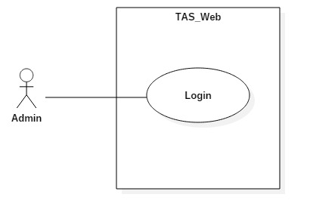

Figure 39: <Admin> Login Use Case

|  |  |  |  |
| --- | --- | --- | --- |
| **USE CASE – UC_ TAS29** | | | |
| **Use Case No.** | UC_ TAS29 | **Use Case Version** | 0.2 |
| **Use Case Name** | Login | | |
| **Author** | Trịnh Thanh Vũ | | |
| **Date** | 15/6/2018 | **Priority** | High |
| **Actor:**   * Unauthorized User   **Summary:**   * This use case allows unauthorized user to login to system.   **Goal:**   * To login to the system.   **Triggers:**   * Actor sends login command.   **Preconditions:** N/A  **Post conditions:**   * Success: Actor accesses to system successfully. * Fail: System shows error messages.   **Main Success Scenario:**   |  |  |  | | --- | --- | --- | | **Step** | **Actor Action** | **System Response** | | 1 | Actor goes to login page | System requires information:   * “Tên đăng nhập”: Text input * “Mật khẩu”: Text input | | 2 | Actor inputs information |  | | 3 | Actor clicks on “Đăng nhập button” | [Exception no.1]  [Exception no.2]  System navigates to home page. |   **Alternative Scenario:** N/A  **Exceptions:**   |  |  |  | | --- | --- | --- | | **No** | **Cause** | **System Response** | | 1 | Actor inputs wrong information. | System shows message:“Thông tin đăng nhập không hợp lệ” | | 2 | Actor left blank to required fields. | System shows message: “Vui lòng điền đầy đủ thông tin”. |   **Relationships:** N/A  **Business Rules:**   * Username must be in range of 5-35 characters. * Password must be in range of 4-30 characters. * Password must be encrypted before being sent to server. | | | |

Table 36: <Admin> Login specification

##### <Admin> Logout

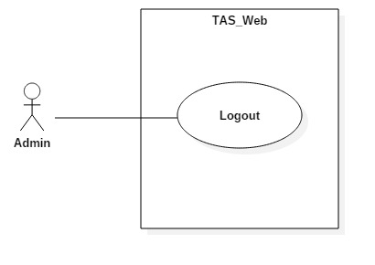

Figure 40: <Admin> Logout Use Case

|  |  |  |  |
| --- | --- | --- | --- |
| **USE CASE – UC_ TAS30** | | | |
| **Use Case No.** | UC_ TAS30 | **Use Case Version** | 0.2 |
| **Use Case Name** | Logout | | |
| **Author** | Trịnh Thanh Vũ | | |
| **Date** | 22/7/2018 | **Priority** | High |
| **Actor:**   * Admin   **Summary:**   * This use case allows admin to logout the system.   **Goal:**   * To logout the system.   **Triggers:**   * Actor sends logout command.   **Preconditions:**   * User logged in the system.   **Post conditions:**   * Success: User session is removed, and system displays login page. * Fail: System displays error messages.   **Main Success Scenario:**   |  |  |  | | --- | --- | --- | | **Step** | **Actor Action** | **System Response** | | 1 | Actor clicks “Đăng xuất” button. | User session is removed, and system displays login page. |   **Alternative Scenario:**N/A  **Exceptions:** N/A  **Relationships:** N/A  **Business Rules:**   * Actor has already accessed to the system. * After signing out, Admin will become “Unauthorized User” | | | |

Table 37: <Admin> Logout specification

##### <Admin> View User

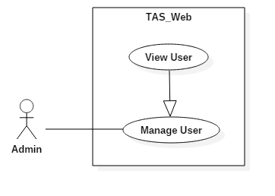

Figure 41: <Admin> View User Use Case

|  |  |  |  |
| --- | --- | --- | --- |
| **USE CASE – UC_ TAS31** | | | |
| **Use Case No.** | UC_ TAS31 | **Use Case Version** | 0.2 |
| **Use Case Name** | View User | | |
| **Author** | Trịnh Thanh Vũ | | |
| **Date** | 22/7/2018 | **Priority** | High |
| **Actor:**   * Admin   **Summary:**   * This use case allows admin to view user list.   **Goal:**   * to view user list.   **Triggers:**   * Actor sends view user command.   **Preconditions:**   * User logged in the system.   **Post conditions:**   * Success: Admin can see all user information. * Fail: System shows error messages.   **Main Success Scenario:**   |  |  |  | | --- | --- | --- | | **Step** | **Actor Action** | **System Response** | | 1 | Actor clicks “Người dùng” tab. | System navigates to “Người dùng” page.  System displays “Người dùng” page with:  - List of users.  - “Update” button. |   **Alternative Scenario:** N/A  **Exceptions:** N/A  **Relationships:** N/A  **Business Rules:**   * Admin already logged in the system. * Users exist in database. | | | |

Table 38: <Admin> View User specification

##### <Admin> Manage Order

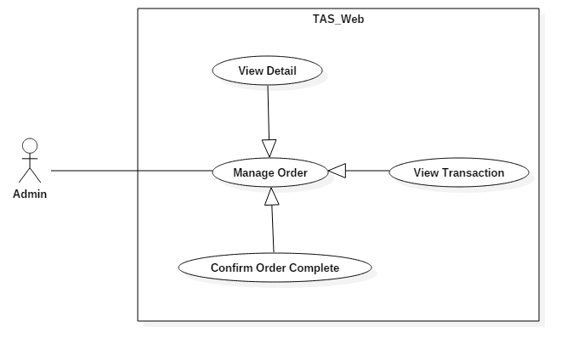

Figure 42: <Admin> Manage Order Use Case

|  |  |  |  |
| --- | --- | --- | --- |
| **USE CASE – UC_ TAS32** | | | |
| **Use Case No.** | UC_ TAS32 | **Use Case Version** | 0.2 |
| **Use Case Name** | Manage Order | | |
| **Author** | Trịnh Thanh Vũ | | |
| **Date** | 22/7/2018 | **Priority** | High |
| **Actor:**   * Admin   **Summary:**   * This use case allows admin to manage order.   **Goal:**   * to manage order.   **Triggers:**   * Actor sends manage order command.   **Preconditions:**   * User logged in the system.   **Post conditions:**   * Success: User can manage all orders. * Fail: System shows error messages.   **Main Success Scenario:**   |  |  |  | | --- | --- | --- | | **Step** | **Actor Action** | **System Response** | | 1 | Actor clicks “Đơn hàng” tab. | System navigates to “Đơn hàng” page.  System displays “Đơn hàng” page with:  - List of orders.  - Manage button. |   **Alternative Scenario:** N/A  **Exceptions:** N/A  **Relationships:** N/A  **Business Rules:**   * Admin already logged in the system. * Order created. | | | |

Table 39: <Admin> Manage Order specification

##### <Admin> Update Status

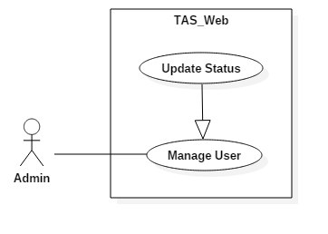

Figure 43: <Admin> Update Status Use Case

|  |  |  |  |
| --- | --- | --- | --- |
| **USE CASE – UC_ TAS33** | | | |
| **Use Case No.** | UC_ TAS33 | **Use Case Version** | 0.2 |
| **Use Case Name** | Update Status | | |
| **Author** | Trịnh Thanh Vũ | | |
| **Date** | 22/7/2018 | **Priority** | High |
| **Actor:**   * Admin   **Summary:**   * This use case allows admin to update user status.   **Goal:**   * to view order.   **Triggers:**   * Actor sends update status command.   **Preconditions:**   * User logged in the system.   **Post conditions:**   * Success: Admin can update user status. * Fail: System shows error messages.   **Main Success Scenario:**   |  |  |  | | --- | --- | --- | | **Step** | **Actor Action** | **System Response** | | 1 | Actor clicks “Người dùng” tab. | System navigates to “Người dùng” page.  System displays “Người dùng” page with:  - List of users.  - “Update” button. | | 2 | Actor clicks on update button | System pops up status checkbox | | 3 | Actor click on status checkbox |  | | 4 | Actor clicks on “Update” button | User status from “Hiệu lực” to “Không hiệu lực” |   **Alternative Scenario:** N/A  **Exceptions:** N/A  **Relationships:** N/A  **Business Rules:**   * Admin already logged in the system. * Users exist in database. | | | |

Table 40: <Admin> Update Status specification

##### <Admin> View Detail

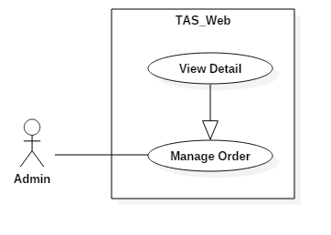

Figure 44: <Admin> View Detail Use Case

|  |  |  |  |
| --- | --- | --- | --- |
| **USE CASE – UC_ TAS34** | | | |
| **Use Case No.** | UC_ TAS34 | **Use Case Version** | 0.2 |
| **Use Case Name** | View Detail | | |
| **Author** | Trịnh Thanh Vũ | | |
| **Date** | 22/7/2018 | **Priority** | High |
| **Actor:**   * Admin   **Summary:**   * This use case allows admin to view order detail.   **Goal:**   * to view order detail.   **Triggers:**   * Actor sends view order detail command.   **Preconditions:**   * User logged in the system.   **Post conditions:**   * Success: User can view detail order. * Fail: System shows error messages.   **Main Success Scenario:**   |  |  |  | | --- | --- | --- | | **Step** | **Actor Action** | **System Response** | | 1 | Actor clicks “Đơn hàng” tab. | System navigates to “Đơn hàng” page.  System displays “Đơn hàng” page with:  - List of orders.  - Manage button. | | 2 | Actor clicks on manage button. | System pops up new page with:  - Order detail  - “Thông tin đơn hàng” tab  - “Giao dịch phát sinh” tab  - “Hủy” button  - “Xác nhận” button |   **Alternative Scenario:** N/A  **Exceptions:** N/A  **Relationships:** N/A  **Business Rules:**   * Admin already logged in the system. * Order created | | | |

Table 41: <Admin> View Detail specification

##### <Admin> View Transaction

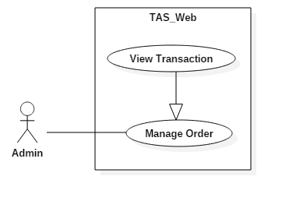

Figure 45: <Admin> View Transaction Use Case

|  |  |  |  |
| --- | --- | --- | --- |
| **USE CASE – UC_ TAS35** | | | |
| **Use Case No.** | UC_ TAS35 | **Use Case Version** | 0.2 |
| **Use Case Name** | View Transaction | | |
| **Author** | Trịnh Thanh Vũ | | |
| **Date** | 22/7/2018 | **Priority** | High |
| **Actor:**   * Admin   **Summary:**   * This use case allows admin view order transaction.   **Goal:**   * To view certain order transaction.   **Triggers:**   * Actor sends view order transaction command.   **Preconditions:**   * Admin logged in the system. * Order already exist in database.   **Post conditions:**   * Success: admin can view order transaction. * Fail: System shows error messages.   **Main Success Scenario:**   |  |  |  | | --- | --- | --- | | **Step** | **Actor Action** | **System Response** | | 1 | Actor clicks “Đơn hàng” tab. | System navigates to “Đơn hàng” page.  System displays “Đơn hàng” page with:  - List of orders.  - Manage button. | | 2 | Actor clicks on manage button. | System pops up new page with:  - Order detail  - “Thông tin đơn hàng” tab  - “Giao dịch phát sinh” tab  - “Hủy” button  - “Xác nhận” button | | 3 | Actor clicks on “Giao dịch phát sinh” tab | System navigates to “Giao dịch phát sinh” page with:  - “Ngày giao dịch”  - “Nội dung”  - “Số tiền” |   **Alternative Scenario:** N/A  **Exceptions:** N/A  **Relationships:** N/A  **Business Rules:**   * User already logged in the system. * Order exist in database. | | | |

Table 42: <Admin> View Transaction specification

##### <Admin> Confirm Order Complete

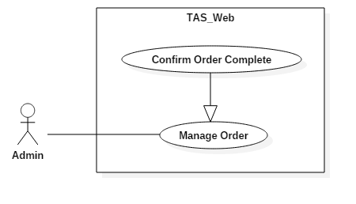

Figure 46: <Admin> Confirm Order Complete Use Case

|  |  |  |  |
| --- | --- | --- | --- |
| **USE CASE – UC_ TAS36** | | | |
| **Use Case No.** | UC_ TAS36 | **Use Case Version** | 0.2 |
| **Use Case Name** | Confirm Order Complete | | |
| **Author** | Trịnh Thanh Vũ | | |
| **Date** | 22/7/2018 | **Priority** | High |
| **Actor:**   * Admin   **Summary:**   * This use case allows admin to confirm order complete.   **Goal:**   * to confirm order complete.   **Triggers:**   * Actor sends confirm order complete command.   **Preconditions:**   * User logged in the system.   **Post conditions:**   * Success: User can confirm order complete. * Fail: System shows error messages.   **Main Success Scenario:**   |  |  |  | | --- | --- | --- | | **Step** | **Actor Action** | **System Response** | | 1 | Actor clicks “Đơn hàng” tab. | System navigates to “Đơn hàng” page.  System displays “Đơn hàng” page with:  - List of orders.  - Manage button. | | 2 | Actor clicks on manage button. | System pops up new page with:  - Order detail  - “Thông tin đơn hàng” tab  - “Giao dịch phát sinh” tab  - “Hủy” button  - “Xác nhận” button | | 3 | Actor clicks on “Xác nhận” button. | System navigates back to “Đơn hàng” page with new information updated. |   **Alternative Scenario:** N/A  **Exceptions:** N/A  **Relationships:** N/A  **Business Rules:**   * Admin already logged in the system. * Order created | | | |

Table 43: <Admin> Confirm Order Complete specification

## Software System Attribute

### Usability

#### Graphic User Interface

* All the texts, labels, alerts and messages will be written in Vietnamese.
* GUI for mobile application is designed base on material design with Navigation Bar at the bottom contains the main functions of the application.

#### Usability

* The system usability is easy to use that users generally don’t need to spend too much time looking around.
* Icons that indicate the actions should be easy to understand and users will not meet any troubles to recognize the feature of page.

### Reliability

* The data should be backed up every day.

### Availability

* The android application must be available 24/7.
* System reply in maximum 3 seconds.
* System schedule auto calculate order and add it to Nosql.

### Security

* Users is authentication/authorization for all users when they login to the system.
* API and controller is authorized access with Jwt authentication

### Maintainability

* The system is divided into separated modules for easy maintain.

### Portability

* The software is a mobile application so it can be access anywhere with internet connection.
* User can use the mobile application running android 4.1 or later.
* Web application can be run on Chrome browser version 42 or later.

### Performance

* Requests from users are responded in less than 10 seconds at 5 Mbps bandwidth speed.
* System can handle 100 requests at one time.
* If the system crash, it shall ensure security less than 30 minutes and fixing hardware less than 2 days.

## Conceptual diagram

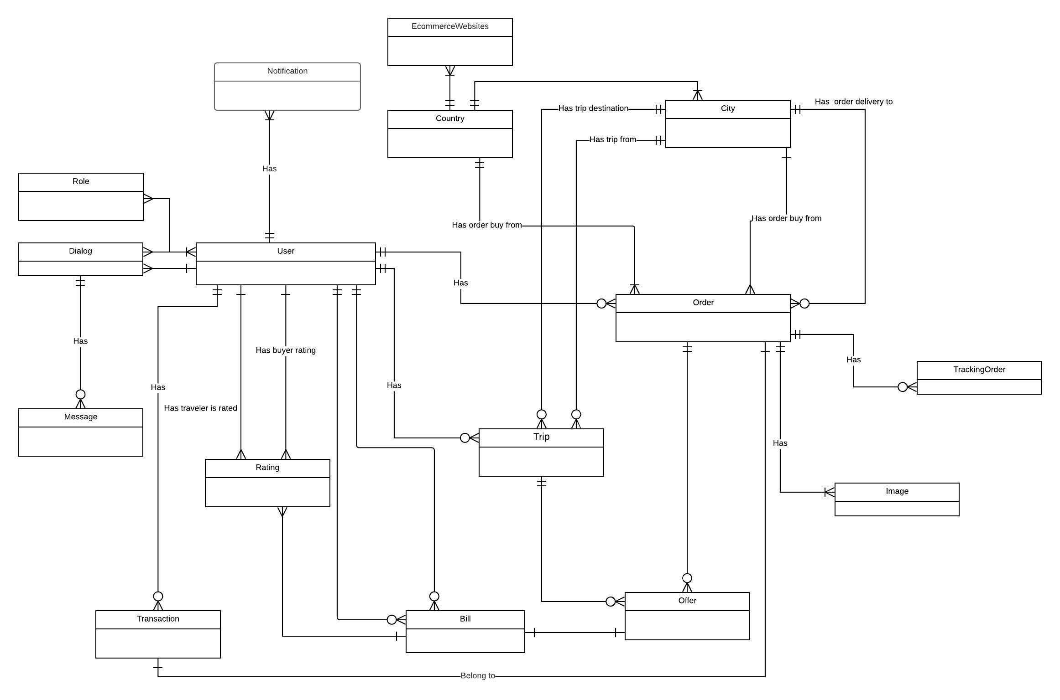

Figure 47: Conceptual Diagram

|  |  |
| --- | --- |
| **ENTITY DATA DICTIONARY: DESCRIBE** | |
| **ENTITY NAME** | **DESCRIPTION** |
| **Role** | Contains roles information |
| **Dialog** | Contains chat dialogs |
| **Message** | Contain chat messages |
| **Transaction** | Contains transaction information |
| **User** | Contains users information |
| **Rating** | Contains rating information |
| **Country** | Contains countries information |
| **EcommerceWebsites** | Contains ecommerce websites domains |
| **Trip** | Contains trips information |
| **Bill** | Contains bills information |
| **City** | Contains cities information |
| **Order** | Contains orders information |
| **Offer** | Contains offers information |
| **TrackingOrder** | Contains timeline information |
| **Image** | Contains images information |
| **Notification** | Contains notification message |

Table 44: Conceptual Diagram Dictionary

# D. Software Design Description

## Design Overview

* This document describes the technical and user interface design of **TAS**. It includes the architectural design, the detailed design of common functions and business functions and the design of database model.
* The architectural design describes the overall architecture of the system and the architecture of each main component and subsystem.
* The detailed design describes static and dynamic structure for each component and functions. It includes class diagrams, class explanations and sequence diagrams for each use cases.
* The database design describes the relationships between entities and details of each entity.
* Document overview:
* Section 2: gives an overall description of the system architecture design.
* Section 3: gives component diagrams that describe the connection and integration of the system.
* Section 4: gives the detail design description which includes class diagram, class explanation, and sequence diagram to details the application functions.
* Section 5: describe screens design.
* Section 6: describe a fully attributed ERD.
* Section 7: describe algorithms.

## System Architecture Design

### Web service Application Architecture Description

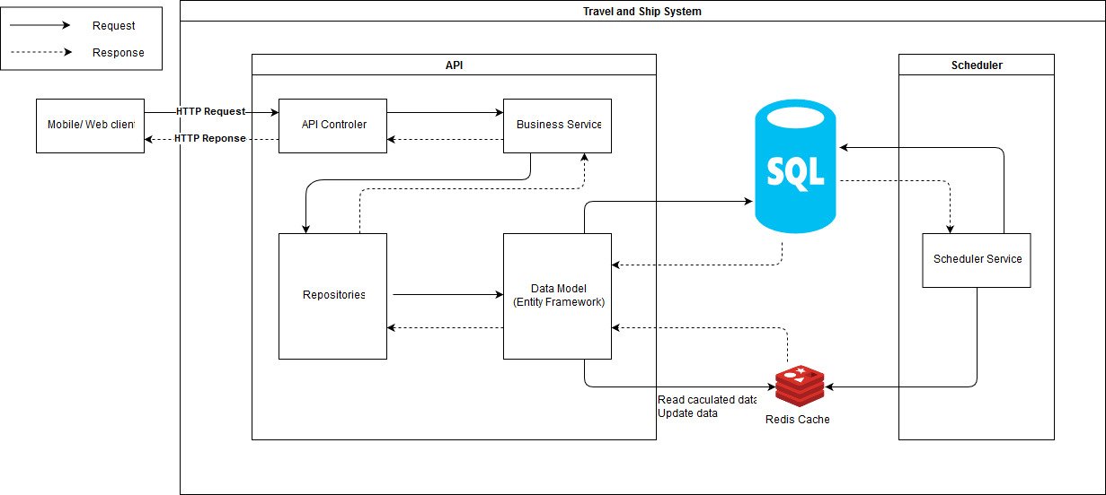

Figure 48: Web Server Application Architure Design

### Mobile Application Architecture Description

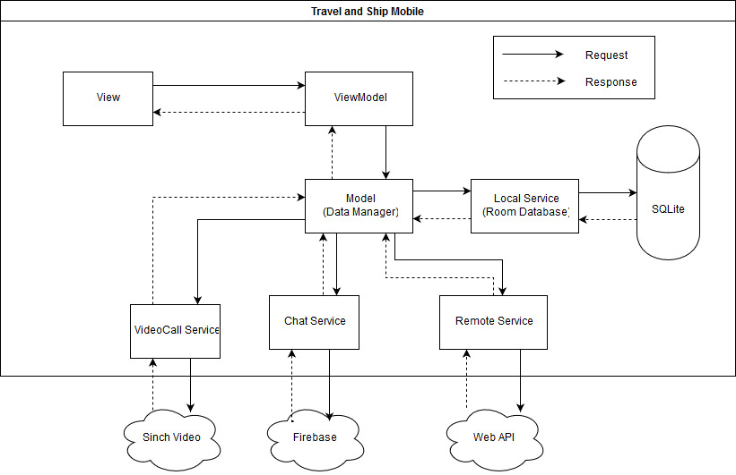

Figure 49: Mobile Application Architecture Design

Our application is developed mainly follows the MVVM architectural pattern. We choose this pattern for android appluication because of its advantages:

* **Maintainability**
* A clean separation of different kinds of code should make it easier to go into one or several of those more granular and focused parts and make changes without worrying.
* That means you can remain agile and keep moving out to new releases quickly.
* **Testability**
* With MVVM each piece of code is more granular and if it is implemented right your external and internal dependences are in separate pieces of code from the parts with the core logic that you would like to test.
* That makes it a lot easier to write unit tests against a core logic.
* Make sure it works right when written and keeps working even when things change in maintenance.
* **Extensibility**
* It sometimes overlaps with maintainability, because of the clean separation boundaries and more granular pieces of code.
* You have a better chance of making any of those parts more reusable.
* It has also the ability to replace or add new pieces of code that do similar things into the right places in the architecture.

## Component Diagram

#### Web Application

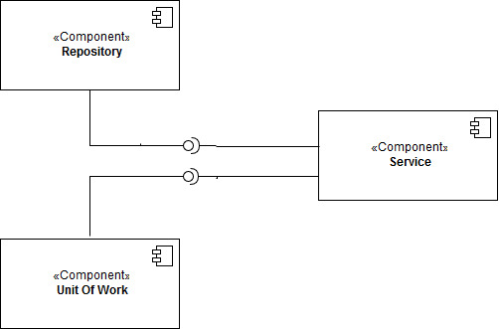

Figure 50: Component Diagram - Web Application

|  |  |
| --- | --- |
| **COMPONENT DICTIONARY: DESCRIBES COMPONENT** | |
| Repository | Component to handle repository |
| UnitOfWork | Component to manipulate database |
| Service | Component to handle service |

Table 45: Component Diagram Dictionary of Web Application

#### Mobile Application

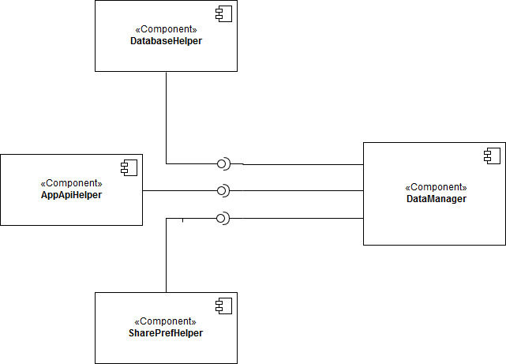

Figure 51: Component Diagram - Mobile Application

|  |  |
| --- | --- |
| **COMPONENT DICTIONARY: DESCRIBES COMPONENT** | |
| DatabaseHelper | Component to connect SQlite |
| AppApiHelper | Component to connect to API |
| DataManager | Component to manage data |
| SharePrefHelper | Component to connect shared preference android |

Table 46: Component Diagram Dictionary of Mobile Application

## Detail Description

### Class Diagram

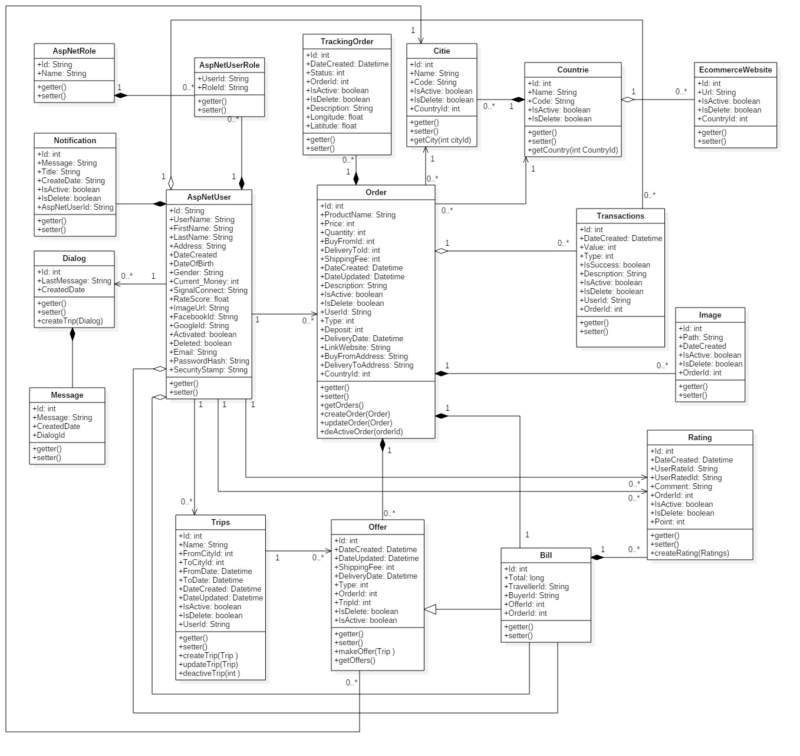

Figure 52: Class Diagram

|  |  |  |
| --- | --- | --- |
| **CLASS DICTIONARY: DESCRIBE CLASS** | | |
| **Class Name** | **Mapping column with Conceptual diagram** | **Description** |
| **AspNetRole** | Role | Contain user roles |
| **AspNetUserRole** | Permission | Contain user permission |
| **AspNetUser** | User | Contains user information |
| **Trips** | Trip | Contains trip information |
| **TrackingOrder** | TrackingOrder | Contains timeline details |
| **Order** | Order | Contains order information |
| **Offers** | Offer | Contains offer information |
| **City** | City | Contains cities name and code |
| **Country** | Country | Contain countries name and code |
| **Transactions** | Transaction | Contain transaction details |
| **Bill** | Bill | Contains bill details |
| **EcommerceWebsite** | EcommerceWebsites | Contains domain of ecommerce websites |
| **Image** | Image | Contains images |
| **Rating** | Rating | Contains rating details |
| **Notification** | Notification | Contains notification message |
| **Dialog** | Dialog | Contains chat dialog |
| **Message** | Message | Contains chat message |

Table 47: Class Diagram Explanation

### Class Diagram Explanation

#### AspNetRole

|  |  |  |  |
| --- | --- | --- | --- |
| **Attribute** | **Type** | **Visibility** | **Description** |
| Id | String | Public | Unique identifier of roles |
| Name | String | Public | Role’s name |
| **Method** | **Return Type** | **Visibility** | **Description** |
| getter | Attribute type | Public | Get value of attribute |
| setter | Void | Public | Set value of attribute |

Table 48: AspNetRoles attribute

#### AspNetUserRole

|  |  |  |  |
| --- | --- | --- | --- |
| **Attribute** | **Type** | **Visibility** | **Description** |
| UserId | String | Public | Identifier of the user |
| RoleId | String | Public | Identifier of role |
| **Method** | **Return Type** | **Visibility** | **Description** |
| getter | Attribute type | Public | Get value of attribute |

Table 49: AspNetUserRoles attribute

#### AspNetUser

|  |  |  |  |
| --- | --- | --- | --- |
| **Attribute** | **Type** | **Visibility** | **Description** |
| Id | String | Public | Unique identifier of the user |
| UserName | String | Public | Name of the user |
| FirstName | String | Public | First name of the user |
| LastName | String | Public | Last name of the user |
| Address | String | Public | Address of the user |
| DateCreated | Datetime | Public | Created date of the user |
| DateOfBirth | Datetime | Public | Birthday of the user |
| Gender | String | Public | Gender of the user |
| Current_Money | Int | Public | Current money in user wallet |
| SignalConnect | String | Public | Save connection string for notification |
| RateScore | Float | Public | Rating score of the user |
| ImageUrl | String | Public | Image of the user |
| FacebookId | String | Public | Facebook identifier of the user |
| GoogleId | String | Public | Google identifier of the user |
| ActivateId | Boolean | Public | Status of user that still available |
| Deleted | Boolean | Public | Status of user that being deleted |
| Email | String | Public | Email of the user |
| PasswordHash | String | Public | Password of user after encrypted |
| SecurityStamp | String | Public | Key to decrypt password hash |
| **Method** | **Return Type** | **Visibility** | **Description** |
| getter | Attribute type | Public | Get value of attribute |
| setter | Void | Public | Set value of attribute |

Table 50: AspNetUsers attribute

#### Trips

|  |  |  |  |
| --- | --- | --- | --- |
| **Attribute** | **Type** | **Visibility** | **Description** |
| Id | Int | Public | Unique identifier of the trip |
| Name | String | Public | Name of the trip |
| FromCityId | String | Public | Identifier of user’s current city |
| ToCityId | String | Public | Identifier of the destination |
| FromDate | Datetime | Public | Date user travel |
| ToDate | Datetime | Public | Date user come back |
| DateCreated | Datetime | Public | Date user have created trip |
| DateUpdated | Datetime | Public | Date user have updated trip |
| IsActive | Boolean | Public | Status of trip that in use |
| IsDelete | Boolean | Public | Status of trip that being deleted |
| UserId | String | Public | Identifier of user create trip |
| **Method** | **Return Type** | **Visibility** | **Description** |
| getter | Attribute type | Public | Get value of attribute |
| setter | Void | Public | Set value of attribute |
| createdTrip | Boolean | Public | Create trip |
| updatedTrip | Boolean | Public | Update trip |
| deactiveTrip | Boolean | Public | Deactive trip |

Table 51: Trips attribute

#### TrackingOrder

|  |  |  |  |
| --- | --- | --- | --- |
| **Attribute** | **Type** | **Visibility** | **Description** |
| Id | Int | Public | Unique identifier of the timeline |
| DateCreated | Datetime | Public | Created date of timeline |
| Status | Int | Public | Status of the order |
| OrderId | Int | Public | Identifier of the oder being tracked |
| IsActive | Boolean | Public | Status of the timeline that in use |
| IsDelete | Boolean | Public | Status of the timeline that being delete |
| Description | String | Public | Description of the order location |
| Longitude | Float | Public | Longitude of the order location |
| Latitude | Float | Public | Latitude of the order location |
| **Method** | **Return Type** | **Visibility** | **Description** |
| getter | Attribute type | Public | Get value of attribute |
| setter | Void | Public | Set value of attribute |

Table 52: TrackingOrders attribute

#### Order

|  |  |  |  |
| --- | --- | --- | --- |
| **Attribute** | **Type** | **Visibility** | **Description** |
| Id | Int | Public | Unique identifier of the order |
| ProductName | String | Public | Name of the product |
| Price | Int | Public | Price of the product |
| Quantity | Int | Public | Quantity of the product |
| BuyFromId | Int | Public | Identifier of the city which the product will be bought from |
| DeliveryToId | Int | Public | Identifier of the city which the product will be brought to |
| ShippingFee | Int | Public | Fee of shipping the product |
| DateCreated | Datetime | Public | Create date of the order |
| DateUpdated | Datetime | Public | Update date of the order |
| Description | String | Public | Descrion of the order |
| IsActive | Boolean | Public | Status of the order that in use |
| IsDelete | Boolean | Public | Status of the order that being delete |
| UserId | String | Public | Identifier of the user who created the order |
| Type | Int | Public | Type of the order |
| Deposit | Int | Public | Deposit money of the order |
| DeliveryDate | Datetime | Public | Delivery date of the order |
| LinkWebsite | String | Public | The website which sell the product |
| BuyFromAddress | String | Public | Address of the place which the product will be bought from |
| DeliveryToAddress | String | Public | Address of the palce where the product will be deliveried to |
| CountryId | String | Public | Identifier of the country where to buy the product |
| **Method** | **Return Type** | **Visibility** | **Description** |
| getter | Attribute type | Public | Get value of attribute |
| setter | Void | Public | Set value of attribute |
| getOrders | List <Order> | Public | Get list orders |
| createOrder | Boolean | Public | Create order |
| updateOrder | Boolean | Public | Update order |
| deActiveOrder | Boolean | Public | Deactive order |

Table 53: Order attribute

#### Offer

|  |  |  |  |
| --- | --- | --- | --- |
| **Attribute** | **Type** | **Visibility** | **Description** |
| Id | Int | Public | Unique identifier of the offer |
| DateCreated | Datetime | Public | Date when the offer being made |
| DateUpdated | Datetime | Public | Date when the offer being updated |
| ShippingFee | Int | Public | Fee of shipping the order |
| DeliveryDate | Datetime | Public | Delivery date of the order |
| Type | Int | Public | Type of the offer |
| BuyerId | String | Public | Identifier of the buyer who accepted the offer |
| TravelerId | String | Public | Identifier of the traveler who made the offer |
| Bill_Id | Int | Public | Identifier of bill |
| TripId | Int | Public | Identifier of the trip |
| IsActive | Boolean | Public | Status of the offer that in use |
| IsDelete | Boolean | Public | Status of the offer that being delete |
| **Method** | **Return Type** | **Visibility** | **Description** |
| getter | Attribute type | Public | Get value of attribute |
| setter | Void | Public | Set value of attribute |
| makeOffer | Offer | Public | Make offer |
| getOffers | List <Offers> | Public | Get list offers |

Table 54: Offers attribute

#### City

|  |  |  |  |
| --- | --- | --- | --- |
| **Attribute** | **Type** | **Visibility** | **Description** |
| Id | Int | Public | Unique identifier of the city |
| Name | String | Public | Name of the the city |
| Code | String | Public | Code of the city |
| IsActive | Boolean | Public | Status of the city that in use |
| Isdelete | Boolean | Public | Status of the city that being delete |
| CountryId | Int | Public | Identifier of the country contains the city |
| **Method** | **Return Type** | **Visibility** | **Description** |
| getter | Attribute type | Public | Get value of attribute |
| setter | Void | Public | Set value of attribute |
| getCity | List <Cities> | Public | Get list of cities |

Table 55: Cities attribute

#### Country

|  |  |  |  |
| --- | --- | --- | --- |
| **Attribute** | **Type** | **Visibility** | **Description** |
| Id | Int | Public | Unique identifier of the country |
| Name | String | Public | Name of the country |
| Code | String | Public | Code of the country |
| IsActive | Boolean | Public | Status of the country that in use |
| Isdelete | Boolean | Public | Status of the country that being delete |
| **Method** | **Return Type** | **Visibility** | **Description** |
| getter | Attribute type | Public | Get value of attribute |
| setter | Void | Public | Set value of attribute |
| getCountry | List <Countries> | Public | Get list of countries |

Table 56: Countries attribute

#### Transactions

|  |  |  |  |
| --- | --- | --- | --- |
| **Attribute** | **Type** | **Visibility** | **Description** |
| Id | Int | Public | Unique identifier of the transaction |
| DateCreated | Datetime | Public | Created date of the transaction |
| Value | Int | Public | Value of the transaction |
| Type | Int | Public | Type of the transaction |
| IsSuccess | Boolean | Public | Status of the success transaction |
| Description | String | Public | Description of the transaction |
| IsActive | Boolean | Public | Status of the transaction that in use |
| Isdelete | Boolean | Public | Status of the transaction that being delete |
| UserId | Int | Public | Identifier of the user that create the transaction |
| OrderId | Int | Public | Identifier of the order that transaction pay for |
| **Method** | **Return Type** | **Visibility** | **Description** |
| getter | Attribute type | Public | Get value of attribute |
| setter | Void | Public | Set value of attribute |

Table 57: Transactions attribute

#### Bill

|  |  |  |  |
| --- | --- | --- | --- |
| **Attribute** | **Type** | **Visibility** | **Description** |
| Id | Int | Public | Unique identifier of the bill |
| DateCreated | Datetime | Public | Created date of the bill |
| DateUpdated | Datetime | Public | Updated date of the bill |
| Shippingfee | Int | Public | Fee of shipping the bill |
| DeliveryDate | Datetime | Public | Delivery date of the order |
| Total | Long | Public | Total bill |
| Status | Int | Public | Status of the bill |
| IsActive | Boolean | Public | Status of the bill that in use |
| IsDelete | Boolean | Public | Status of the bill that being delete |
| TripId | Int | Public | Identifier of the bill use for the trip |
| TravelerId | Int | Public | Identifier of the traveler who make the bill |
| BuyerId | Int | Public | Identifier of the buer who pay for the bill |
| OfferId | Int | Public | Identifier of the offer which became the bill |
| **Method** | **Return Type** | **Visibility** | **Description** |
| getter | Attribute type | Public | Get value of attribute |
| setter | Void | Public | Set value of attribute |

Table 58: Bill attribute

#### EcommerceWebsite

|  |  |  |  |
| --- | --- | --- | --- |
| **Attribute** | **Type** | **Visibility** | **Description** |
| Id | Int | Public | Unique identifier of ecommerce website |
| Url | String | Public | Url of ecommerce website |
| IsActive | Boolean | Public | Status of the website that in use |
| IsDelete | Boolean | Public | Status of the website that being delete |
| CountryId | Int | Public | Identifier of countries contains website |
| **Method** | **Return Type** | **Visibility** | **Description** |
| getter | Attribute type | Public | Get value of attribute |
| setter | Void | Public | Set value of attribute |

Table 59: EcommerceWebsite attribute

#### Image

|  |  |  |  |
| --- | --- | --- | --- |
| **Attribute** | **Type** | **Visibility** | **Description** |
| Id | Int | Public | Unique identifier of the image |
| Path | String | Public | Path of the image |
| IsActive | Boolean | Public | Status of the image that in use |
| IsDelete | Boolean | Public | Status of the image that being delete |
| OrderId | Int | Public | Identifier of order |
| **Method** | **Return Type** | **Visibility** | **Description** |
| getter | Attribute type | Public | Get value of attribute |
| setter | Void | Public | Set value of attribute |

Table 60: Images attribute

#### Rating

|  |  |  |  |
| --- | --- | --- | --- |
| **Attribute** | **Type** | **Visibility** | **Description** |
| Id | Int | Public | Unique identifier of the rating |
| DateCreated | Datetime | Public | Created date of the rating |
| UserRateId | String | Public | Identifier of the user who rate other user |
| UserRatedId | String | Public | Identifier of the user who being rated by other users |
| Comment | String | Public | Comment about the user who being rated |
| OrderId | Int | Public | Identifier of the order where the rating work |
| IsActive | Boolean | Public | Status of the rating that in use |
| IsDelete | Boolean | Public | Status of the rating that being delete |
| Point | Int | Public | The point of the rating |
| **Method** | **Return Type** | **Visibility** | **Description** |
| getter | Attribute type | Public | Get value of attribute |
| setter | Void | Public | Set value of attribute |
| createRating | Boolean | Public | Create rating |

Table 61: Rating attribute

#### 4.2.15 Notification

|  |  |  |  |
| --- | --- | --- | --- |
| **Attribute** | **Type** | **Visibility** | **Description** |
| Id | Int | Public | Unique identifier of the notification |
| Message | String | Public | Message of the notification |
| Title | String | Public | Title of the notification |
| CreateDate | String | Public | Created date of the notification |
| IsActive | Boolean | Public | Status of the notification that in use |
| IsDelete | Boolean | Public | Status of the notification that being delete |
| AspNetUserId | Int | Public | Identifier of the user |
| **Method** | **Return Type** | **Visibility** | **Description** |
| getter | Attribute type | Public | Get value of attribute |
| setter | Void | Public | Set value of attribute |

Table 62: Notification attribute

#### 4.2.16 Dialog

|  |  |  |  |
| --- | --- | --- | --- |
| **Attribute** | **Type** | **Visibility** | **Description** |
| Id | Int | Public | Unique identifier of the dialog |
| LastMessage | String | Public | Last message user chat with other user |
| CreateDate | String | Public | Created date of the dialog |
| **Method** | **Return Type** | **Visibility** | **Description** |
| getter | Attribute type | Public | Get value of attribute |
| setter | Void | Public | Set value of attribute |
| createDialog | Boolean | Public | Create dialog |

Table 63: Dialog attribute

#### 4.2.17 Message

|  |  |  |  |
| --- | --- | --- | --- |
| **Attribute** | **Type** | **Visibility** | **Description** |
| Id | Int | Public | Unique identifier of the message |
| Message | String | Public | Message/image url content of buyer and traveler |
| CreateDate | String | Public | Created date of the message |
| DialogId | Int | Public | Identifier of the dialog |
| **Method** | **Return Type** | **Visibility** | **Description** |
| getter | Attribute type | Public | Get value of attribute |
| setter | Void | Public | Set value of attribute |

Table 64: Message attribute

### Interactive diagram

#### Sequence Diagram

##### Accept Offer

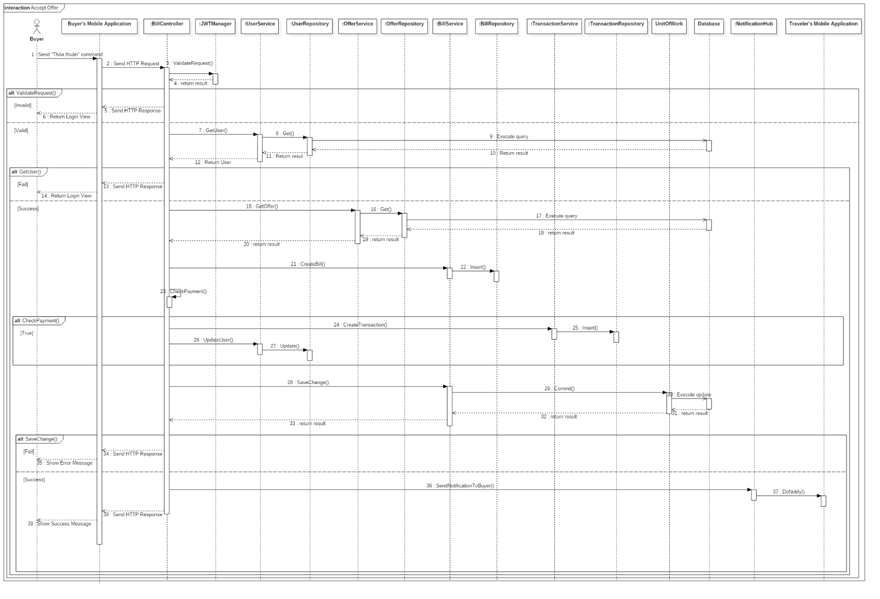

Figure 53: Sequence Diagram - <Buyer> Accept Offer

##### Complete Order

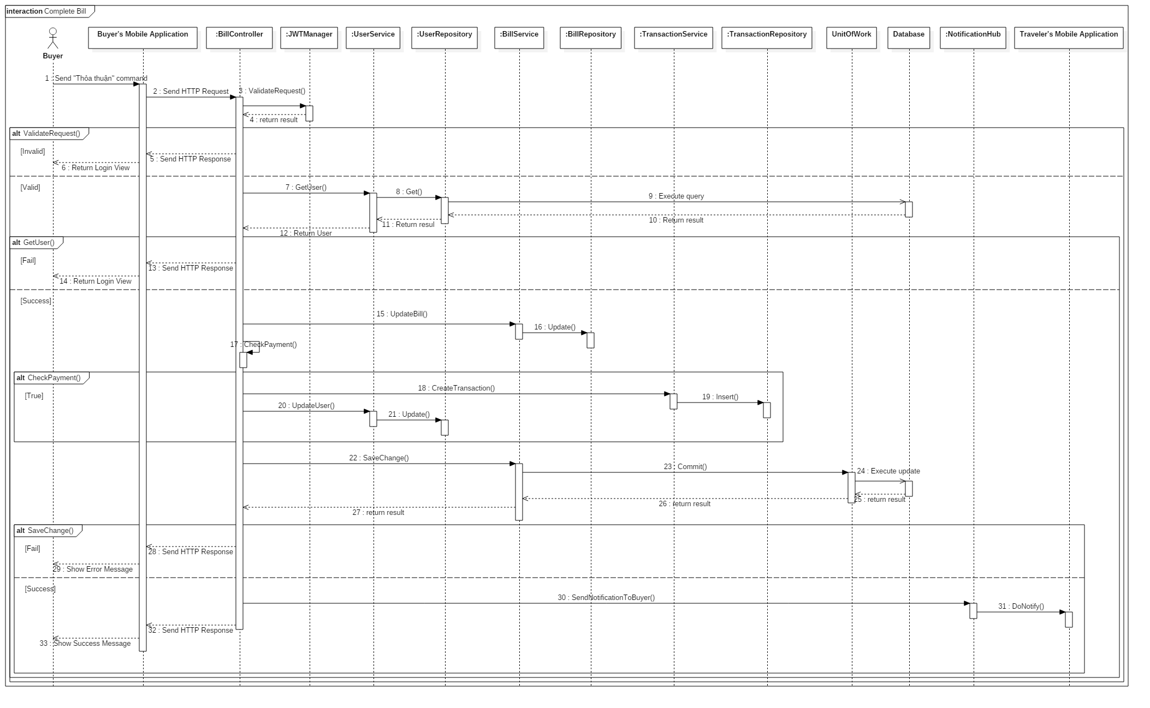

Figure 54: Sequence Diagram - <Buyer> Complete Bill

##### Create Order

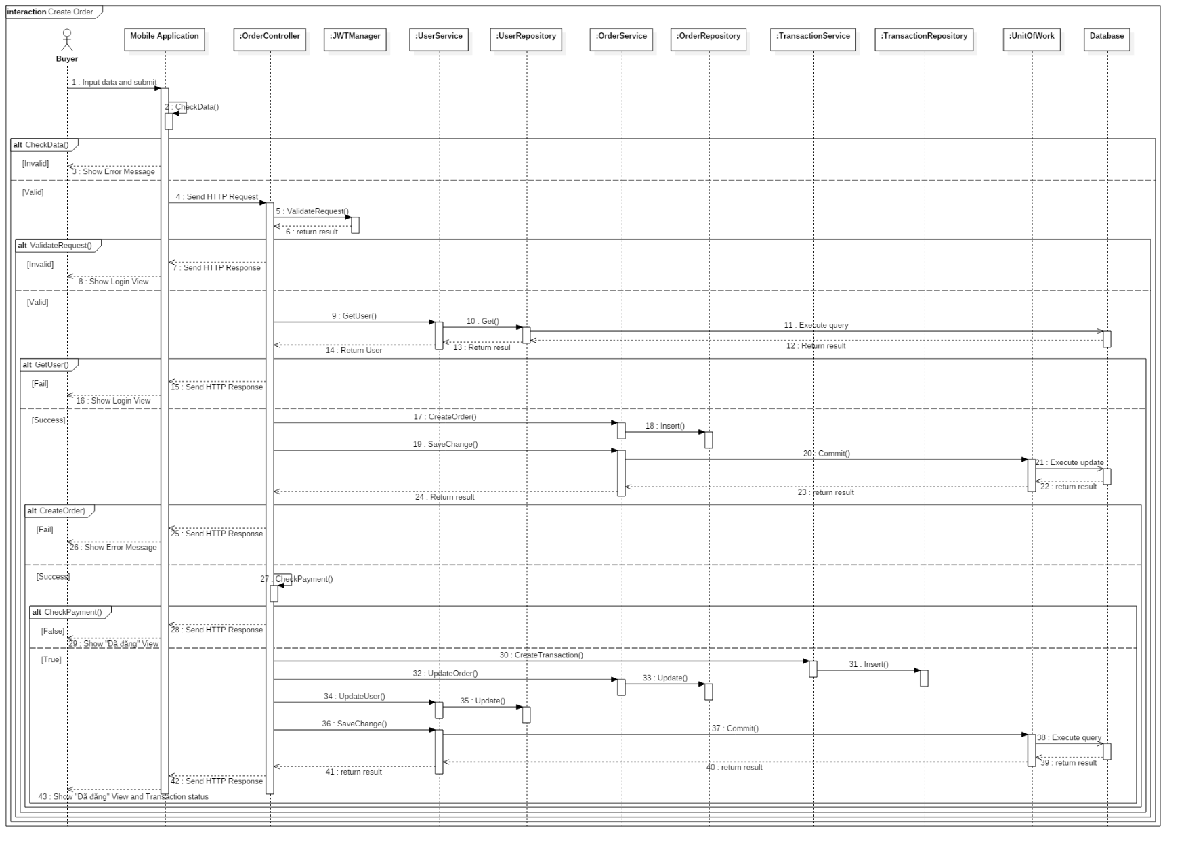

Figure 55: Sequence Diagram - <Buyer> Create Order

##### Create Trip

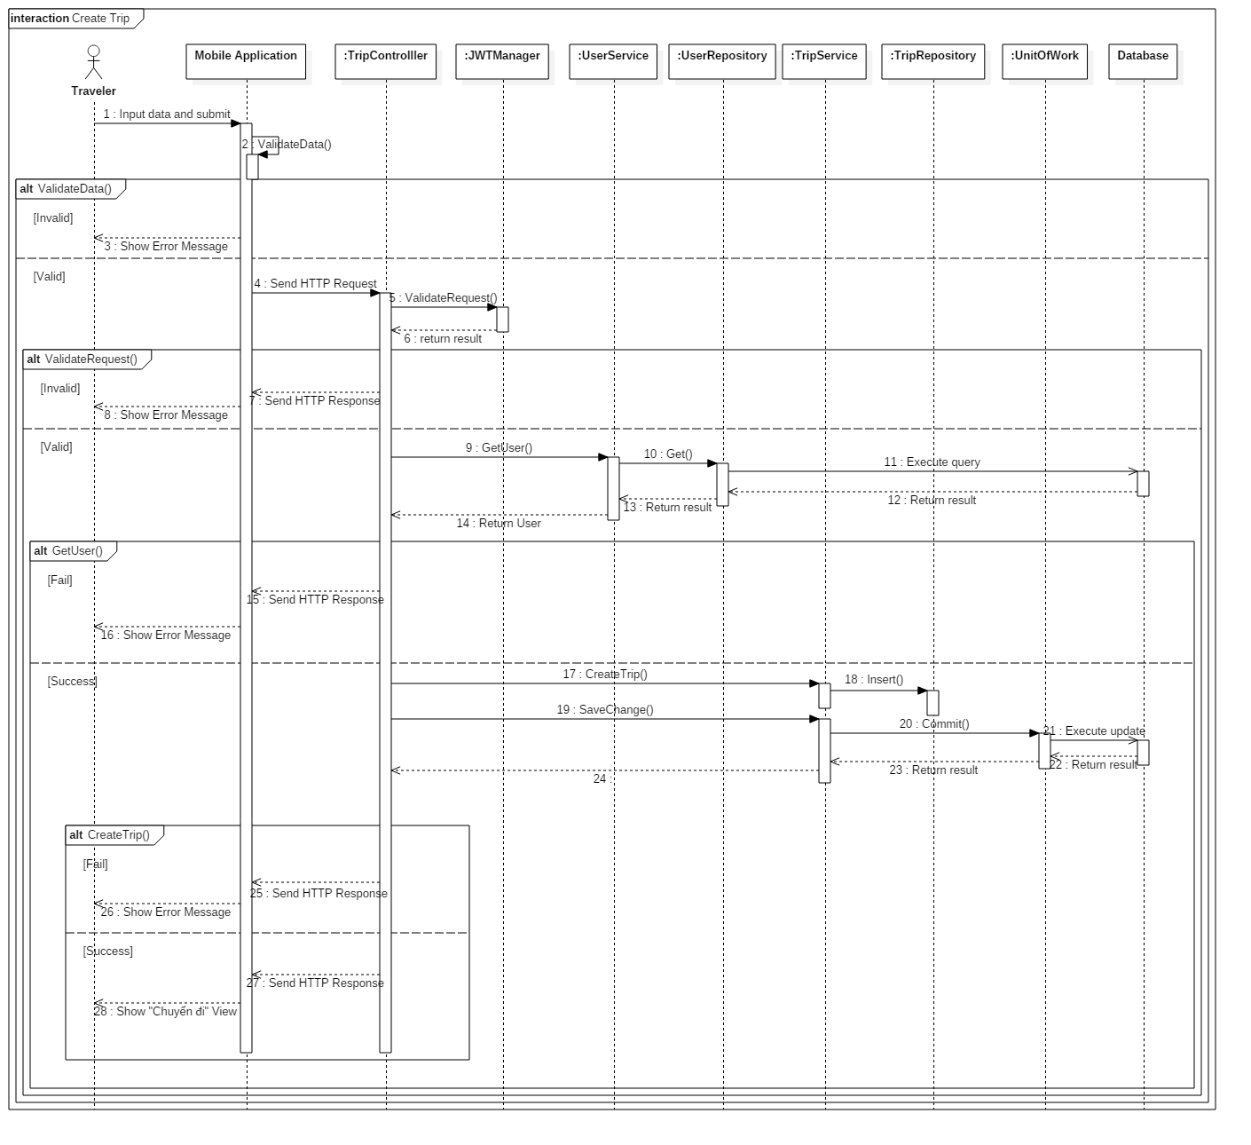

Figure 56: Sequence Diagram - <Traveler> Create Trip

##### Login Via Form

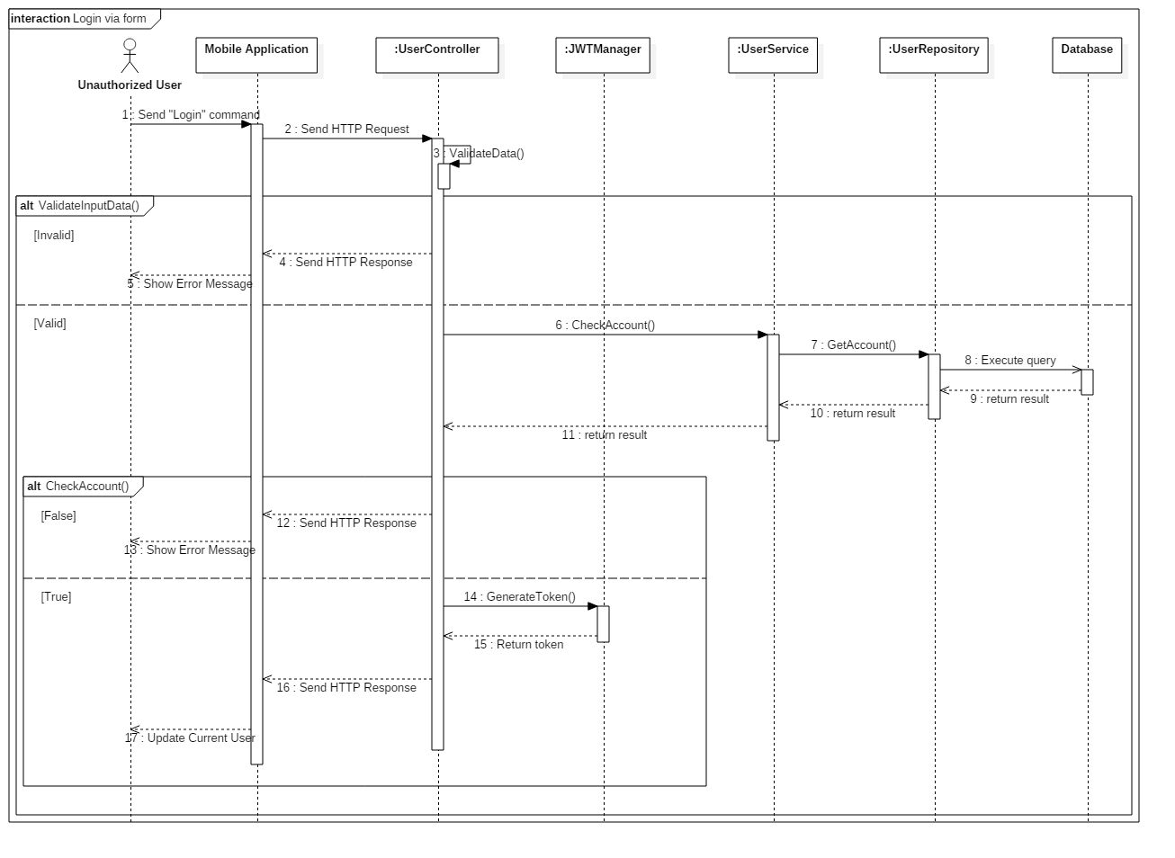

Figure 57: Sequence Diagram - <Unauthorized User> Login via Form

##### Make Offer

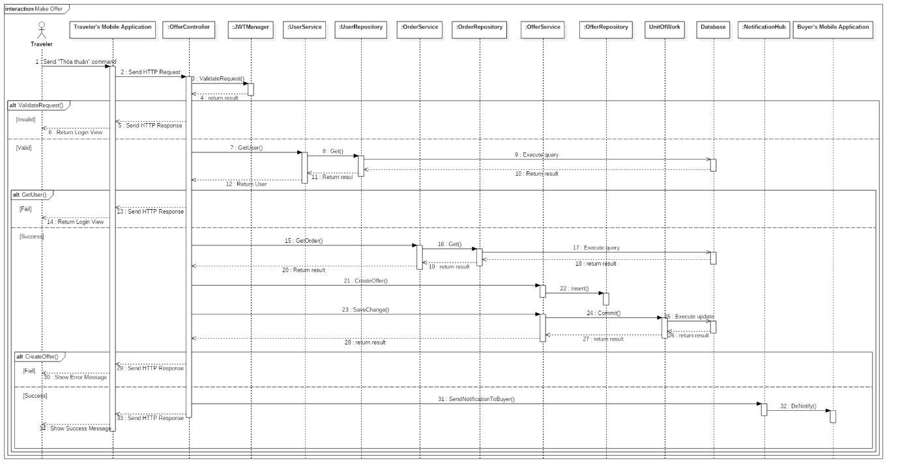

Figure 58: Sequence Diagram - <Traveler> Make Offer

##### Deposit

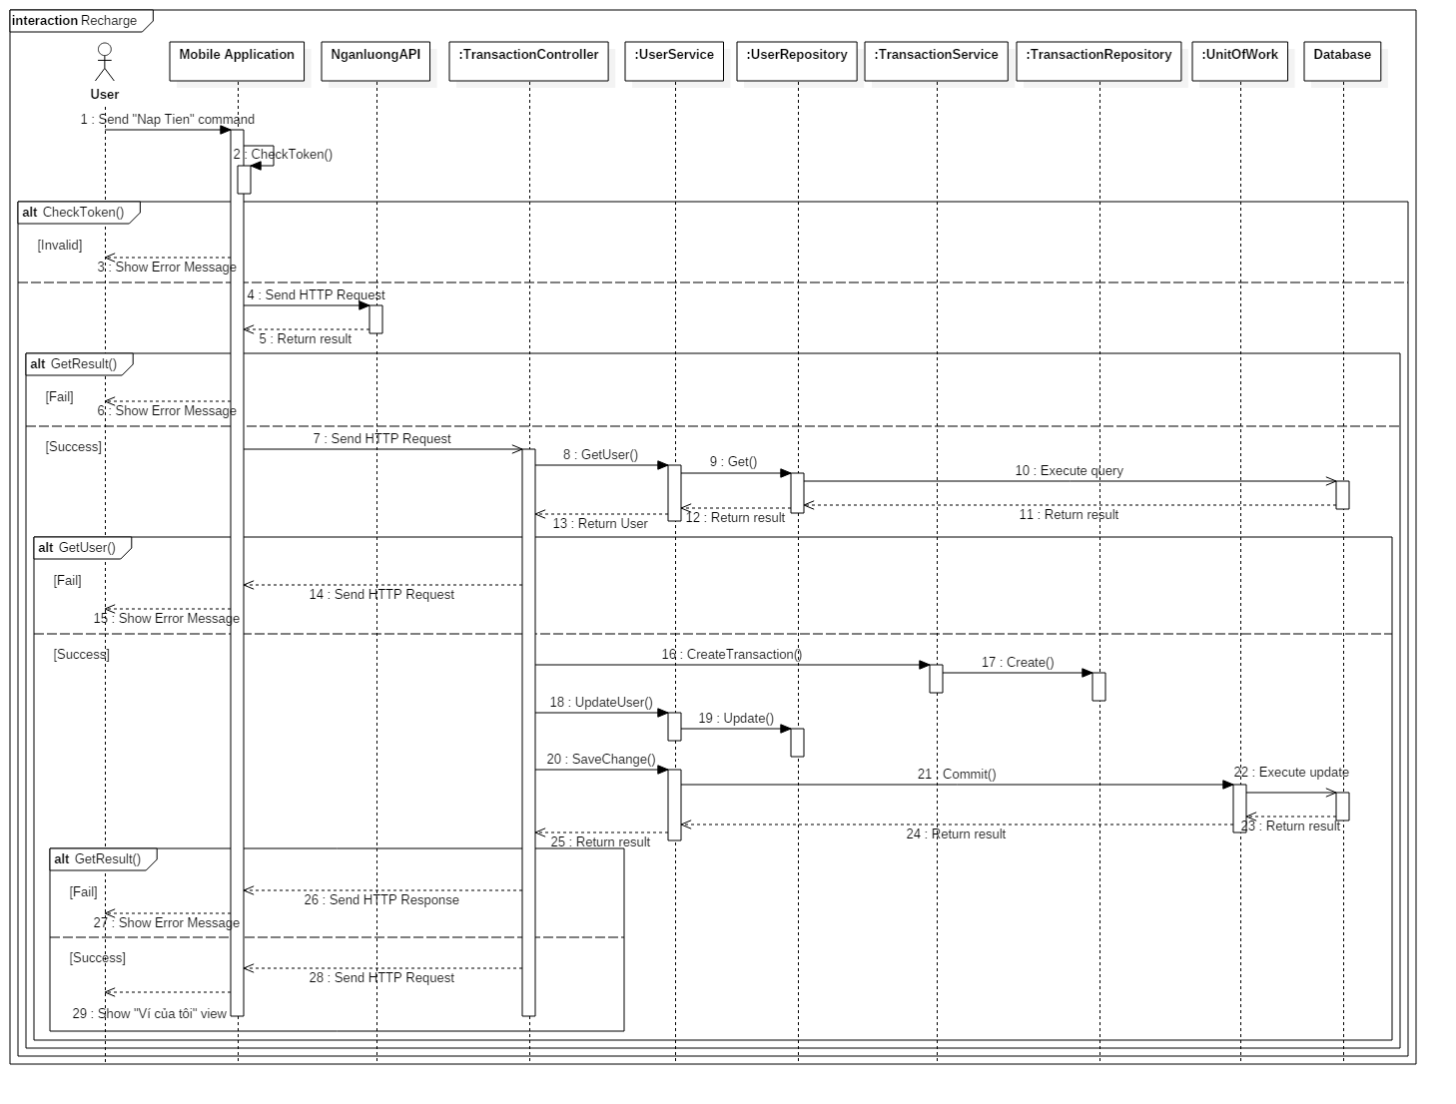

Figure 59: Sequence Diagram - <Authorized User> Deposit

##### Update Order

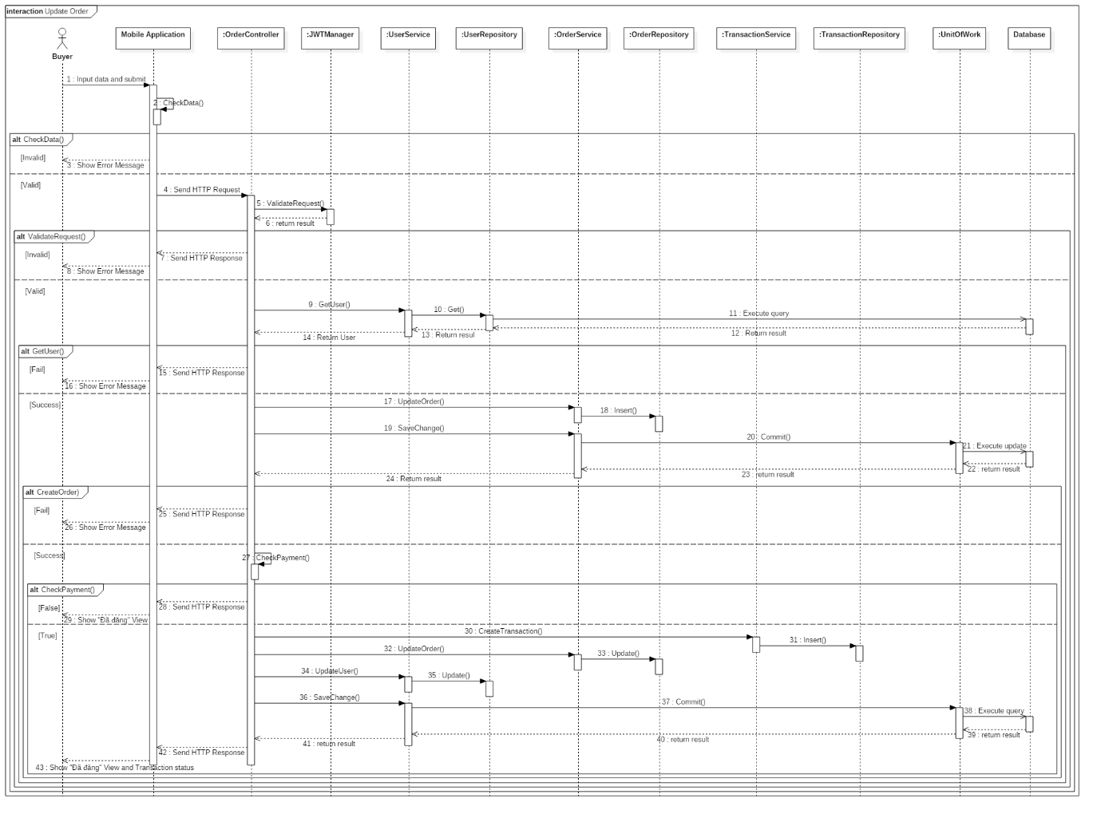

Figure 60: Sequence Diagram - <Buyer> Update Order

##### View Order Detail

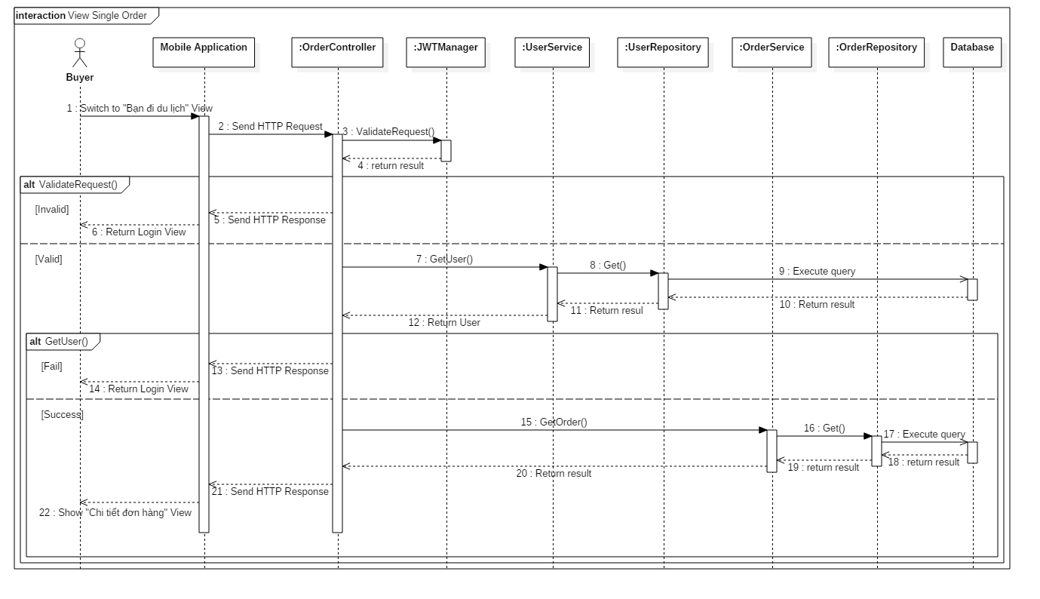

Figure 61: Sequence Diagram - <Buyer> Order Detail

##### View Suggested Order

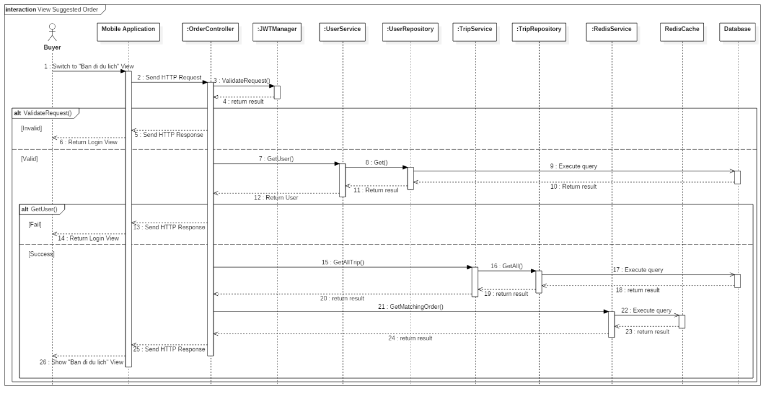

Figure 62: Sequence Diagram - <Buyer> View Suggest Order

## Interface

### Admin Interface Design

#### Login

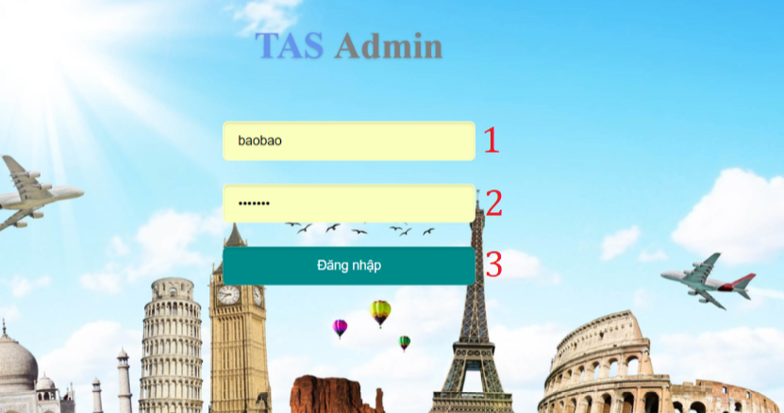

Figure 63: <Admin> Login Interface

|  |  |  |  |  |  |  |  |
| --- | --- | --- | --- | --- | --- | --- | --- |
| **FIELDS** | | | | | | | |
| **No** | **Field Name** | **Description** | **Read Only** | **Mandatory** | **Control Type** | **Data Type** | **Length** |
| 1 | txtUsername | Fill username | No | Yes | Textbox | String | N/A |
| 2 | txtPassword | Fill password | No | Yes | Textbox | String | N/A |
| **BUTTONS/HYPERLINKS** | | | | | | | |
| **No** | **Function** | **Description** | | **Validation** | **Outcome** | | |
| 3 | btnLogin | Login to system | | N/A | Go to mainpage | | |

Table 65: Admin login - Field, Buttons, Hyperlinks

#### Manage User

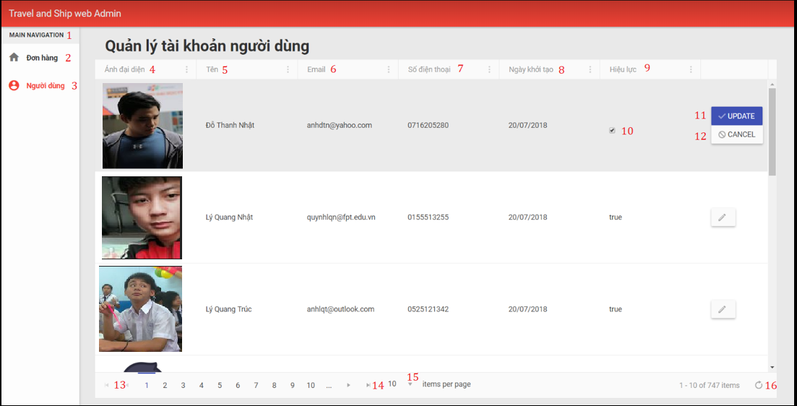

Figure 64: <Admin> Manage User Interface

|  |  |  |  |  |  |  |  |
| --- | --- | --- | --- | --- | --- | --- | --- |
| **FIELDS** | | | | | | | |
| **No** | **Field Name** | **Description** | **Read Only** | **Mandatory** | **Control Type** | **Data Type** | **Length** |
| 1 | mainMenu | Admin features | Yes | Yes | Label | String | N/A |
| 4 | userAvatar | User picture | Yes | Yes | Image | N/A | N/A |
| 5 | userName | Name of user | Yes | Yes | Label | String | N/A |
| 6 | userEmail | Mail of user | Yes | Yes | Label | String | N/A |
| 7 | userPhone | Phone of user | Yes | Yes | Label | String | N/A |
| 8 | regDate | Register date of user | Yes | Yes | Label | Datetime | N/A |
| 9 | userStatus | Status of user | Yes | Yes | Label | String | N/A |
| **BUTTONS/HYPERLINKS** | | | | | | | |
| **No** | **Function** | **Description** | | **Validation** | **Outcome** | | |
| 2 | btnOrder | View order information | | N/A | Navigate to order page | | |
| 3 | btnUser | View user information | | N/A | Navigate to user information page | | |
| 10 | checkboxStt | Check user band or not | | N/A | Check if admin ban user | | |
| 11 | btnUpdate | Update user status | | N/A | Update status of user | | |
| 12 | btnSttCancel | Cancel update status | | N/A | Cancel update status of user | | |
| 13 | btnPrevious | Previous page of user list | | N/A | Navigate to previous page of user list | | |
| 14 | btnNext | Next page of user list | | N/A | Navigate to next page of user list | | |
| 15 | btnShow | Number of user show on current page | | N/A | Show certain number of users information in page | | |
| 16 | btnRefresh | Refresh current page | | N/A | Show new information updated in user page | | |

Table 66: Admin Manage User - Field, Buttons, Hyperlinks

#### View Order List

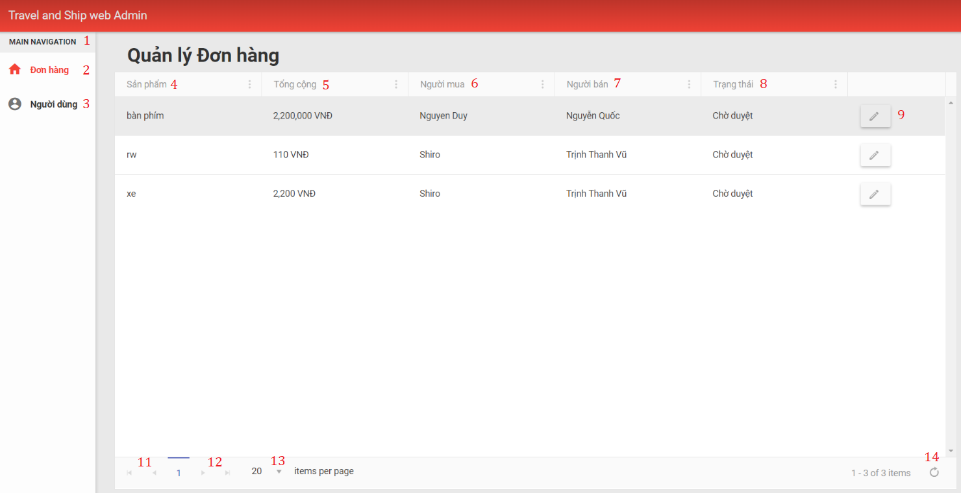

Figure 65: <Admin> View Order List Interface

|  |  |  |  |  |  |  |  |
| --- | --- | --- | --- | --- | --- | --- | --- |
| **FIELDS** | | | | | | | |
| **No** | **Field Name** | **Description** | **Read Only** | **Mandatory** | **Control Type** | **Data Type** | **Length** |
| 1 | mainMenu | Admin features | Yes | Yes | Label | String | N/A |
| 4 | orderName | Name of order | Yes | Yes | Label | String | N/A |
| 5 | totalFee | Total money of order | Yes | Yes | Label | String | N/A |
| 6 | travelerName | Name of traveler | Yes | Yes | Label | String | N/A |
| 7 | buyerName | Name of buyer | Yes | Yes | Label | String | N/A |
| 8 | orderStatus | Status of order | Yes | Yes | Label | String | N/A |
| **BUTTONS/HYPERLINKS** | | | | | | | |
| **No** | **Function** | **Description** | | **Validation** | **Outcome** | | |
| 2 | btnOrder | View order information | | N/A | Navigate to order page | | |
| 3 | btnUser | View user information | | N/A | Navigate to user information page | | |
| 9 | btnManage | Manage order transaction | | N/A | Mananage order transaction | | |
| 11 | btnPrevious | Previous page of order list | | N/A | Navigate to previous page of order list | | |
| 12 | btnNext | Next page of order list | | N/A | Navigate to next page of order list | | |
| 13 | btnShow | Number of order show on current page | | N/A | Show certain number of orders information in page | | |
| 14 | btnRefresh | Refresh current page | | N/A | Show new information updated in order page | | |

Table 67: Admin View Order List - Field, Buttons, Hyperlinks

#### Tranfer Money To Traveler

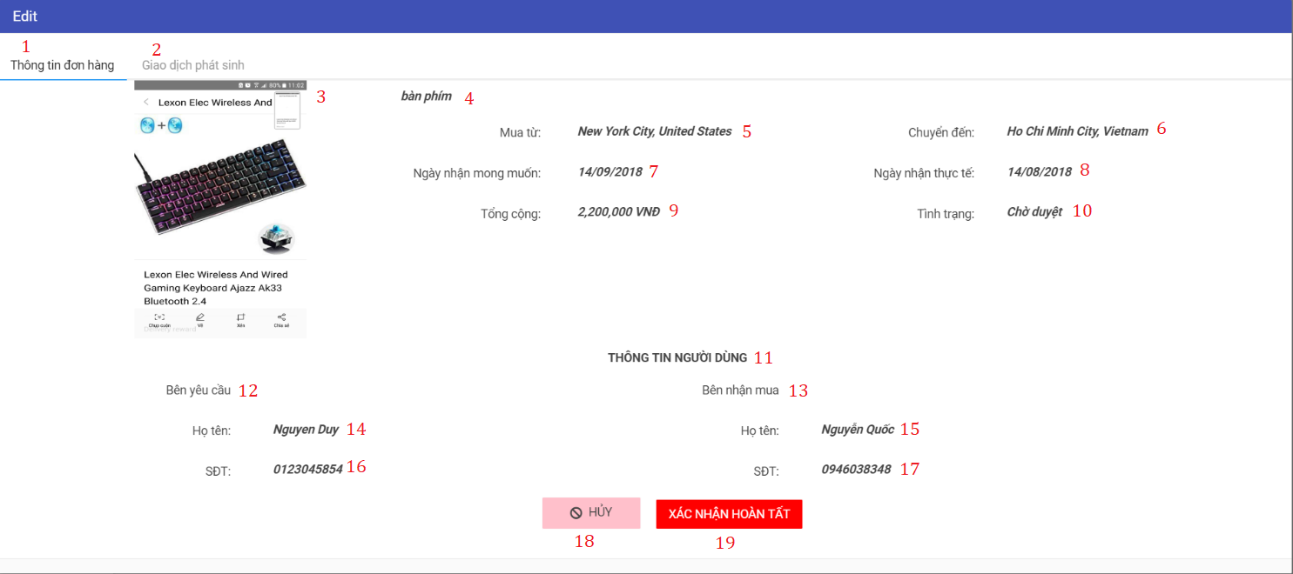

Figure 66: <Admin> Tranfer Money to Traveler Interface

|  |  |  |  |  |  |  |  |
| --- | --- | --- | --- | --- | --- | --- | --- |
| **FIELDS** | | | | | | | |
| **No** | **Field Name** | **Description** | **Read Only** | **Mandatory** | **Control Type** | **Data Type** | **Length** |
| 3 | orderPicture | Picture of order | Yes | Yes | Image | N/A | N/A |
| 4 | orderName | Name of order | Yes | Yes | Label | String | N/A |
| 5 | buyFrom | Location to buy order | Yes | Yes | Label | String | N/A |
| 6 | shipTo | Location traveler ship order to | Yes | Yes | Label | String | N/A |
| 7 | deliveryDate | Delivery date of buyer | Yes | Yes | Label | Datetime | N/A |
| 8 | receiveDate | Receive date of buyer after negotiate | Yes | Yes | Label | Datetime | N/A |
| 9 | totalFee | Total money of the order | Yes | Yes | Label | String | N/A |
| 10 | orderStatus | Status of the payment | Yes | Yes | Label | String | N/A |
| 11 | userInfo | Information of buyer and traveler | Yes | Yes | Label | String | N/A |
| 12 | buyerInfo | Information of buyer | Yes | Yes | Label | String | N/A |
| 13 | travelerInfo | Information of traveler | Yes | Yes | Label | String | N/A |
| 14 | buyerName | Name of buyer | Yes | Yes | Label | String | N/A |
| 15 | travelerName | Name of traveler | Yes | Yes | Label | String | N/A |
| 16 | buyerPhone | Phone number of buyer | Yes | Yes | Label | String | N/A |
| 17 | travelerPhone | Phone umber of traveler | Yes | Yes | Label | String | N/A |
| **BUTTONS/HYPERLINKS** | | | | | | | |
| **No** | **Function** | **Description** | | **Validation** | **Outcome** | | |
| 1 | navOrderInfor | Order detail | | N/A | Navigate to order detail page | | |
| 2 | navTransaction | Order transaction | | N/A | Navigate to order transaction page | | |
| 18 | btnCancel | Cancel order mangement | | N/A | Navigate to view order detail page | | |
| 19 | btnComplete | Confirm order complete | | N/A | Send money from buyer to traveler | | |

Table 68: Admin Tranfer Money to Traveler - Field, Buttons, Hyperlinks

#### Notification Of Order

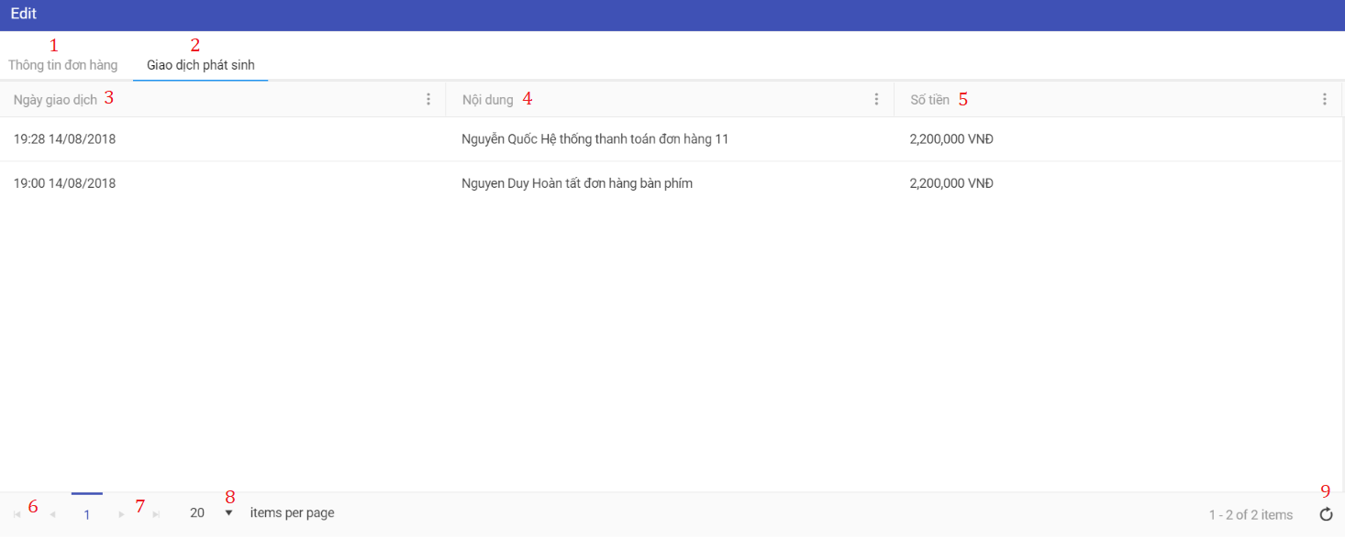

Figure 67: <Admin> View Notification

|  |  |  |  |  |  |  |  |
| --- | --- | --- | --- | --- | --- | --- | --- |
| **FIELDS** | | | | | | | |
| **No** | **Field Name** | **Description** | **Read Only** | **Mandatory** | **Control Type** | **Data Type** | **Length** |
| 3 | transactionDate | Date of transaction notice | Yes | Yes | Label | Datetime | N/A |
| 4 | transactionContent | Content of transaction | Yes | Yes | Label | String | N/A |
| 5 | transactionFee | Fee of that transaction | Yes | Yes | Label | String | N/A |
| **BUTTONS/HYPERLINKS** | | | | | | | |
| **No** | **Function** | **Description** | | **Validation** | **Outcome** | | |
| 1 | navOrderInfor | Order detail | | N/A | Navigate to order detail page | | |
| 2 | navTransaction | Order transaction | | N/A | Navigate to order transaction page | | |
| 6 | btnPrevious | Previous page of order list | | N/A | Navigate to previous page of order list | | |
| 7 | btnNext | Next page of order list | | N/A | Navigate to next page of order list | | |
| 8 | btnShow | Number of order show on current page | | N/A | Show certain number of orders information in page | | |
| 9 | btnRefresh | Refresh current page | | N/A | Show new information updated in order page | | |

Table 69: Admin View Notification - Field, Buttons, Hyperlinks

### Unauthorized User Interface Design

#### Login

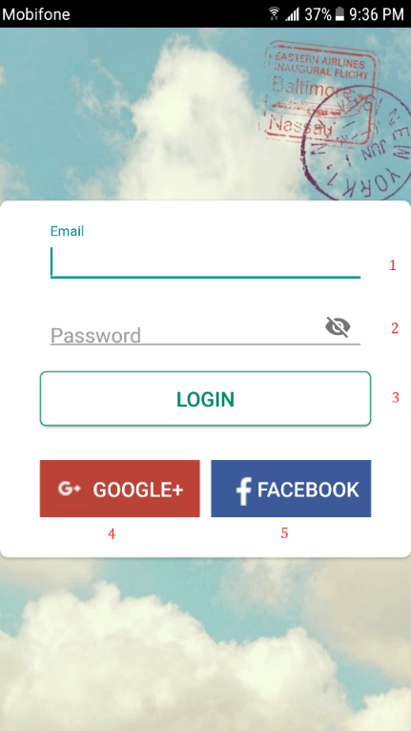

Figure 68: <Unauthorized User> Login Interface

|  |  |  |  |  |  |  |  |
| --- | --- | --- | --- | --- | --- | --- | --- |
| **FIELDS** | | | | | | | |
| **No** | **Field Name** | **Description** | **Read Only** | **Mandatory** | **Control Type** | **Data Type** | **Length** |
| **1** | txtEmail | Fill email | No | Yes | Textbox | String | N/A |
| **2** | txtPassword | Fill password | No | Yes | Textbox | String | N/A |
| **BUTTONS/HYPERLINKS** | | | | | | | |
| **No** | **Function** | **Description** | | **Validation** | **Outcome** | | |
| **3** | btnLogin | Login to system | | N/A | Go to main page | | |
| **4** | btnGoogle | Login via Google | | N/A | Go to Google login section | | |
| **5** | btnFacebook | Login via Facebook | | N/A | Go to Facebook login section | | |

Table 70: Login - Field, Buttons, Hyperlinks

### Authorized User Interface Design

#### View Setting

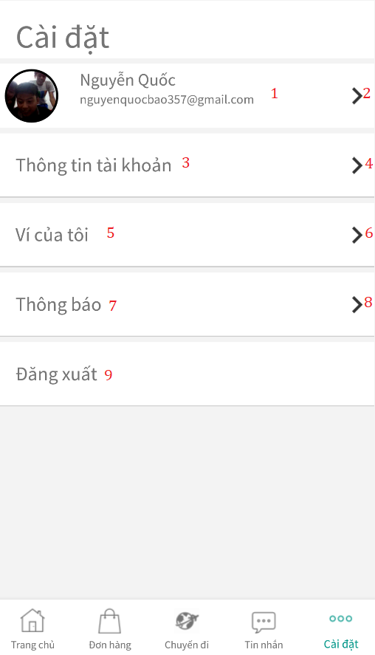

Figure 69: <Authorized User> View Setting Interface

|  |  |  |  |  |  |  |  |
| --- | --- | --- | --- | --- | --- | --- | --- |
| **FIELDS** | | | | | | | |
| **No** | **Field Name** | **Description** | **Read Only** | **Mandatory** | **Control Type** | **Data Type** | **Length** |
| **1** | userInfo | Name of the current user | Yes | Yes | Label | String | N/A |
| **3** | userAccount | Account of the current user | Yes | Yes | Label | String | N/A |
| **5** | userWallet | Wallet of the current user | Yes | Yes | Label | String | N/A |
| **7** | Notification | Manage application notifications | Yes | Yes | Label | String | N/A |
| **BUTTONS/HYPERLINKS** | | | | | | | |
| **No** | **Function** | **Description** | | **Validation** | **Outcome** | | |
| **2** | btnInfo | View user information | | N/A | Navigate to information page | | |
| **4** | btnAccount | View user account | | N/A | Navigate to account page | | |
| **6** | btnWallet | View user wallet | | N/A | Navigate to wallet page | | |
| **8** | btnNoti | Manage application notification | | N/A | Navigate to notifications page | | |
| **9** | btnLogout | Logout of the system | | N/A | Navigate to login page | | |

Table 71: View Setting - Field, Buttons, Hyperlinks

#### Chat

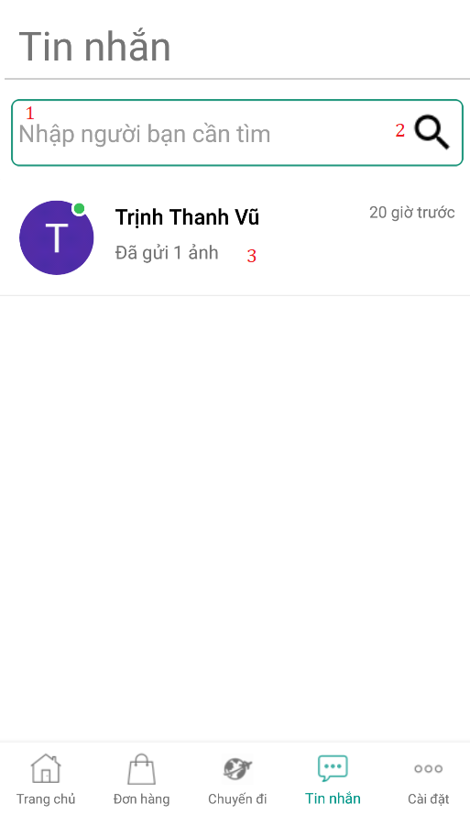

Figure 70: <Authorized User> Chat Interface (1)

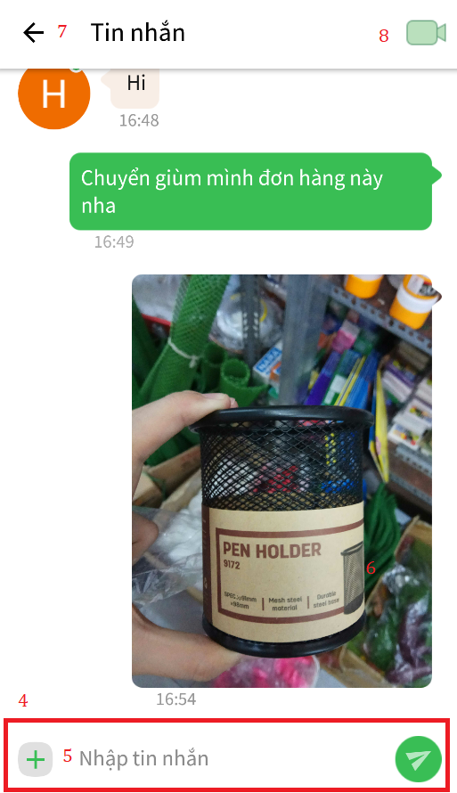

Figure 71: <Authorized User> Chat Interface (2)

|  |  |  |  |  |  |  |  |
| --- | --- | --- | --- | --- | --- | --- | --- |
| **FIELDS** | | | | | | | |
| **No** | **Field Name** | **Description** | **Read Only** | **Mandatory** | **Control Type** | **Data Type** | **Length** |
| **1** | txtName | Fill user name | No | Yes | Textbox | String | N/A |
| **4** | txtMessage | Fill chat message | No | Yes | Textbox | String | N/A |
| **BUTTONS/HYPERLINKS** | | | | | | | |
| **No** | **Function** | **Description** | | **Validation** | **Outcome** | | |
| **2** | btnSearch | Search for user name | | N/A | Show list of users with matching name. | | |
| **3** | Dialog | Move to personal conversation | | N/A | Move to personal chat section | | |
| **5** | btnUtil | Open utilities section | | N/A | Add more utilities to chat section | | |
| **6** | btnSend | Send chat message | | N/A | New chat message appear on chat section | | |
| **7** | btnBack | Back to dialog screen | | N/A | Navigate to dialog screen | | |
| **8** | btnVideo | Make video call | | N/A | Call current user in chat | | |

Table 72: Chat - Field, Buttons, Hyperlinks

#### Video Call

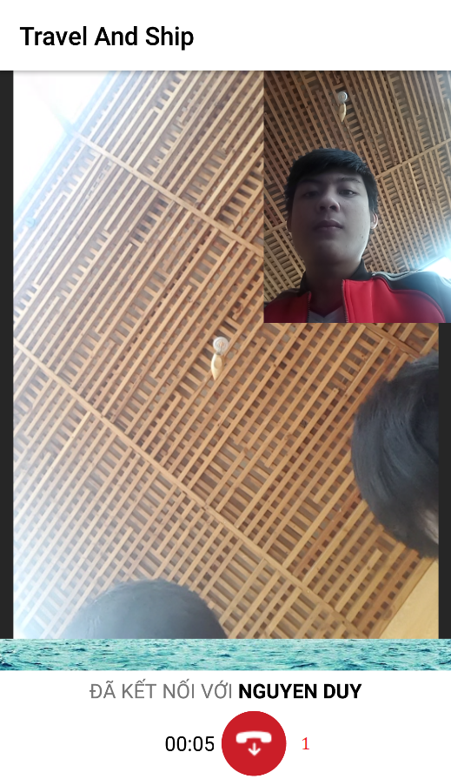

Figure 72: <Authorized User> Video Call Interface

|  |  |  |  |  |  |  |  |
| --- | --- | --- | --- | --- | --- | --- | --- |
| **FIELDS** | | | | | | | |
| **No** | **Field Name** | **Description** | **Read Only** | **Mandatory** | **Control Type** | **Data Type** | **Length** |
| **BUTTONS/HYPERLINKS** | | | | | | | |
| **No** | **Function** | **Description** | | **Validation** | **Outcome** | | |
| **1** | btnCancel | Cancel video call | | N/A | Navigate back to chat page | | |

Table 73: Video Call - Field, Buttons, Hyperlinks

#### Update User Information

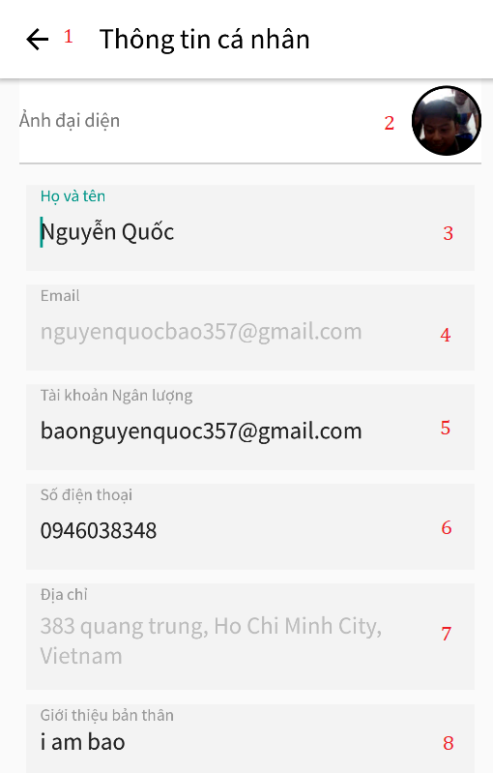

Figure 73: <Authorized User> Update Information Interface (1)

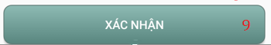

Figure 74: <Authorized User> Update Information Interface (2)

|  |  |  |  |  |  |  |  |
| --- | --- | --- | --- | --- | --- | --- | --- |
| **FIELDS** | | | | | | | |
| **No** | **Field Name** | **Description** | **Read Only** | **Mandatory** | **Control Type** | **Data Type** | **Length** |
| **3** | txtName | Fill fullname | No | Yes | Textbox | String | N/A |
| **4** | txtEmail | Fill email | Yes | Yes | Textbox | String | N/A |
| **5** | txtNganluongEmail | Fill Nganluong.vn Email | No | Yes | Textbox | String | N/A |
| **6** | txtPhone | Fill phone number | No | Yes | Textbox | String | N/A |
| **7** | txtAddress | Fill user address | No | Yes | Textbox | String | N/A |
| **8** | txtDescription | Fill description | No | No | TextArea | String | N/A |
| **BUTTONS/HYPERLINKS** | | | | | | | |
| **No** | **Function** | **Description** | | **Validation** | **Outcome** | | |
| **1** | btnBack | Back to setting page | | N/A | Navigate to setting page | | |
| **2** | btnUpload | Upload picture | | N/A | Select picture from library and upload to system | | |
| **9** | btnConfirm | Confirm change | | N/A | Refresh current page with new information | | |

Table 74: Update User Information - Field, Buttons, Hyperlinks

#### Withdraw/Deposit

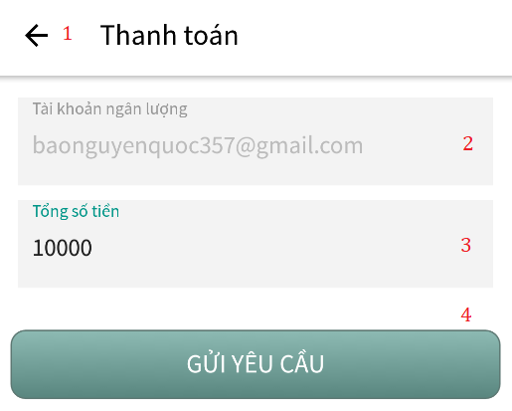

Figure 75: <Authorized User> Withdraw/Deposit Interface

|  |  |  |  |  |  |  |  |
| --- | --- | --- | --- | --- | --- | --- | --- |
| **FIELDS** | | | | | | | |
| **No** | **Field Name** | **Description** | **Read Only** | **Mandatory** | **Control Type** | **Data Type** | **Length** |
| 2 | nganluongMail | Email of Nganluong.vn | Yes | Yes | Label | String | N/A |
| 3 | txtValue | Total money want to make transaction | No | Yes | Textbox | String | N/A |
| **BUTTONS/HYPERLINKS** | | | | | | | |
| **No** | **Function** | **Description** | | **Validation** | **Outcome** | | |
| 1 | btnBack | Back to setting page | | N/A | Navigate to setting page | | |
| 4 | btnSend | Send request to Nganluong.vn | | N/A | Navigate back to wallet screen with new money value | | |

Table 75: Withdraw/Deposit - Field, Buttons, Hyperlinks

#### View Transaction History

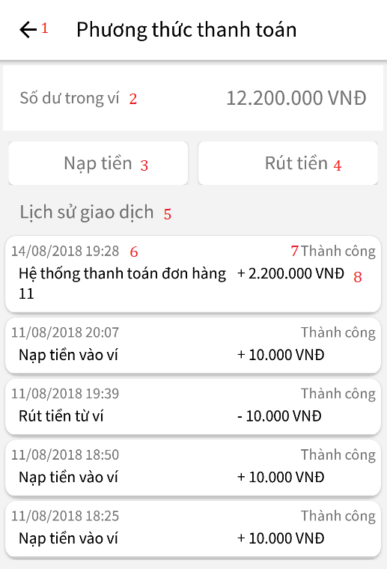

Figure 76: <Authorized User> View Transaction History Interface

|  |  |  |  |  |  |  |  |
| --- | --- | --- | --- | --- | --- | --- | --- |
| **FIELDS** | | | | | | | |
| **No** | **Field Name** | **Description** | **Read Only** | **Mandatory** | **Control Type** | **Data Type** | **Length** |
| **2** | walletValue | Total money in wallet | Yes | Yes | Label | String | N/A |
| **5** | transactionHistory | N/A | Yes | Yes | Label | String | N/A |
| **6** | createdDate | Created date of transaction | Yes | Yes | Label | String | N/A |
| **7** | transactionStatus | Status of the transaction | Yes | Yes | Label | String | N/A |
| **8** | transactionContent | Content of the transaction | Yes | Yes | Label | String | N/A |
| **BUTTONS/HYPERLINKS** | | | | | | | |
| **No** | **Function** | **Description** | | **Validation** | **Outcome** | | |
| **1** | btnBack | Back to setting page | | N/A | Navigate to wallet page | | |
| **3** | btnDeposit | Deposit money to wallet | | N/A | Navigate to deposit page | | |
| **4** | btnWithdraw | Withdraw money to wallet | | N/A | Navigate to withdraw page | | |

Table 76: View Transaction History - Field, Buttons, Hyperlinks

### Traveler Interface Design

#### View Suggest Order

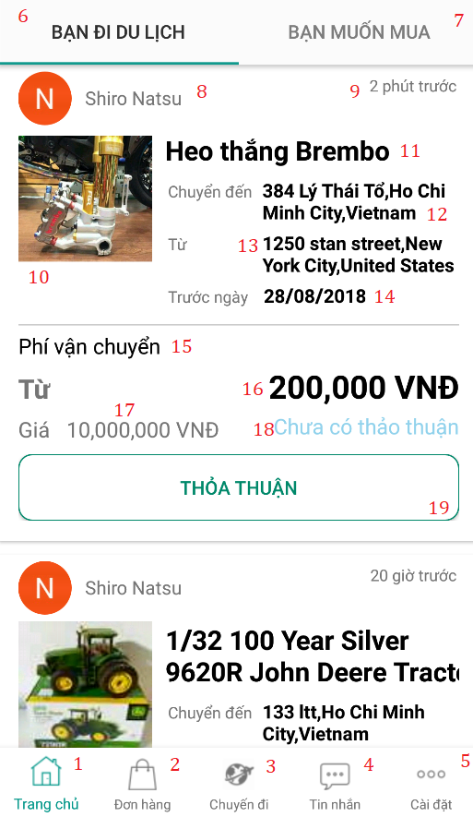

Figure 77: <Traveler> View Suggested Order

|  |  |  |  |  |  |  |  |
| --- | --- | --- | --- | --- | --- | --- | --- |
| **FIELDS** | | | | | | | |
| **No** | **Field Name** | **Description** | **Read Only** | **Mandatory** | **Control Type** | **Data Type** | **Length** |
| **8** | userName | Buyer name | Yes | Yes | Label | String | N/A |
| **9** | dateBefore | Date created order until now | Yes | Yes | Label | String | N/A |
| **10** | orderImage | Order‘s picture | Yes | Yes | Image | N/A | N/A |
| **11** | orderName | Order’s name | Yes | Yes | Label | String | N/A |
| **12** | shipTo | Ship to location | Yes | Yes | Label | String | N/A |
| **13** | shipFrom | Ship from location | Yes | Yes | Label | String | N/A |
| **14** | beforeDate | Ship before date | Yes | Yes | Label | String | N/A |
| **15** | shippingFee | Shipping’s fee | Yes | Yes | Label | String | N/A |
| **16** | shippingPrice | Fill shipping fee | No | Yes | Label | String | N/A |
| **17** | orderPrice | Order prce | Yes | Yes | Label | String | N/A |
| **18** | offeredNumber | Number of offered made | Yes | Yes | Label | String | N/A |
| **BUTTONS/HYPERLINKS** | | | | | | | |
| **No** | **Function** | **Description** | | **Validation** | **Outcome** | | |
| **1** | btnMainpage | View main page | | N/A | Navigate to main page | | |
| **2** | btnOrder | View order page | | N/A | Navigate to order page | | |
| **3** | btnTrip | View trip page | | N/A | Navigate to trip page | | |
| **4** | btnMessage | View message dialog page | | N/A | Navigate to message page | | |
| **5** | btnSetting | View setting page | | N/A | Navigate to setting page | | |
| **6** | btnSuggOrder | View suggested order | | N/A | Navigate to suggested order page | | |
| **7** | btnSuggTrip | View suggested trip | | N/A | Navigate to suggested trip page | | |
| **20** | btnMakeOffer | To make offer | | N/A | Order disappear. | | |

Table 77: View Suggest Order - Field, Buttons, Hyperlinks

#### Create Trip

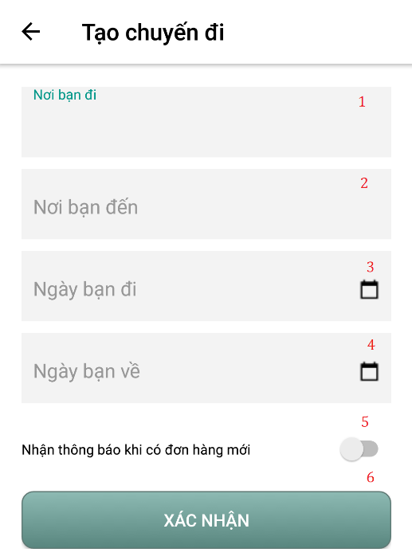

Figure 78: <Traveler> Create Trip Interface

|  |  |  |  |  |  |  |  |
| --- | --- | --- | --- | --- | --- | --- | --- |
| **FIELDS** | | | | | | | |
| **No** | **Field Name** | **Description** | **Read Only** | **Mandatory** | **Control Type** | **Data Type** | **Length** |
| **1** | txtFromLoca | Current location | No | Yes | Textbox | String | N/A |
| **2** | txtToLoca | Destination | No | Yes | Textbox | String | N/A |
| **3** | txtBeginDate | Date user go | No | Yes | Textbox | String | N/A |
| **4** | txtEndDate | Date user back | No | Yes | Textbox | String | N/A |
| **BUTTONS/HYPERLINKS** | | | | | | | |
| **No** | **Function** | **Description** | | **Validation** | **Outcome** | | |
| **5** | btnNoti | Get notice from order | | N/A | Notice user when order matched. | | |
| **6** | btnConfirm | Create trip | | N/A | Show new created trip in trip page. | | |

Table 78: Create Trip - Field, Buttons, Hyperlinks

#### View Trip

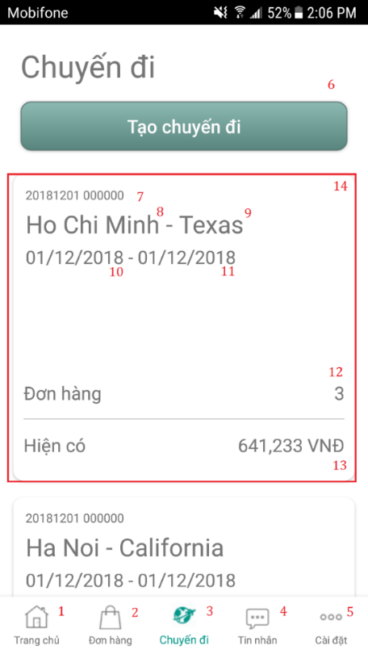

Figure 79: <Traveler> View Trip Interface

|  |  |  |  |  |  |  |  |
| --- | --- | --- | --- | --- | --- | --- | --- |
| **FIELDS** | | | | | | | |
| **No** | **Field Name** | **Description** | **Read Only** | **Mandatory** | **Control Type** | **Data Type** | **Length** |
| **7** | createdDate | Date created trip | Yes | Yes | Label | String | N/A |
| **8** | fromLocation | User current location | Yes | Yes | Label | String | N/A |
| **9** | toLocation | User travel to location | Yes | Yes | Label | String | N/A |
| **10** | fromDate | Date’s user travel | Yes | Yes | Label | String | N/A |
| **11** | toDate | Date’s user back | Yes | Yes | Label | String | N/A |
| **12** | offerNumber | Number of offered | Yes | Yes | Label | String | N/A |
| **13** | totalPrice | Total money user earn from all orders | Yes | Yes | Label | String | N/A |
| **BUTTONS/HYPERLINKS** | | | | | | | |
| **No** | **Function** | **Description** | | **Validation** | **Outcome** | | |
| **1** | btnMainpage | View main page | | N/A | Navigate to main page | | |
| **2** | btnOrder | View order page | | N/A | Navigate to order page | | |
| **3** | btnTrip | View trip page | | N/A | Navigate to trip page | | |
| **4** | btnMessage | View message dialog page | | N/A | Navigate to message page | | |
| **5** | btnSetting | View setting page | | N/A | Navigate to setting page | | |
| **6** | btnCreateTrip | Create new trip | | N/A | Navigate to create trip page | | |
| **14** | btnTripDetail | See trip detail and offer | | N/A | Navigate to trip detail page | | |

Table 79: View Trip - Field, Buttons, Hyperlinks

#### Make Offer

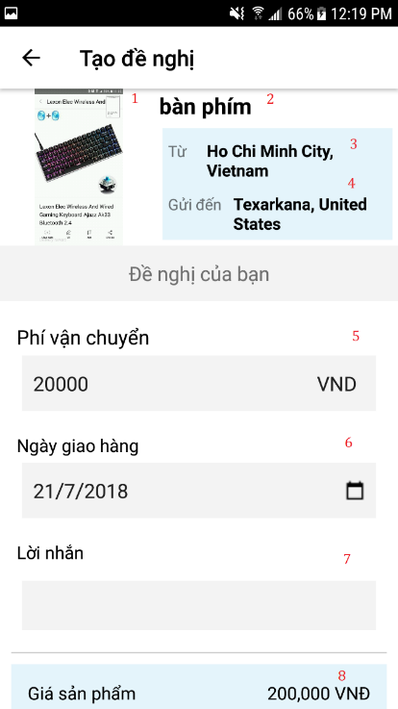

Figure 80: <Traveler> Make Offer Interface (1)

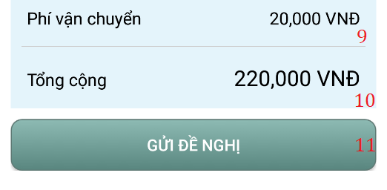

Figure 81: <Traveler> Make Offer Interface (2)

|  |  |  |  |  |  |  |  |
| --- | --- | --- | --- | --- | --- | --- | --- |
| **FIELDS** | | | | | | | |
| **No** | **Field Name** | **Description** | **Read Only** | **Mandatory** | **Control Type** | **Data Type** | **Length** |
| **1** | orderAvatar | Picture of item | Yes | Yes | Image | N/A | N/A |
| **2** | orderName | Name of item | Yes | Yes | Label | String | N/A |
| **3** | fromLocation | Order current location | Yes | Yes | Label | String | N/A |
| **4** | toLocation | Order ships to location | Yes | Yes | Label | String | N/A |
| **5** | txtShippingFee | Fee of shipping | No | Yes | Textbox | String | N/A |
| **6** | txtDeliveryDate | Date to delivery | No | Yes | Textbox | String | N/A |
| **7** | txtNote | User note | No | Yes | TextArea | String | N/A |
| **8** | price | Order’s price | Yes | Yes | Label | String | N/A |
| **9** | shippingFee | Fee of shipping | Yes | Yes | Label | String | N/A |
| **10** | totalFee | Total fee | Yes | Yes | Label | String | N/A |
| **BUTTONS/HYPERLINKS** | | | | | | | |
| **No** | **Function** | **Description** | | **Validation** | **Outcome** | | |
| **11** | btnMakeOffer | To make offer | | N/A | Offer send to buyer. | | |

Table 80: Make Offer - Field, Buttons, Hyperlinks

#### Tracking Order

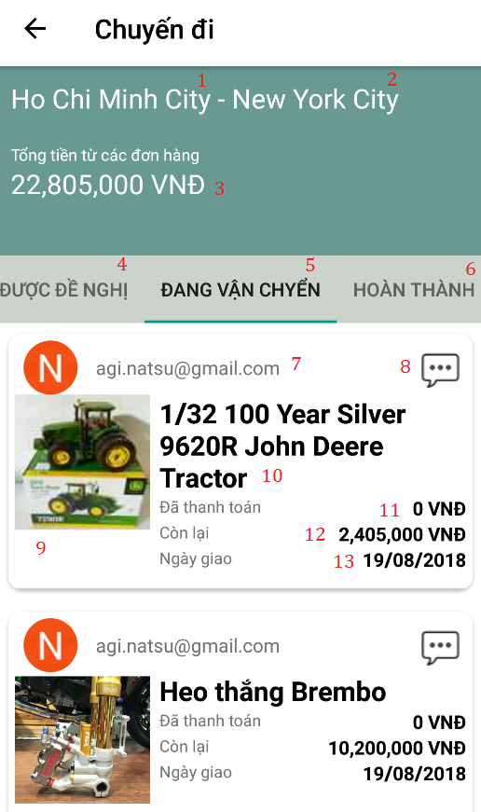

Figure 82: <Traveler> Tracking Order Interface

|  |  |  |  |  |  |  |  |
| --- | --- | --- | --- | --- | --- | --- | --- |
| **FIELDS** | | | | | | | |
| **No** | **Field Name** | **Description** | **Read Only** | **Mandatory** | **Control Type** | **Data Type** | **Length** |
| **1** | fromLocation | User current location | Yes | Yes | Label | String | N/A |
| **2** | toLocation | User travel to location | Yes | Yes | Label | String | N/A |
| **3** | totalFee | Total fee | Yes | Yes | Label | String | N/A |
| **7** | buyerName | Name of buyer | Yes | Yes | Label | String | N/A |
| **9** | orderImage | Image of item | Yes | Yes | Image | N/A | N/A |
| **10** | orderName | Name of item | Yes | Yes | Label | String | N/A |
| **11** | prepay | Pre pay fee | Yes | Yes | Label | String | N/A |
| **12** | payLeft | Pay all | Yes | Yes | Label | String | N/A |
| **BUTTONS/HYPERLINKS** | | | | | | | |
| **No** | **Function** | **Description** | | **Validation** | **Outcome** | | |
| **4** | btnOffered | View offered order | | N/A | Navigate to offered order page | | |
| **5** | btnTransit | View transited order | | N/A | Navigate to transited order page | | |
| **6** | btnReceived | View received order | | N/A | Navigate to received order page | | |
| **8** | btnChat | Chat with buyer | | N/A | Navigate to message page | | |
| **13** | btnTimeline | View timeline of order | | N/A | Navigate to view timeline page | | |
| **15** | btnTrip | View all trips created | | N/A | Back to trip manage page | | |

Table 81: Tracking Order - Field, Buttons, Hyperlinks

### Buyer Interface Design

#### View Suggest Trip

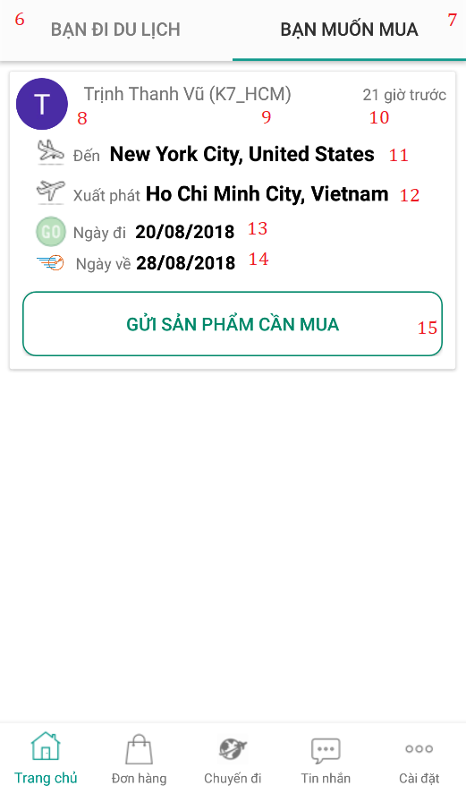

Figure 83: <Buyer> View Suggest Trip Inteface

|  |  |  |  |  |  |  |  |
| --- | --- | --- | --- | --- | --- | --- | --- |
| **FIELDS** | | | | | | | |
| **No** | **Field Name** | **Description** | **Read Only** | **Mandatory** | **Control Type** | **Data Type** | **Length** |
| **8** | travelerAvatar | Avatar of traveler | Yes | Yes | Image | N/A | N/A |
| **9** | travelerName | Name of traveler | Yes | Yes | Label | String | N/A |
| **10** | status | Status of traveler | Yes | Yes | N/A | bit | N/A |
| **11** | fromLocation | Traveler current location | Yes | Yes | Label | String | N/A |
| **12** | toLocation | Traveler travel to location | Yes | Yes | Label | String | N/A |
| **13** | fromDate | Date’s traveler travel | Yes | Yes | Label | String | N/A |
| **14** | toDate | Date’s traveler back | Yes | Yes | Label | String | N/A |
| **BUTTONS/HYPERLINKS** | | | | | | | |
| **No** | **Function** | **Description** | | **Validation** | **Outcome** | | |
| **1** | btnMainpage | View main page | | N/A | Navigate to main page | | |
| **2** | btnOrder | View order page | | N/A | Navigate to order page | | |
| **3** | btnTrip | View trip page | | N/A | Navigate to trip page | | |
| **4** | btnMessage | View message dialog page | | N/A | Navigate to message page | | |
| **5** | btnSetting | View setting page | | N/A | Navigate to setting page | | |
| **6** | btnSuggOrder | View suggested order | | N/A | Navigate to suggested order page | | |
| **7** | btnSuggTrip | View suggested trip | | N/A | Navigate to suggested trip page | | |
| **15** | btnConfirm | Confirm trip | | N/A | Trip disappears in page. | | |

Table 82: View Suggest Trip - Field, Buttons, Hyperlinks

#### Create Order

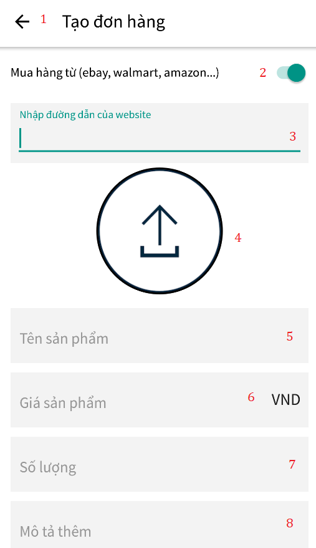

Figure 84: <Buyer> Create Order Interface (1)

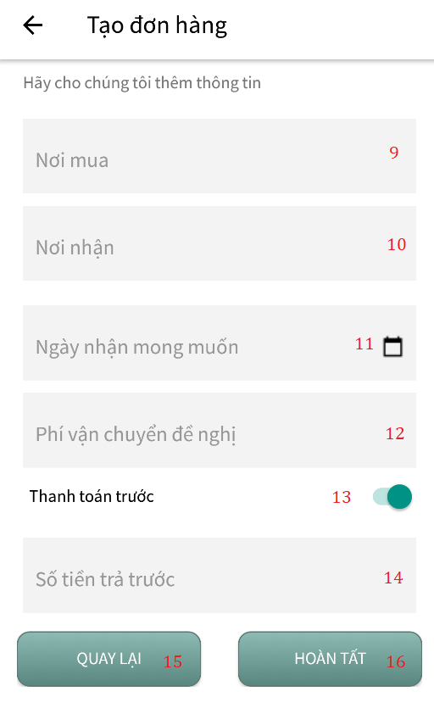

Figure 85: <Buyer> Create Order Interface (2)

|  |  |  |  |  |  |  |  |
| --- | --- | --- | --- | --- | --- | --- | --- |
| **FIELDS** | | | | | | | |
| **No** | **Field Name** | **Description** | **Read Only** | **Mandatory** | **Control Type** | **Data Type** | **Length** |
| **3** | txtProductUrl | Url of the product | No | Yes | Textbox | String | N/A |
| **5** | txtOrderName | Order’s name | No | Yes | Textbox | String | N/A |
| **6** | txtOrderPrice | Order’s price | No | Yes | Textbox | String | N/A |
| **7** | txtOrderQtt | Order’s quantity | No | Yes | Texbox | String | N/A |
| **8** | txtDescription | Order’s detail | No | Yes | TextArea | String | N/A |
| **9** | txtGetOrder | Order buy from location | No | Yes | Textbox | String | N/A |
| **10** | txtShipOrder | Order ships to location | No | Yes | Textbox | String | N/A |
| **11** | txtDeliveryDate | Date to delivery | No | Yes | Textbox | String | N/A |
| **12** | txtShippingFee | Shipping fee | No | Yes | Textbox | String | N/A |
| **14** | txtPrePay | Pre pay fee | No | Yes | Textbox | String | N/A |
| **BUTTONS/HYPERLINKS** | | | | | | | |
| **No** | **Function** | **Description** | | **Validation** | **Outcome** | | |
| **1** | btnMain | Back to main page | | N/A | Back to main page | | |
| **2** | swShowUrl | Show txtProductUrl | | N/A | Product url appear | | |
| **4** | btnImage | Select order’s image | | N/A | Order have image | | |
| **7** | btnNext | Move to next section | | N/A | Move to next page | | |
| **13** | swPrePay | Fee of pre pay the order | | N/A | Pre pay section editable | | |
| **15** | btnBack | Back to previous section | | N/A | Move to previous page | | |
| **16** | btnComplete | Complete created order | | N/A | Navigate back to order page | | |

Table 83: Create Order - Field, Buttons, Hyperlinks

#### View Order

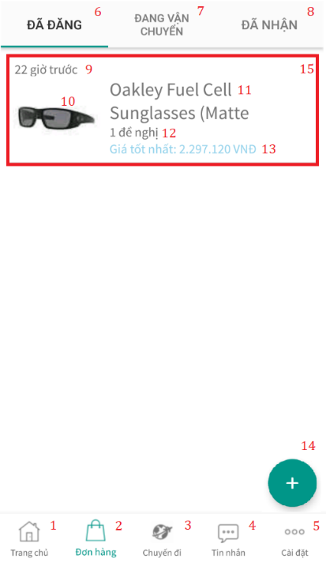

Figure 86: <Buyer> View Order Interface

|  |  |  |  |  |  |  |  |
| --- | --- | --- | --- | --- | --- | --- | --- |
| **FIELDS** | | | | | | | |
| **No** | **Field Name** | **Description** | **Read Only** | **Mandatory** | **Control Type** | **Data Type** | **Length** |
| **9** | dateBefore | Date created till now | Yes | Yes | Label | String | N/A |
| **10** | orderImage | Order‘s picture | Yes | Yes | Image | N/A | N/A |
| **11** | orderName | Order’s name | Yes | Yes | Label | String | N/A |
| **12** | offeredNumber | Number of offered made | Yes | Yes | Label | String | N/A |
| **13** | bestPrice | Best price traveler offer | Yes | Yes | Label | String | N/A |
| **BUTTONS/HYPERLINKS** | | | | | | | |
| **No** | **Function** | **Description** | | **Validation** | **Outcome** | | |
| **1** | btnMainpage | View main page | | N/A | Navigate to main page | | |
| **2** | btnOrder | View order page | | N/A | Navigate to order page | | |
| **3** | btnTrip | View trip page | | N/A | Navigate to trip page | | |
| **4** | btnMessage | View message dialog page | | N/A | Navigate to message page | | |
| **5** | btnSetting | View setting page | | N/A | Navigate to setting page | | |
| **6** | btnPosted | View posted order | | N/A | Navigate to posted order page | | |
| **7** | btnTransit | View transited order | | N/A | Navigate to transited order page | | |
| **8** | btnReceived | View received order | | N/A | Navigate to received order page | | |
| **14** | btnCreate | Create new order | | N/A | Navigate to create order page | | |
| **15** | frmOrder | View order detail | | N/A | Navigate to order detail page | | |

Table 84: View Order - Field, Buttons, Hyperlinks

#### Accept Offer

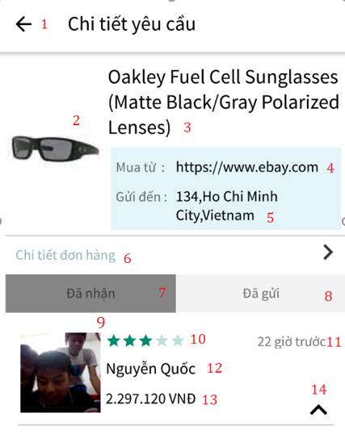

Figure 87: <Buyer> Accept Offer Interface (1)

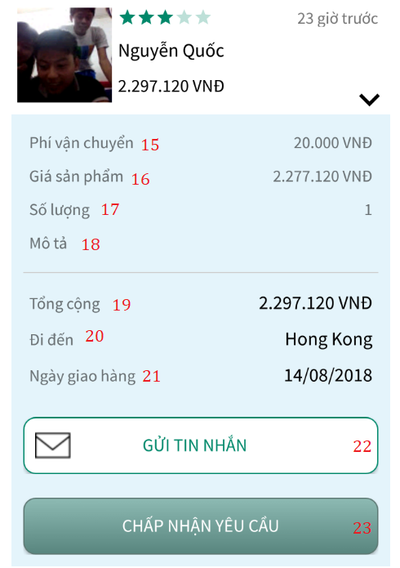

Figure 88: <Buyer> Accept Offer Interface (2)

|  |  |  |  |  |  |  |  |
| --- | --- | --- | --- | --- | --- | --- | --- |
| **FIELDS** | | | | | | | |
| **No** | **Field Name** | **Description** | **Read Only** | **Mandatory** | **Control Type** | **Data Type** | **Length** |
| **2** | orderImage | Order‘s picture | Yes | Yes | Image | N/A | N/A |
| **3** | orderName | Order’s name | Yes | Yes | Label | String | N/A |
| **4** | fromLocation | Order current location | Yes | Yes | Label | String | N/A |
| **5** | toLocation | Order ships to location | Yes | Yes | Label | String | N/A |
| **9** | travelerAvatar | Avatar of traveler | Yes | Yes | Image | N/A | N/A |
| **10** | rateStar | Star of traveler | Yes | Yes | Rate bar | N/A | N/A |
| **11** | dateBefore | Date created till now | Yes | Yes | Label | String | N/A |
| **12** | travelerName | Name of traveler | Yes | Yes | Label | String | N/A |
| **13** | travelerOfferPrice | Price traveler offered | Yes | Yes | Label | String | N/A |
| **15** | orderShippingFee | Fee of shipping | Yes | Yes | Label | String | N/A |
| **16** | orderPrice | Price of order | Yes | Yes | Label | String | N/A |
| **17** | quantity | Quantity of item in order | Yes | Yes | Label | String | N/A |
| **18** | offerDescription | Description of offer | Yes | Yes | Label | String | N/A |
| **19** | orderTotalFee | Total fee | Yes | Yes | Label | String | N/A |
| **20** | fromLocation | Traveler current location | Yes | Yes | Label | String | N/A |
| **21** | deliveryDate | Date of delivery | Yes | Yes | Label | String | N/A |
| **BUTTONS/HYPERLINKS** | | | | | | | |
| **No** | **Function** | **Description** | | **Validation** | **Outcome** | | |
| **1** | btnBack | Back to offer page | | N/A | Navigate back to offer page | | |
| **6** | hlOrderDetail | View order detail | | N/A | Navigate to order detail page | | |
| **7** | btnReceivedOffer | View received offer | | N/A | Show received offer list | | |
| **8** | btnSentOffer | View sent offer | | N/A | Show sent offer list | | |
| **14** | btnShowList | View received offer information | | N/A | Show offer information | | |
| **22** | btnChat | Send chat command | | N/A | Navigate to chat section | | |
| **23** | btnAccept | Send accept offer | | N/A | Navigate to transit page | | |

Table 85: Accept Offer - Field, Buttons, Hyperlinks

#### Rate

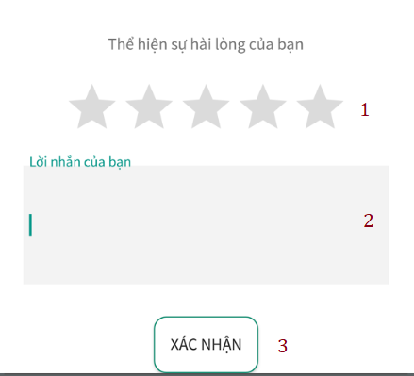

Figure 89: <Buyer> Rate Interface

|  |  |  |  |  |  |  |  |
| --- | --- | --- | --- | --- | --- | --- | --- |
| **FIELDS** | | | | | | | |
| **No** | **Field Name** | **Description** | **Read Only** | **Mandatory** | **Control Type** | **Data Type** | **Length** |
| 2 | txtMessage | Review of user | No | No | Label | String | N/A |
| **BUTTONS/HYPERLINKS** | | | | | | | |
| **No** | **Function** | **Description** | | **Validation** | **Outcome** | | |
| 1 | rbRating | Rate for user | | N/A | Rate for user | | |
| 3 | btnConfirm | Confirm rating | | N/A | Navigate to received screen | | |

Table 86: Rate - Field, Buttons, Hyperlinks

## Database Design

### Entity relationship diagram (ERD)

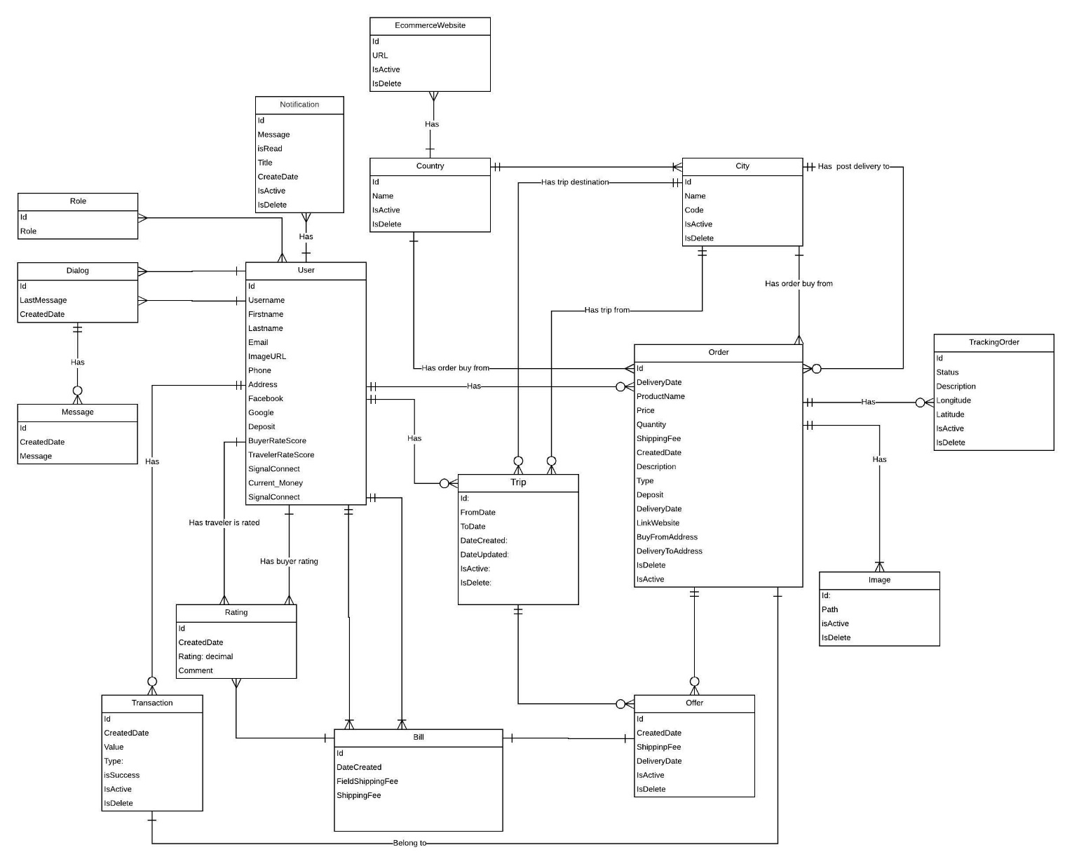

Figure 90: Entity Relationship diagram

### Entity dictionary

|  |  |
| --- | --- |
| **ENTITY DATA DICTIONARY: DESCRIBE CONTENT OF ALL ENTITIES** | |
| **Entity Name** | **Description** |
| **Role** | Contains roles information |
| **Dialog** | Contains chat dialogs |
| **Message** | Contain chat messages history |
| **Transaction** | Contains transaction information |
| **User** | Contains users information |
| **Rating** | Contains rating information |
| **Country** | Contains countries information |
| **EcommerceWebsites** | Contains ecommerce websites domains |
| **Trip** | Contains trips information |
| **Bill** | Contains bills information |
| **City** | Contains cities information |
| **Order** | Contains orders information |
| **Offer** | Contains offers information |
| **TrackingOrder** | Contains timeline information |
| **Image** | Contains images information |
| **Notification** | Contains notification message |

Table 87: Entity Data dictionary

## Algorithms

### Definition

Recommendation is the way to get matching order for trip request to buy a product. When a request for help is created, a worker service will create a recommendation expert list for this request. Then, this worker service will assign an expert for this request from the recommendation list.

### Define Problem

System contains large database where user inputs trips and order. So, in order to match order and trip to each other to reduce searching time of user, we define a solution cover it up.

### Solution

Scheduler system executes information of user and order to show an order's list with calculated order score and credit user score. We use noSQL(Redis) to store volatile value about order score and credit user score to show appropriate suggestions. We have two algorithms to define that process:

**Suggest order**

**- Buyer Credit**

Buyer Credit=35% Rate + 25% completed order + 15% Total money transfer for traveler on order completed +25% Order Rate

**S** = ${\text{ R}}_{\text{1}}$*0.35+ ${\text{ R}}_{\text{2}}$*0.25+ ${\text{ R}}_{\text{3}}$*0.15 + ${\text{ R}}_{\text{4}}$*0.25

${\text{ S}}_{\text{Max}}$ =100 score

* Complete order = ${\text{ R}}_{\text{1}}$ = $\frac{Completed }{Order}$*100
* Rate = ${\text{ R}}_{\text{2}}$ = ($\frac{Total rate score(by traveler) }{\begin{aligned}Total order completed ({buyer}^{'}order) * 5 \end{aligned}}$) *100
* Total money transfer for traveler on order completed = ${\text{ R}}_{\text{3}}$
* Total transfer > 5.000.000 VND: ${\text{ R}}_{\text{3}}$ = 25
* Total transfer > 10.000.000 VND: ${\text{ R}}_{\text{3}}$ = 50
* Total transfer > 20.000.000 VND: ${\text{ R}}_{\text{3}}$ = 100
* Order rate= $\frac{Total order completed}{Highest total order completed }$*100

- **Order score**

Order Score = 40% Profit margin + 60% Deposit rate

**S** = ${\text{ R}}_{\text{1}}$*0.4 + ${\text{ R}}_{\text{2}}$*0.6

${\text{ S}}_{\text{Max}}$ = 100 score

* + Profit margin : ${\text{ R}}_{\text{1}}$

If $\frac{Shipping fee }{Total}≥0.3$

=> ${\text{ R}}_{\text{1} }$ = $100$

Else

=

* + Deposit rate : ${\text{ R}}_{\text{2}}=\frac{Deposit }{Total}$*100
  + Total = Price * Quantity + Shipping Fee

- **Suggest order**

Suggest order= $\frac{Order score*0.6 +Buyer Credit *0.4}{ Time}$

**S= $\frac{{ R}_{1}*0.4 +{ R}_{2} *0.6}{ Time}$**

* Time = Current date time- last modify time
  + - Last modify time: update when traveler make offer
    - Unit: day
    - Minimum time = 1
    - Time rounded decimal up to integer.

**Suggest trip**

Suggest trip base on traveler credit

Traveler Credit =35% Rate + 25% Complete order + 15% Total money earn on order completed +25% Order Score

**S** = ${\text{ R}}_{\text{1}}$*0.35+ ${\text{ R}}_{\text{2}}$*0.25+ ${\text{ R}}_{\text{3}}$*0.15 + ${\text{ R}}_{\text{4}}$*0.25

${\text{ S}}_{\text{Max}}$**=** 100 score

* Complete order = ${\text{ R}}_{\text{1}}$ = $\frac{Complete}{Order}$*100
* Rate = ${\text{ R}}_{\text{2}}$ = ($\frac{Total rate score(by buyer) }{Total order completed ({traveler}^{'}s order) * 5}$) * 100
* Total money earn on order completed = ${\text{ R}}_{\text{3}}$
* Total transfer > 5.000.000 VND: ${\text{ R}}_{\text{3}}$ = 25
* Total transfer > 10.000.000 VND: ${\text{ R}}_{\text{3}}$ = 50
* Total transfer > 20.000.000 VND: ${\text{ R}}_{\text{3}}$ = 100
* Order score= $\frac{Total order completed for one user}{Highest total order completed for one user}$*100

### Flowchart

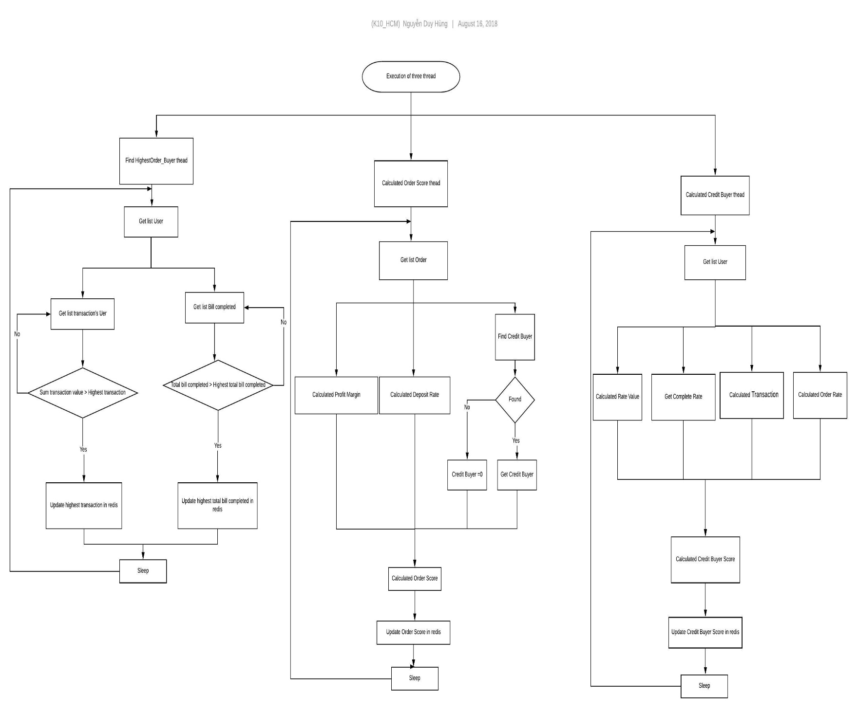

Figure 91: Flowchart

# E. System Implementation & Test

## Introduction

### Overview

This section describes the approach and methodologies used by group to plan, organize and manage the testing of TAS system. It provides in the detail all necessary information about the implementation and testing procedure of the system included test plans, test cases, test result, test environments, pass/fail criteria and risks estimations as well as a checklist to cover all possible cases.

### Test approach

We use system test approach to estimate our keeping track of children system quality, tester to aware of what TAS should do but does not have the knowledge of how because it does it. If tester had knowledge about the technical inside it, testing process won’t be objectivity.

## Database Relationship Diagram

### Physical diagram



Figure 92: Physical diagram

### Data dictionary

|  |  |
| --- | --- |
| **DATA DICTIONARY: DESCRIBE CONTENT OF ALL TABLES** | |
| **Table name** | **Description** |
| Coutry | Contains countries information |
| City | Contains cities information |
| EcommerceWebsites | Contains ecommerce websites domains |
| Trips | Contains trips information |
| Offers | Contains offers information |
| Images | Contains images information |
| Orders | Contains orders information |
| Transactions | Contrains transactions information |
| AspNetUserRoles | Contains permissions information |
| AspNetRoles | Contains roles information |
| TrackingOrders | Contains timeline information |
| AspNetUsers | Contains users information |
| Ratings | Contains rating information |
| Bills | Contains bills information |
| Dialog | Contains dialog information |
| Message | Contains message information |
| Notification | Contains noti information |

Table 88: Data dictionary

|  |  |  |  |  |
| --- | --- | --- | --- | --- |
| **Table Name** | **Attributes** | **Description** | **Domain** | **Null** |
| **Country** | Id | Unique identifier the of countries | Int | No |
| Name | Name of countries | Nvarchar(MAX) | No |
| Code | Code of the countries | Nvarchar(MAX) | No |
| IsActive | Status of countries that still available | Bit | No |
| IsDelete | Status of countries that being deleted | Bit | No |
| **City** | Id | Unique identifier of cities | Int | No |
| Name | Name of the cities | Nvarchar(MAX) | No |
| Code | Code of the cities | Nvarchar(MAX) | No |
| CountryID | Identifier of the country | Int | No |
| IsActive | Status of cities that still available | Bit | No |
| IsDelete | Status of cities that being deleted | Bit | No |
| **Orders** | Id | Unique identifier of the orders | Int | No |
| ProductName | Name of the product | Nvarchar(MAX) | No |
| Price | Price of the product | Int | No |
| Quantity | Quantity of the product | Int | No |
| BuyFromId | Identifier of the city which the product will be bought from | Int | Yes |
| DeliveryToId | Identifier of the city which the product will be brought to | Int | Yes |
| ShippingFee | Fee of shipping | Int | No |
| DateCreated | Create date of order | Datetime | No |
| DateUpdated | Updated date of order | Datetime | No |
| Description | Description of order | Nvarchar(MAX) | Yes |
| UserId | Identifier of user | Nvarchar(MAX) | No |
| IsActive | Status of order that still available | Bit | No |
| IsDelete | Status of order that being deleted | Bit | No |
| Type | Type of order | Int | Yes |
| Deposit | Deposit money of the order | Int | Yes |
| DeliveryDate | Delivery date of the order | Datetime | Yes |
| LinkWebsite | The website which sell the product | Nvarchar(MAX) | Yes |
| BuyFromAddress | Address of the place which the product will be bought from | Nvarchar(MAX) | Yes |
| DeliveryToAddress | Address of the palce where the product will be deliveried to | Nvarchar(MAX) | Yes |
| CountryId | Identifier of the country where to buy the product | Int | Yes |
| **AspNetRoles** | Id | Unique identifier of roles | Nvarchar(MAX) | No |
| Name | Roles name | Nvarchar(MAX) | No |
| **EcommerceWebsite** | Id | Unique identifier of ecommerce website | Int | No |
| Url | Url of ecommerce website | Nvarchar(MAX) | No |
| CountryId | Identifier of the country | int | No |
| IsActive | Status of the website that in use | Bit | No |
| IsDelete | Status of the website that being delete | Bit | No |
| **Images** | Id | Unique identifier of image | Int | No |
| Path | Path of images | Nvarchar(MAX) | No |
| DateCreated | Created date of the image | Datetime | No |
| OrderId | Identifier of the order | Int | no |
| IsActive | Status of the images that in use | Bit | No |
| IsDelete | Status of the images that being delete | Bit | No |
| **AspNetUserRoles** | UserId | Identifier of user | Nvarchar(MAX) | No |
| RoleId | Identifier of role | Nvarchar(MAX) | No |
| **Trip** | Id | Unique identifier of category | Int | No |
| Name | Name of the category | Nvarchar(MAX) | No |
| FromCityId | Identifier of user’s current city | Nvarchar(MAX) | No |
| ToCityId | Identifier of the destination | Nvarchar(MAX) | No |
| FromDate | Date user travel | Datetime | No |
| ToDate | Date user come back | Datetime | No |
| DateCreated | Created date of category | Datetime | No |
| DateUpdated | Updated date of category | Datetime | No |
| IsActive | Status of trip that in use | Bit | No |
| IsDelete | Status of trip that being deleted | Bit | No |
| UserId | Identifier of user create trip | Nvarchar(MAX) | No |
| **Offers** | Id | Unique identifier of offer | Int | No |
| DateCreated | Created date of the offer | Datetime | No |
| DateUpdated | Updated date of the offer | Datetime | No |
| ShippingFee | Fee of shipping | Int | No |
| DeliveryDate | Date delivery the offer | Datetime | No |
| Message | Message from traveler | Nvarchar(MAX) | No |
| BuyerId | Identifier of the buyer | Nvarchar(MAX) | No |
| TravelerId | Identifier of the traveler | Nvarchar(MAX) | No |
| OrderId | Identifier of the order | Int | No |
| TripId | Identifier of the trip | Int | No |
| Type | Type of the offer | Int | No |
| IsActive | Status of offer that in use | Bit | No |
| IsDelete | Status of offer that being deleted | Bit | No |
| **Rating** | Id | Unique identifier of rating | Int | No |
| DateCreated | Created date of the rating | Datetime | No |
| UserRateId | Identifier of rating user | Nvarchar(MAX) | No |
| UserRatedId | Identifier of rated user | Nvarchar(MAX) | No |
| Comment | Comment about rated user | Nvarchar(MAX) | Yes |
| Bill_Id | Identifier of the bill | Int | No |
| Type | Type of rating | Int | No |
| Point | The point of the rating | Int | No |
| IsActive | Status of rating that in use | Bit | No |
| IsDelete | Status of rating that being deleted | Bit | No |
| **AspNetUsers** | Id | Unique identifier of user | Nvarchar(MAX) | No |
| FirstName | First name of the user | Nvarchar(MAX) | Yes |
| LastName | Last name of thje user | Nvarchar(MAX) | Yes |
| Address | Address of the user | Nvarchar(MAX) | Yes |
| DateCreated | Registration date of user | Datetime | No |
| Activated | User have activated account | Bit | No |
| Gender | User’s gender | Int | No |
| RoleId | Identifier of the role | Nvarchar(MAX) | No |
| DateOfBirth | Birthday of the user | Datetime | Yes |
| ImageUrl | Avatar link of the user | Nvarchar(MAX) | Yes |
| FacebookId | Identifier of user’s facebook account | Nvarchar(MAX) | Yes |
| GoogleId | Identifier of user’s google account | Nvarchar(MAX) | Yes |
| Deleted | Status of user that being deleted | Bit | No |
| Email | Email of the user | Nvarchar(MAX) | No |
| PasswordHash | Password of the user | Nvarchar(MAX) | No |
| SecurityStamp | Key to decrypt the password hash | Nvarchar(MAX) | No |
| PhoneNumber | Phone number of the user | Nvarchar(MAX) | Yes |
| UserName | Account name of the user | Nvarchar(MAX) | No |
| Current_Money | Current money in user wallet | Int | No |
| BuyerRateScore | Rating score for the buyer | Float | No |
| TravelerRateScore | Rating score for traveler | Float | No |
| SignalConnect | Save connection string for notification | Nvarchar(MAX) | Yes |
| TKNL | Nganluong’s account | Nvarchar(MAX) | No |
| **TrackingOrder** | Id | Unique identifier of the timeline | Int | No |
| DateCreated | Created date of timeline | Datetime | No |
| Status | Status of the order | Int | No |
| OrderId | Identifier of the order being tracked | Int | No |
| IsActive | Status of the timeline that in use | Bit | No |
| IsDelete | Status of the timeline that being delete | Bit | No |
| Description | Description of the order location | Nvarchar(MAX) | No |
| Longitude | Longitude of the order location | Float | No |
| Latitude | Latitude of the order location | Float | no |
| **Bill** | Id | Unique identifier of the bill | Int | No |
| DateCreated | Created date of the bill | Datetime | No |
| DateUpdated | Updated date of the bill | Datetime | No |
| ShippingFee | Fee of shipping the bill | Int | No |
| Total | Total number of bills | bigInt | No |
| BuyerId | Identifier of the buyer | Nvarchar(MAX) | No |
| TravelerId | Identifier of the traveler | Nvarchar(MAX) | No |
| Status | The status of bill | Int | No |
| IsActive | Status of bills that in use | Bit | No |
| IsDelete | Status of bills that being deleted | Bit | No |
| **Transactions** | Id | Unique identifier of the transaction | Int | No |
| DateCreated | Create date of the transaction | Datetime | No |
| Value | Value of the transaction | Int | No |
| UserId | Identifier of the user | Nvarchar(MAX) | Yes |
| Type | Type of the transaction | Int | No |
| IsSuccess | Check success of the transaction | Bit | No |
| Description | The description of the transaction | Nvarchar(MAX) | Yes |
| IsActive | Status of the transaction that in use | Bit | No |
| IsDelete | Status of the transaction that being delete | Bit | No |
| OrderId | Identifier of the order | Int | No |
| **Dialog** | Id | Unique identifier of dialog | Int | No |
| LastMessage | Last message received | Nvarchar(MAX) | No |
| LastModify | Last time dialog updated | Nvarchar(MAX) | No |
| CreateDate | Create date of dialog | Datetime | No |
| SenderId | Identifier of sender | Int | No |
| ReceiverId | Identifier of receiver | Int | No |
| **Message** | Id | Unique identifier of message | Int | No |
| Message | Content of message | Nvarchar(MAX) | No |
| CreateDate | Create date of message | Datetime | No |
| SenderId | Identifier of sender | Int | No |
| ReceiverId | Identifier of receiver | Int | No |
| **Notification** | Id | Unique identifier of notification | Int | No |
| Message | Content of notification | Nvarchar(MAX) | No |
| Title | Title of notification | Nvarchar(MAX) | No |
| DateCreate | Create date of notification | Datetime | No |
| isRead | Check if user read notification | Bit | No |
| isActive | Status |  |  |
| isDelete | Status of notification that available | Bit | No |
| UserId | Status of notification that being deleted | Bit | No |

Table 89: Data Table description

## Performance Measure

### Show list result of offers performance

In general, when user open application, show list take less than 1 second to perform.

### Show list result of orders performance

In general, when user open application, show list take less than 1 second to perform.

### Show lists result of trips performance

In general, when user open application, show list take less than 1 second to perform.

### Add new trip performance

New trip will be shown at trip list after user added new trip completely take less than 1 second.

### Add new order performance

New order will be shown at home page and order page after user have created new order completely take less than 1 second.

### Get bill GPS tracking performance

After user click on tracking button, the application will show the location of the bill and it take less than 3 seconds.

### Notifications performance

User will get notifications when offers, orders, trips get updated. It’s take less than 1 second.

## Test Plan

The overall purpose of testing is to ensure TAS meets its entire technical, functional and business requirement. The purpose of this document is to describe the overall test plan and strategy for testing the TAS. The approach described in this document provides the framework for all testing related to this application. Individual test cases will be written for each version of the application that is released. This document will also be updated as required for each release.

### Features to be tested

* Unauthorized User: Login.
* Authorized User: Chat, update user info.
* Traveler: Make offer, view suggest order, create trip.
* Buyer: Create order, view suggest trip, accept offer, rate, confirm complete.
* Admin: Manage user, manage order.

### Features not to be tested

* Withdraw.
* Deposit.
* Manage bill.

## System Testing Test Case

### Test case

#### <Unauthorized User> Login

|  |  |  |  |  |  |
| --- | --- | --- | --- | --- | --- |
| **ID** | **Test Case Description** | **Test Case Procedure** | **Expected Output** | **Result** | **Test Date** |
| **L_1** | Test user logins successfully | 1. User inputs “Email” field.  2. User inputs “Mật khẩu” field.  3. User clicks “Đăng nhập” button. | 1. System shows message “Đăng nhập thành công”.  2. System navigates to main page. | Pass | 28/7/2018 |
| **L_2** | Test user logins with wrong “Email” format. | 1. User inputs “Email” field with wrong format.  2. User inputs “Mật khẩu” field.  2. User clicks “Đăng nhập” button. | 1. System shows message “Sai email”. | Pass | 28/7/2018 |
| **L_3** | Test user logins with wrong “Mật khẩu” fields. | 1. User inputs “Email” field.  2. User inputs wrong “Mật khẩu” field.  3. User clicks “Đăng nhập” button. | 1. System shows message “Sai mật khẩu”. | Pass | 28/7/2018 |
| **L_4** | Test user logins with blank requirement fields. | 1. User clicks “Đăng nhập” button. | 1. System shows message “Email hoặc mật khẩu không được để trống”. | Pass | 28/7/2018 |
| **L_5** | Test user logins with no internet connection. | 1. User inputs requirement fields.  2. User clicks “Đăng nhập” button. | 1. System shows message “Kết nối thất bại” | Pass | 28/7/2018 |

Table 90: Test case <Unauthorized User> Login

#### <Authorized User> Chat

|  |  |  |  |  |  |
| --- | --- | --- | --- | --- | --- |
| **ID** | **Test Case Description** | **Test Case Procedure** | **Expected Output** | **Result** | **Test Date** |
| **C_1** | Test user chats with other user. | 1. User logins into system.  2. User clicks on “Tin nhắn” tab.  3. User inputs other user name in “Nhập người cần tìm.  4. User clicks on search button.  5. User clicks on certain user dialog.  6. User inputs “Nhập tin nhắn” field.  7. User clicks on “Gửi” button. | 1. System sends message to chat dialog. | Pass | 28/7/2018 |

Table 91: Test case <Authorized User> Chat

#### <Authorized User> Update User Information

|  |  |  |  |  |  |
| --- | --- | --- | --- | --- | --- |
| **ID** | **Test Case Description** | **Test Case Procedure** | **Expected Output** | **Result** | **Test Date** |
| **UUS_1** | Test user updates their own information successfully. | 1. User logins into system.  2. User clicks on “Cài đặt” tab.  3. User clicks on “Hồ sơ cá nhân” tab.  4. User clicks on “Tải ảnh lên”.  5. User chooses picture from gallery.  6. User inputs “Họ” field.  7. User inputs “Tên” field.  8. User inputs “Giới thiệu bản thân” field.  9. User clicks on “Xác nhận” button. | 1. System shows message “Thay đổi thành công.  2. System refresh current page with new information. | Pass | 28/7/2018 |
| **UUS_2** | Test user update their own information with blank fields. | 1. User logins into system.  2. User clicks on “Cài đặt” tab.  3. User clicks on “Hồ sơ cá nhân” tab.  4. User clicks on “Tải ảnh lên”.  5. User inputs blank to requirement fields.  6. User clicks on “Xác nhận” button. | 1. System shows message “Họ không được để trống” and “Tên không được để trống”. | Pass | 28/7/2018 |

Table 92: Test case <Authorized User> Update USer Information

#### <Traveler> Make Offer

|  |  |  |  |  |  |
| --- | --- | --- | --- | --- | --- |
| **ID** | **Test Case Description** | **Test Case Procedure** | **Expected Output** | **Result** | **Test Date** |
| **MO_1** | Test user makes offer successfully. | 1. User logins into system.  2. User clicks “Trang chủ” tab.  3. User clicks on certain post.  4. User clicks on “Thỏa thuận” button.  5. User clicks on “Gửi yêu cầu” button. | 1. System shows message “Thỏa thuận thành công”.  2. System navigates user back to main page. | Pass | 28/7/2018 |

Table 93: Test case <Traveler> Make Offer

#### <Traveler> View Suggest Order

|  |  |  |  |  |  |
| --- | --- | --- | --- | --- | --- |
| **ID** | **Test Case Description** | **Test Case Procedure** | **Expected Output** | **Result** | **Test Date** |
| **VSO_1** | Test user views suggested orders with created trip. | 1. User logins into system.  2. User clicks on “Trang chủ” tab. | 1. System shows orders after matching with trip. | Pass | 28/7/2018 |
| **VSO_2** | Test user views suggested orders without created trip. | 1. User logins into system.  2. User clicks on “Trang chủ” tab. | 1. System shows blank page with “Tạo chuyến đi” button. | Pass | 28/7/2018 |

Table 94: Test case <Traveler> View Suggest Order

#### <Traveler> Create Trip

|  |  |  |  |  |  |
| --- | --- | --- | --- | --- | --- |
| **ID** | **Test Case Description** | **Test Case Procedure** | **Expected Output** | **Result** | **Test Date** |
| **CT_1** | Test user creates trip successfully (User hadn’t created trip before). | 1. User logins into system.  2. User clicks on “Trang chủ” tab.  3. User clicks on “Tạo chuyến đi” button.  4. User inputs “Nơi bạn đi” field.  5. User inputs “Nơi bạn đến” field.  6. User chooses “Ngày bạn đi”.  7. User chooses “Ngày bạn về”.  8. User clicks on “Xác nhận” button. | 1. System navigate to trip page.  2. System shows trip with all user input’s information. | Pass | 28/7/2018 |
| **CT_2** | Test user creates trip successfully (User had created trip before). | 1. User logins into system.  2. User clicks on “Chuyến đi” tab.  3. User clicks on “Tạo chuyến đi” button.  4. User inputs “Nơi bạn đi” field.  5. User inputs “Nơi bạn đến” field.  6. User chooses “Ngày bạn đi”.  7. User chooses “Ngày bạn về”.  8. User clicks on “Xác nhận” button. | 1. System navigate to trip page.  2. System shows trip with all user input’s information. | Pass | 28/7/2018 |
| **CT_3** | Test user creates trip with wrong input requirement fields | 1. User logins into system.  2. User clicks on “Chuyến đi” tab.  3. User clicks on “Tạo chuyến đi” button.  4. User inputs wrong “Nơi bạn đi” field.  5. User inputs wrong “Nơi bạn đến” field.  6. User chooses wrong “Ngày bạn đi”.  7. User chooses wrong “Ngày bạn về”.  8. User clicks on “Xác nhận” button. | 1. System shows message “Sai thông tin”. | Pass | 28/7/2018 |
| **CT_4** | Test user creates trip with blank requirement fields. | 1. User logins into system.  2. User clicks on “Chuyến đi” tab.  3. User clicks on “Tạo chuyến đi” button.  4. User clicks on “Xác nhận” button. | 1. System shows message “Hãy thêm thông tin về chuyến đi của bạn”. | Pass | 28/7/2018 |

Table 95: Test case <Traveler> Create Trip

#### <Buyer> Create Order

|  |  |  |  |  |  |
| --- | --- | --- | --- | --- | --- |
| **ID** | **Test Case Description** | **Test Case Procedure** | **Expected Output** | **Result** | **Test Date** |
| **CO_1** | Test user creates order successfully. | 1. User logins into system.  2. User clicks on “Đơn hàng” tab.  3. User clicks on plus button.  4. User clicks on picture button.  5. User chooses picture from phone gallery.  6. User inputs “Tên sản phẩm” field.  7. User inputs “Giá sản phẩm” field.  8. User inputs “Số lượng” field.  9. “User inputs “Mô tả thêm” field.  10. User clicks on “Kế tiếp” button.  11. User inputs “Nơi mua” field.  12. User inputs “Nơi nhận” field.  13. User chooses “Ngày nhân mong muốn”.  14. User inputs “Phí vận chuyển đề nghị” field.  15. User ticks on “Thanh toán trước”.  16. User inputs “Số tiền trả trước” field.  17. User clicks on “Hoàn tất” button. | 1. System navigates to “Đã đăng” tab in “Đơn hàng” tab.  2. System shows new order with all information. | Pass | 28/7/2018 |
| **CO_3** | Test user creates order with blank requirement fields. | 1. User logins into system.  2. User clicks on “Đơn hàng” tab.  3. User clicks on plus button.  4. User clicks on “Kế tiếp” | 1. System shows message “Hãy thêm thông tin về đơn hàng của bạn”. | Pass | 28/7/2018 |

Table 96: Test case <Buyer> Create Order

#### <Buyer> View Suggest Trip

|  |  |  |  |  |  |
| --- | --- | --- | --- | --- | --- |
| **ID** | **Test Case Description** | **Test Case Procedure** | **Expected Output** | **Result** | **Test Date** |
| **VST_1** | Test user views suggested trips with created orders. | 1. User logins into system.  2. User clicks on “Trang chủ” tab.  3. User clicks on “Bạn muốn mua” tab. | 1. System shows trips after matching with orders. | Pass | 28/7/2018 |
| **VST_2** | Test user views suggested trips without created orders. | 1. User logins into system.  2. User clicks on “Trang chủ” tab.  3. User clicks on “Bạn muốn mua” tab. | 1. System shows blank page with “Tạo đơn hàng” button. | Pass | 28/7/2018 |

Table 97: Test case <Buyer> View Suggest Trip

#### <Buyer> Accept Offer

|  |  |  |  |  |  |
| --- | --- | --- | --- | --- | --- |
| **ID** | **Test Case Description** | **Test Case Procedure** | **Expected Output** | **Result** | **Test Date** |
| **AO_1** | Test user accepts order successfully. | 1. User logins into system.  2. User clicks on “Đơn hàng” tab.  3. User clicks on “Đã đăng” tab.  4. User clicks on certain order. (which was offered from traveler)  5. User clicks on show information button.  6. User clicks on “Chấp nhận yêu cầu” button. | 1. System navigates to “Phương thức thanh toán” page. | Pass | 29/7/2018 |

Table 98: Test case <Buyer> Accept Offer

#### <Buyer> Rate

|  |  |  |  |  |  |
| --- | --- | --- | --- | --- | --- |
| **ID** | **Test Case Description** | **Test Case Procedure** | **Expected Output** | **Result** | **Test Date** |
| **R_1** | Test user rate traveler successfully. | 1. User logins into system.  2. User clicks on “Đơn hàng” tab.  3. User clicks on “Đã nhận” tab.  4. User clicks on certain order.  5. User clicks on traveler avatar.  6. User chooses star in rate bar. | 1. System refreshes “Đã nhận” tab with new information about traveler. | Pass | 29/7/2018 |

Table 99: Test case <Buyer> Rate

#### <Buyer> Confirm Complete

|  |  |  |  |  |  |
| --- | --- | --- | --- | --- | --- |
| **ID** | **Test Case Description** | **Test Case Procedure** | **Expected Output** | **Result** | **Test Date** |
| **CC_1** | Test user confirms order complete. | 1. User logins into system.  2. User clicks on “Đơn hàng” tab.  3. User clicks on “Đang vận chuyển” tab.  4. User clicks on “Đã nhận” button. | 1. System navigates to “Đã nhận” tab in “Đơn hàng” tab.  2. System shows order confirmed complete. | Pass | 29/7/2018 |

Table 100: Test case <Buyer> Confirm Complete

#### <Admin> View User

|  |  |  |  |  |  |
| --- | --- | --- | --- | --- | --- |
| **ID** | **Test Case Description** | **Test Case Procedure** | **Expected Output** | **Result** | **Test Date** |
| **MU_1** | Test user view user list. | 1. User logins into system.  2. User clicks on “Người dùng” tab. | 1. System shows list of users with users information and “Edit” button. | Pass | 29/7/2018 |
| **MU_2** | Test user view user with no user in database. | 1. User logins into system.  2. User clicks on “Người dùng” tab. | 1. System shows blank page | Pass | 29/7/2018 |

Table 101: Test case <Admin> Manage User

#### <Admin> View Order

|  |  |  |  |  |  |
| --- | --- | --- | --- | --- | --- |
| **ID** | **Test Case Description** | **Test Case Procedure** | **Expected Output** | **Result** | **Test Date** |
| **MO_1** | Test user manages order list. | 1. User logins into system.  2. User clicks on “Đơn hàng” tab. | 1. System shows list of orders with orders information and manage button. | Pass | 29/7/2018 |
| **MO_2** | Test user manage order with no order in database. | 1. User logins into system.  2. User clicks on “Đơn hàng” tab. | 1. System shows blank page | Pass | 29/7/2018 |

Table 102: Test case <Admin> Manage Order

# F. Software User’s Manual

## 1. Installation Guide

### 1.1 Setting up environment at server side

The specifications are based on the dependencies requirements and performance test result from previous section of this document.

#### Hardware Requirement

|  |  |  |
| --- | --- | --- |
| **Windows** | **Minimum Requirements** | **Recommend Requirements** |
| Internet Connection | Cable, Wifi (8 Mbps) | Cable, Wifi (16 Mbps) |
| Processor | Intel® Xeon ® 1.4GHz | Intel® Xeon ® Quad-Core (12M Cache, 2.50 GHz) |
| RAM | 1GB | 2GB |

Table 103: Hardware Requirement for Server

#### Software Requirement

|  |  |  |
| --- | --- | --- |
| **Windows** | **Minimum Requirements** | **Recommend Requirements** |
| OS | Window Server 2008 | Window Server 2012 |
| Web server | IIS 10 | IIS 10 |
| DBMS | SQL server 2014 | SQL server 2014 |

Table 104: Software Requirement for Server

### Deployment at server side

#### Check Environment

- Check operation system version

Step 1: Open command prompt

Step 2: Input: systeminfo | findstr OS

Step 3: Check result as describe bellow:

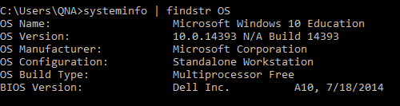

* Check .Net Framework version.

Step 1: Open command prompt

Step 2: Input: dir %WINDIR%\Microsoft.Net\Framework\v*

Step 3: Check result as describe bellow:

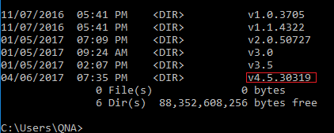

#### Import Database

Using database script file “TASscript.sql” which located under Deployment directory of this document.

#### Build Project

- Open APIProject(APIProject.sln) in Visual Studio.

- Right-click on APIProject Solution, select “Build”.

#### Deploy Project To IIS

- Run Internet Information Service (IIS) Manager

- Make sure that your .NET framework version in Application pools is set to v4.5.x

- Right click on “Default Web Site”, select Add Application

Alias: the name for this site

Physical path: path to source code folder.

- Click Ok, right click on TAS (or other the name you set in alias) -> Manage Application -> Browse. Your site should be run successfully

## 2. User Manual

### 2.1 Unauthorized User

#### 2.1.1 Login

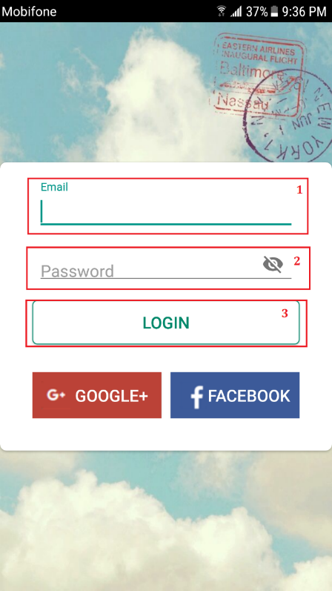

Figure 93: User manual - Login Interface

|  |  |
| --- | --- |
| Step | Description |
| 1 | Fill in field: “Email” |
| 2 | Fill in field: “Password” |
| 3 | Click on: “Login” button |

Table 105: User manual – Login

### 2.2 Authorized User

#### 2.2.1 Message

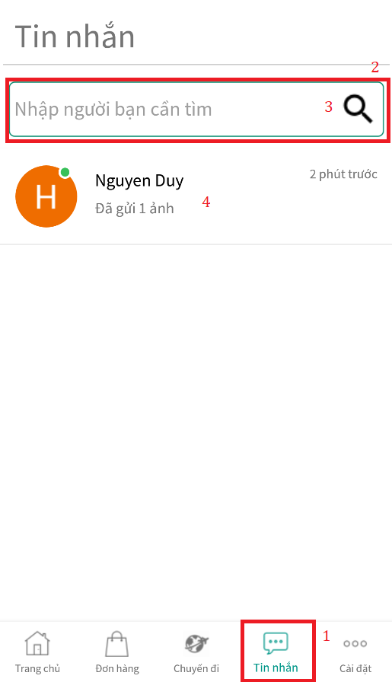

Figure 94: User manual - Message Interface (1)

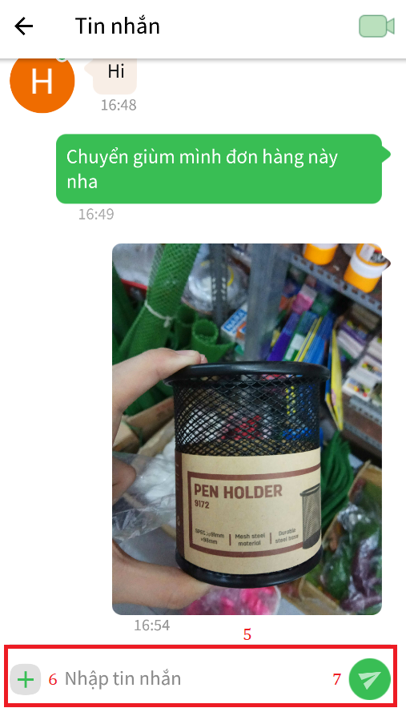

Figure 95: User manual - Message Interface (2)

|  |  |
| --- | --- |
| Step | Decription |
| 1 | Click on “Tin nhắn” button |
| 2 | Fill in field: “Nhập người bạn cần tìm” |
| 3 | Click on “Tìm kiếm” button |
| 4 | Click on “Người dùng” dialog |
| 5 | Fill in field “Nhập tin nhắn” |
| 6 | Click ons ultilites button. |
| 7 | Click on “Gửi” button |

Table 106: User manual - Message

#### 2.2.2 Video Call



Figure 96: User manual - Video Call Interface (1)

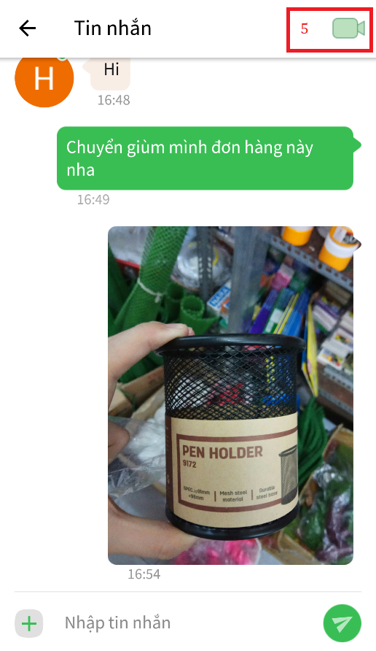

Figure 97: User manual - Video Call Interface (2)

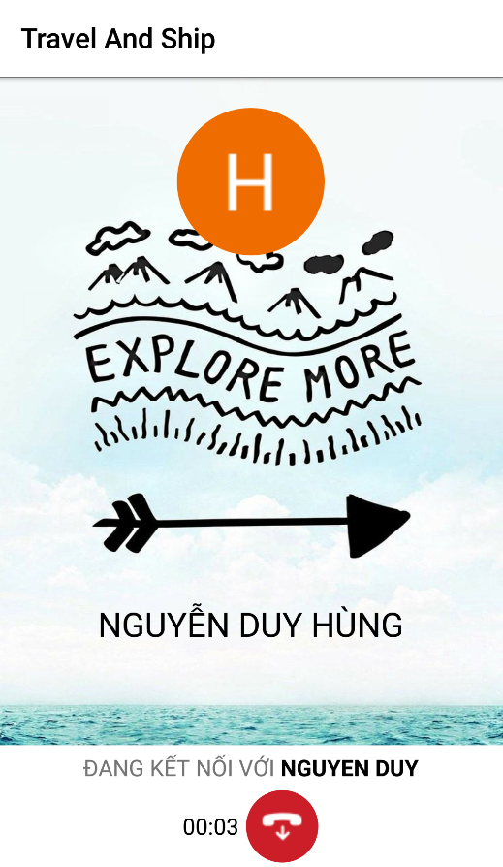

Figure 98: User manual - Video Call (3)

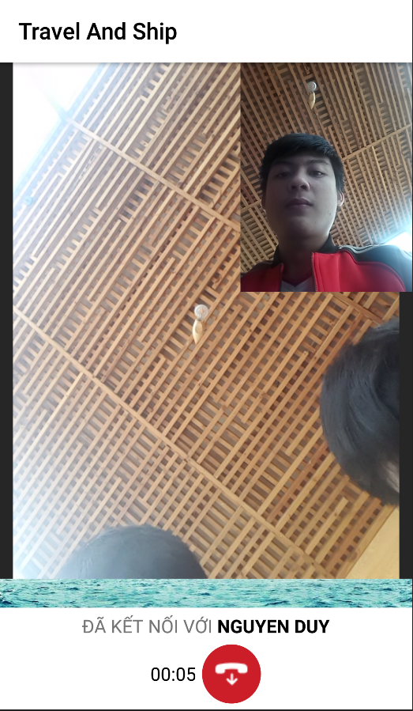

Figure 99: User manual - Video Call Interface (4)

|  |  |
| --- | --- |
| Step | Decription |
| 1 | Click on “Tin nhắn” button |
| 2 | Fill in field: “Nhập người bạn cần tìm” |
| 3 | Click on “Tìm kiếm” button |
| 4 | Click on “Người dùng” dialog |
| 5 | Click on “Camera” icon |

Table 107: User manual - Video Call

#### 2.2.3 Update User Information

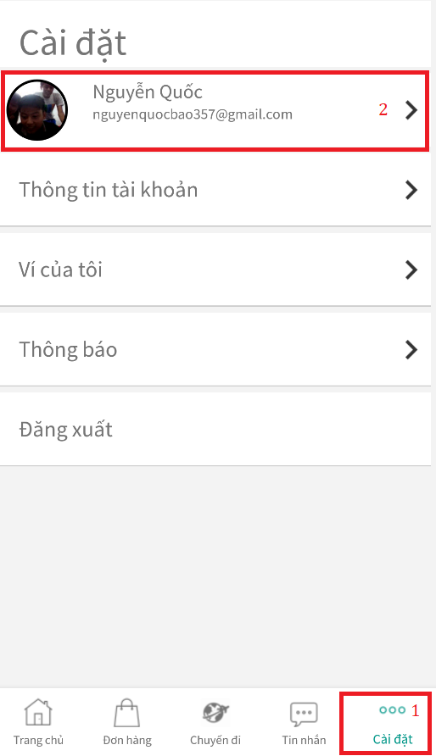

Figure 100: User manual - Update User Information Interface (1)

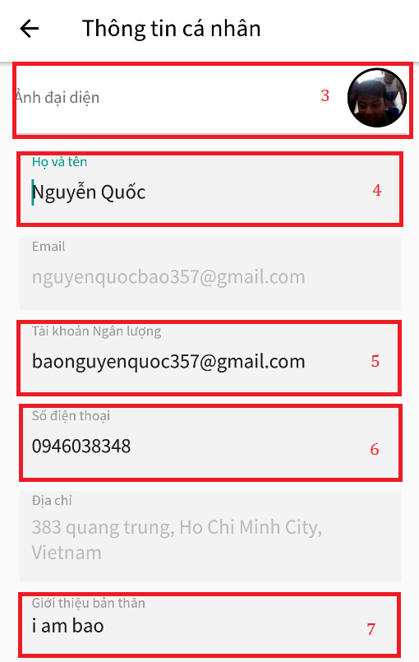

Figure 101: User manual - Update User Information Interface (2)



Figure 102: User manual - Update User Information Interface (3)

|  |  |
| --- | --- |
| Step | Decription |
| 1 | Click on “Cài Đặt” tab. |
| 2 | Click on user own avatar. |
| 3 | Click on “Ảnh đại diện” button. |
| 4 | Fill in field “Họ và tên”. |
| 5 | Fill in field “Tài khoản Ngân lượng”. |
| 6 | Fill in field “Số điện thoại”. |
| 7 | Fill in field “Giới thiệu bản thân” |
| 8 | Click on “Xác nhận” button. |

Table 108: User manual - Update User Information

#### 2.2.4 Withdraw

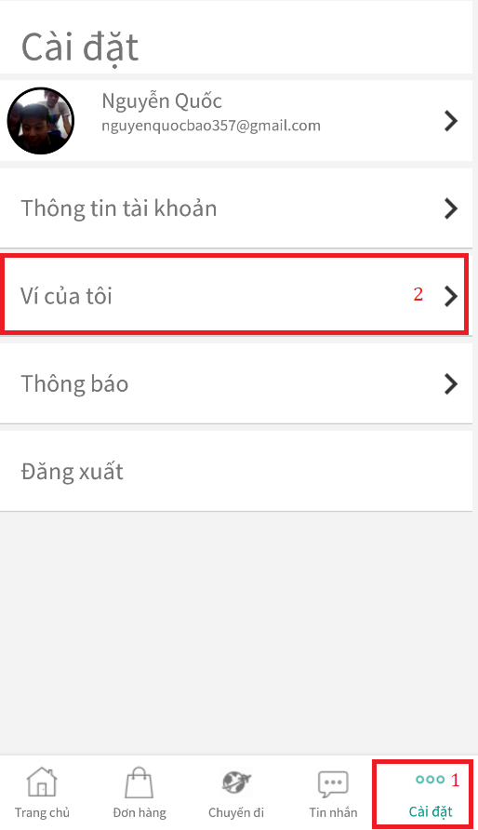

Figure 103: User manual - Withdraw Interface (1)

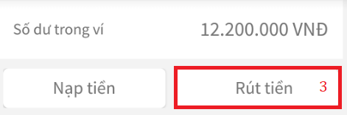

Figure 104: User manual - Withdraw Interface (2)

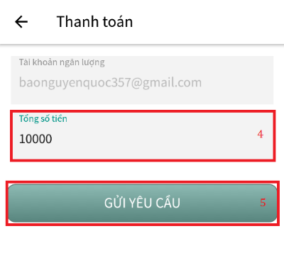

Figure 105: User manual - Withdraw Interface (3)

|  |  |
| --- | --- |
| Step | Decription |
| 1 | Click on “Cài Đặt” tab. |
| 2 | Click on “Ví của tôi” tab. |
| 3 | Click on “Rút tiền” button. |
| 4 | Fill in field “Tổng số tiền” |
| 5 | Click on “Gửi yêu cầu” button. |

Table 109: User manual - Withdraw

#### 2.2.5 Deposit



Figure 106: User manual - Deposit Interface (1)

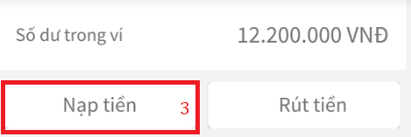

Figure 107: User manual -Deposit Interface (2)



Figure 108: User manual - Deposit Interface (3)

|  |  |
| --- | --- |
| Step | Decription |
| 1 | Click on “Cài Đặt” tab. |
| 2 | Click on “Ví của tôi” tab. |
| 3 | Click on “Nạp tiền” button. |
| 4 | Fill in field “Tổng số tiền” |
| 5 | Click on “Gửi yêu cầu” button. |

Table 110: User manual - Deposit

### 2.3 Admin

#### 2.3.1 Login



Figure 109: User manual - Admin Login Interface

|  |  |
| --- | --- |
| Step | Decription |
| 1 | Fill in field “Username” |
| 2 | Fill in field “Mật khẩu” |
| 3 | Click on “Đăng nhập” button. |

Table 111: User manual - Admin Login

#### 2.3.2 Manage User

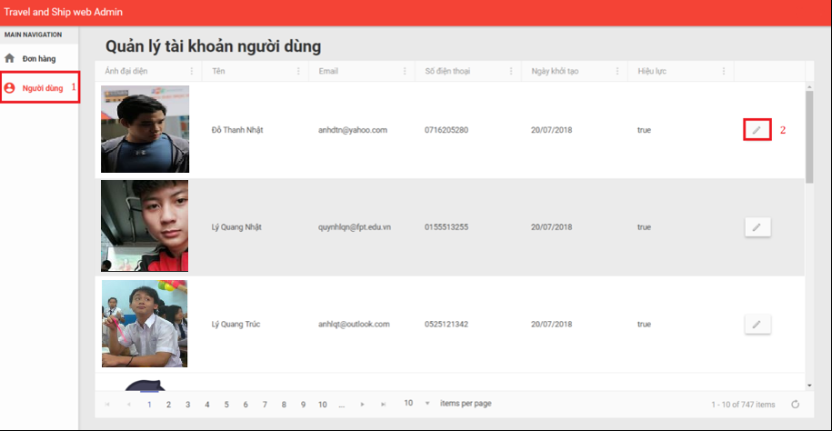

Figure 110: User manual - Admin Manage User Interface (1)

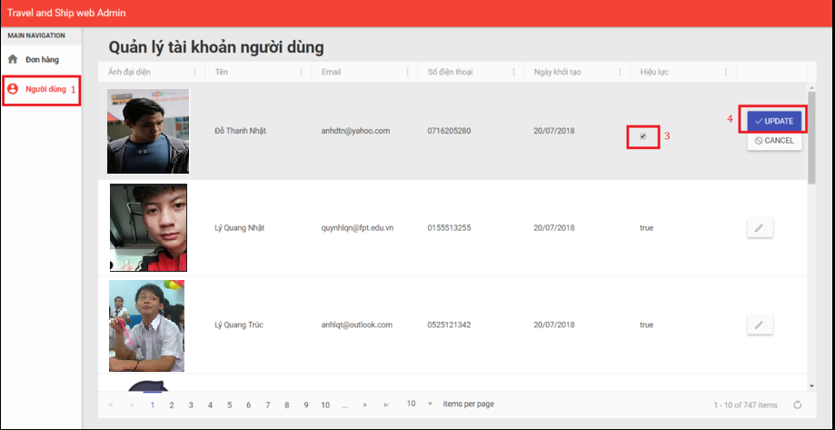

Figure 111: User manual - Admin Manage User Interface (2)

|  |  |
| --- | --- |
| Step | Decription |
| 1 | Click on “Người dùng” tab. |
| 2 | Click on edit button. |
| 3 | Check on check box. |
| 4 | Click on “Update” button. |

Table 112: User manual - Admin Manage User

#### 2.3.3 View Order

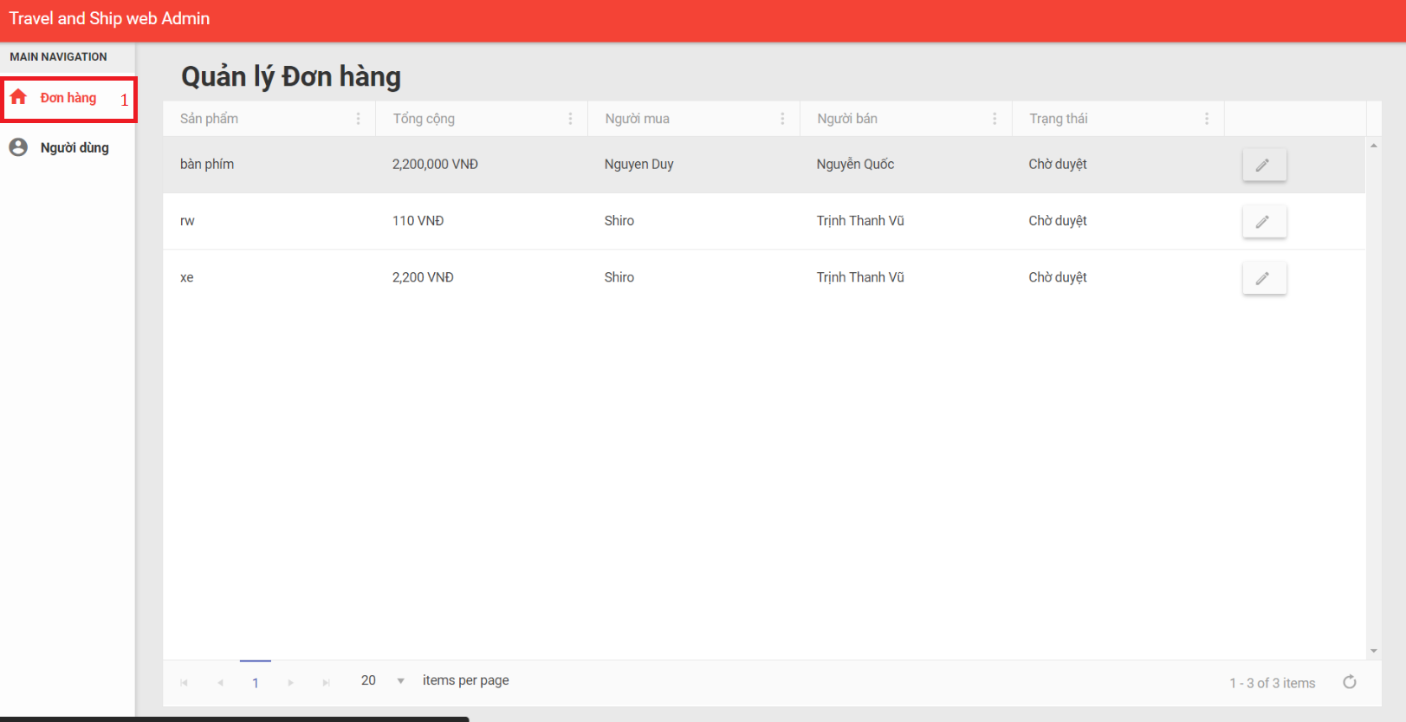

Figure 112: User manual - Admin View Order Interface

|  |  |
| --- | --- |
| Step | Decription |
| 1 | Click on “Đơn hàng” tab. |

Table 113: User manual - Admin View Order

#### 2.3.4 Tranfer Money To Traveler

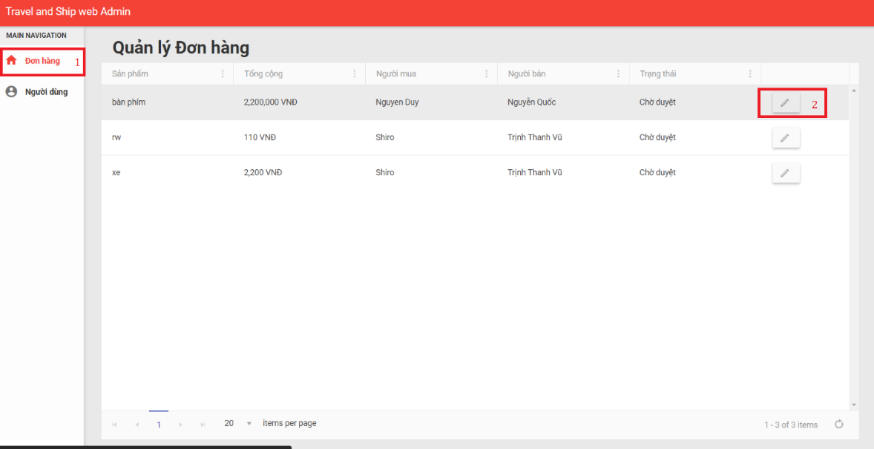

Figure 113: User manual - Admin Tranfer Money to Traveler Interface (1)

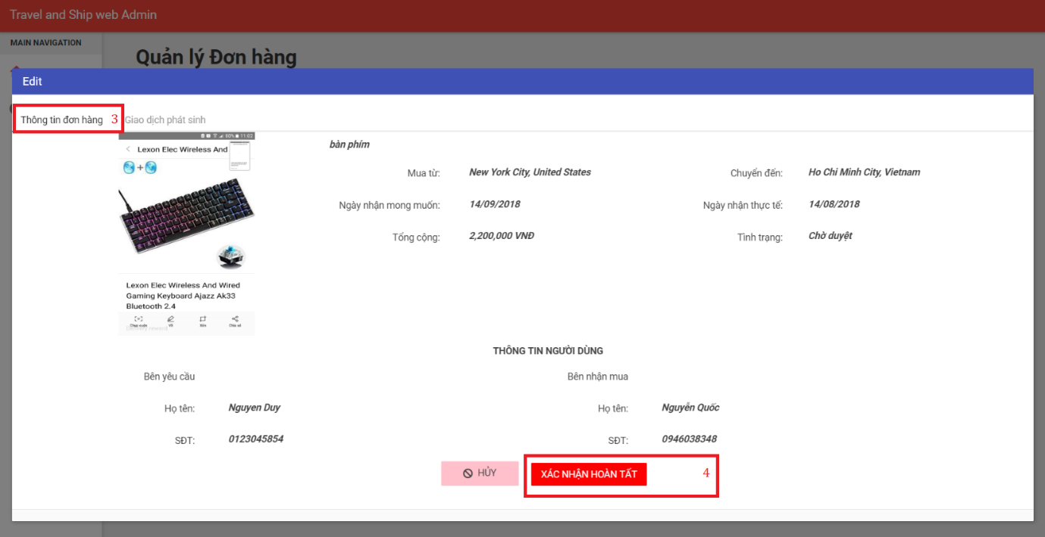

Figure 114: User manual - Admin Tranfer Money to Traveler Interface (2)

|  |  |
| --- | --- |
| Step | Decription |
| 1 | Click on “Đơn hàng” tab. |
| 2 | Click on edit button. |
| 3 | Click on “Thông tin đơn hàng” tab. |
| 4 | Click on “Xác nhận hoàn tất” button. |

Table 114: User manual - Admin Tranfer Money to Traveler

### 2.4 Traveler

#### 2.4.1 Create Trip

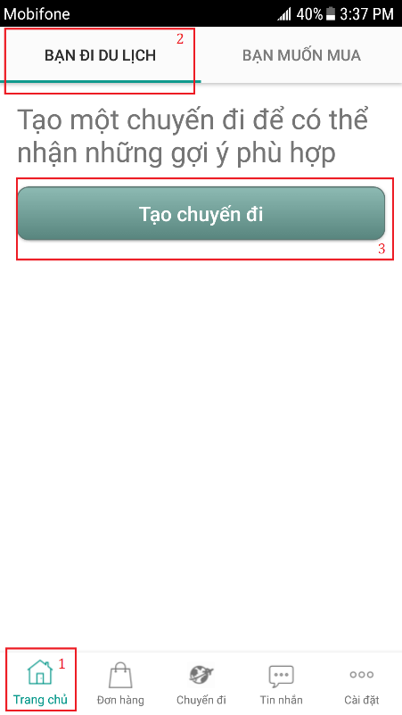

Figure 115: User manual - Create Trip Interface (1)

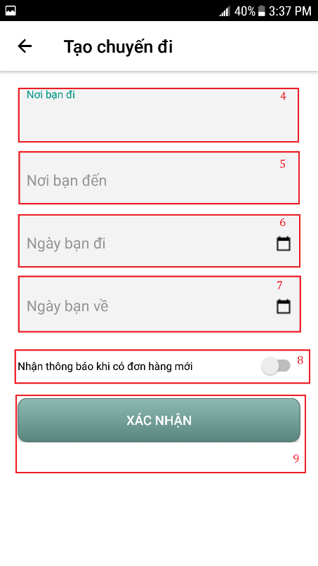

Figure 116: User manual - Create Trip Interface (2)

|  |  |
| --- | --- |
| Step | Decription |
| 1 | Click on “Trang chủ” tab |
| 2 | Click on “Bạn đi du lịch” tab |
| 3 | Click on “Tạo chuyến đi” button |
| 4 | Fill in field: “Nơi bạn đi” |
| 5 | Fill in field: “Nơi bạn đến” |
| 6 | Fill in field: “Ngày bạn đi” |
| 7 | Fill in field: “Ngày bạn vê” |
| 8 | Click on “Nhận thông báo khi có đơn hàng mới” |
| 9 | Click on “Xác nhận” button |

Table 115: User manual - Create Trip

#### 2.4.2 Make Offer

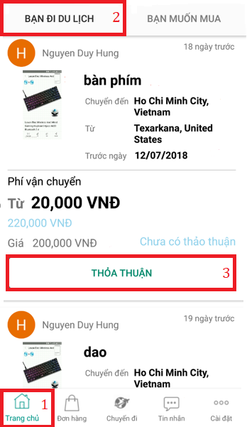

Figure 117: User manual - Make Offer Interface (1)

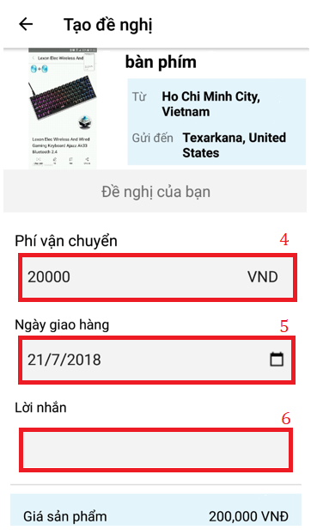

Figure 118: User manual - Make Offer Interface (2)

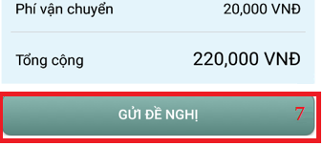

Figure 119: User manual - Make Offer Interface (3)

|  |  |
| --- | --- |
| Step | Decription |
| 1 | Click on “Trang chủ” tab |
| 2 | Click on “Bạn đi du lịch” tab |
| 3 | Click on “Thỏa thuận” button |
| 4 | Fill in field “Phí vận chuyển” |
| 5 | Fill in field “Ngày giao hàng” |
| 6 | Fill in field “Lời nhắn” |
| 7 | Click on “Gửi đề nghị” button |

Table 116: User manual - Make Offer

#### 2.4.3 Share Location Information

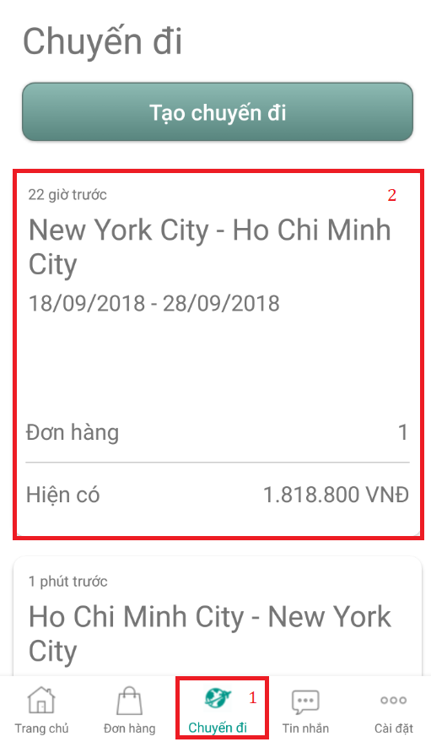

Figure 120: User manual - Share Location Information Interface (1)

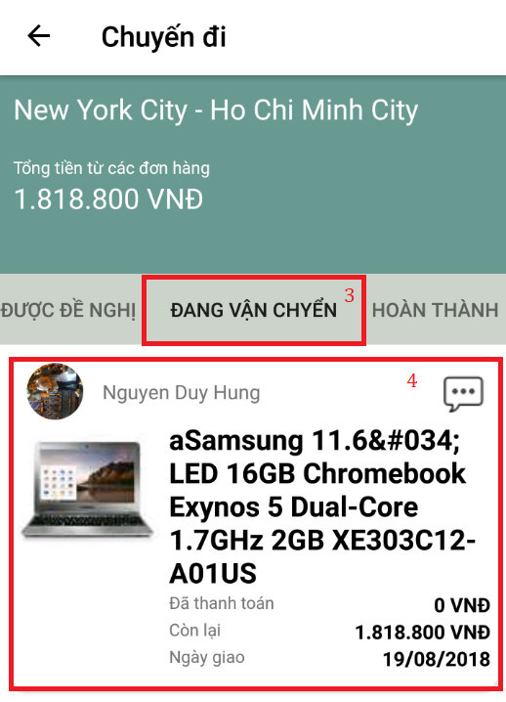

Figure 121: User manual - Share Location Information Interface (2)

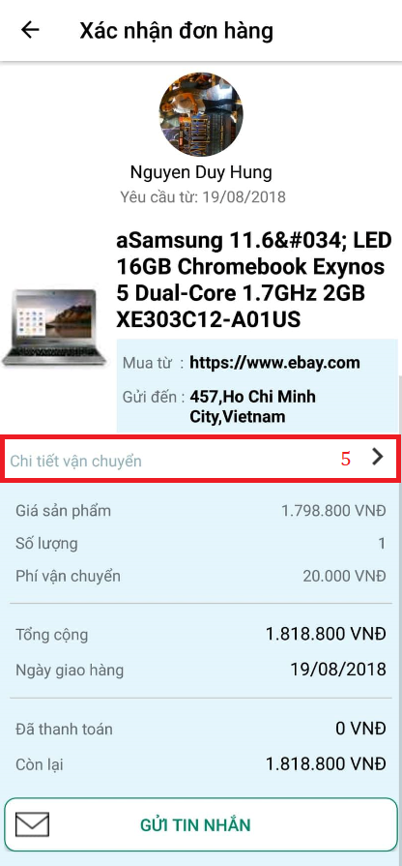

Figure 122: User manual - Share Location Information Interface (3)

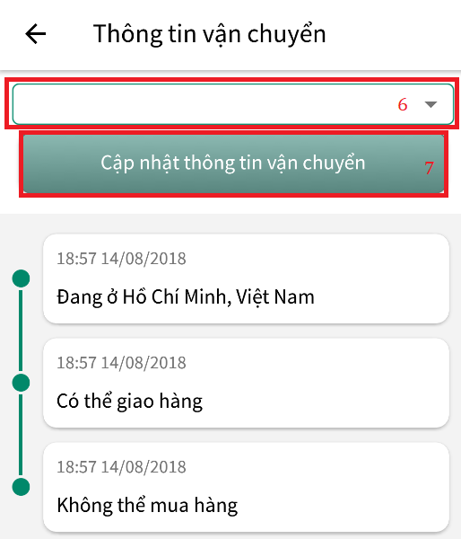

Figure 123: User manual - Share Location Information Interface (4)

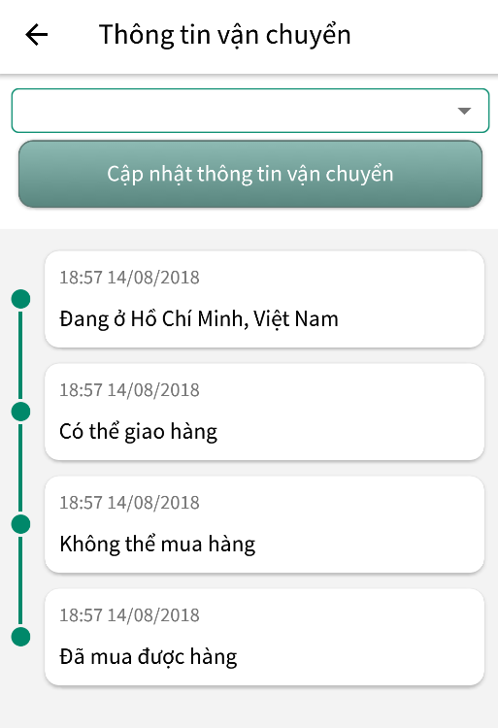

Figure 124: User manual - Share Location Information Interface (5)

|  |  |
| --- | --- |
| Step | Decription |
| 1 | Click on “Chuyến đi” tab |
| 2 | Click on trip section |
| 3 | Click on “Đang vận chuyển” tab |
| 4 | Click on order section |
| 5 | Click on “Chi tiets đơn hàng” hyper link |
| 6 | Choose tracking option |
| 7 | Click on “Cập nhật thông tin vận chuyển” button |

Table 117: User manual - Share Location Information

### 2.5 Buyer

#### 2.5.1 View Suggest Trip

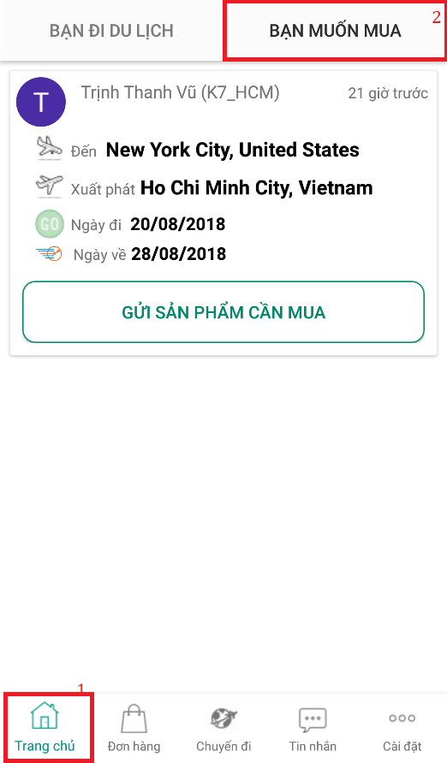

Figure 125: User manual - View Suggested Trip Interface

|  |  |
| --- | --- |
| Step | Decription |
| 1 | Click on “Trang chủ” tab |
| 2 | Click on “Bạn muốn mua” tab |

Table 118: User manual - View Suggest Trip

#### 2.5.2 Create Order

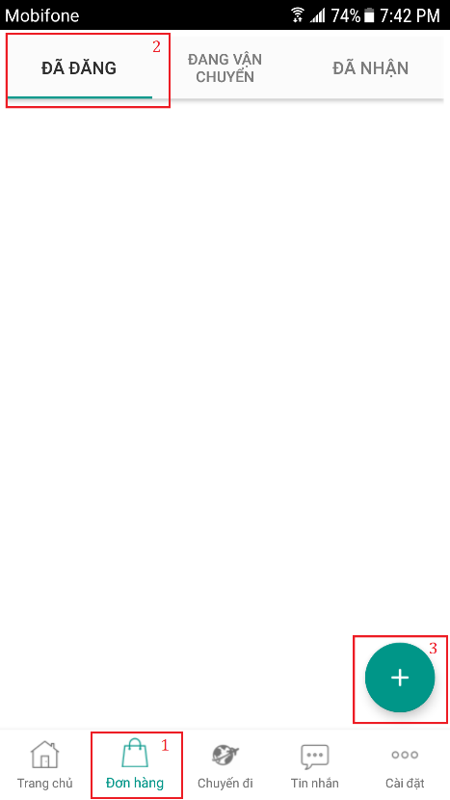

Figure 126: User manual - Create Order Interface (1)

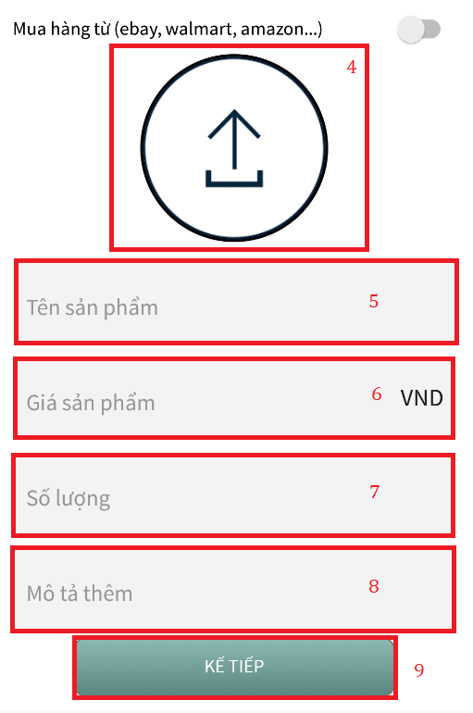

Figure 127: User manual - Create Order Interface (2)

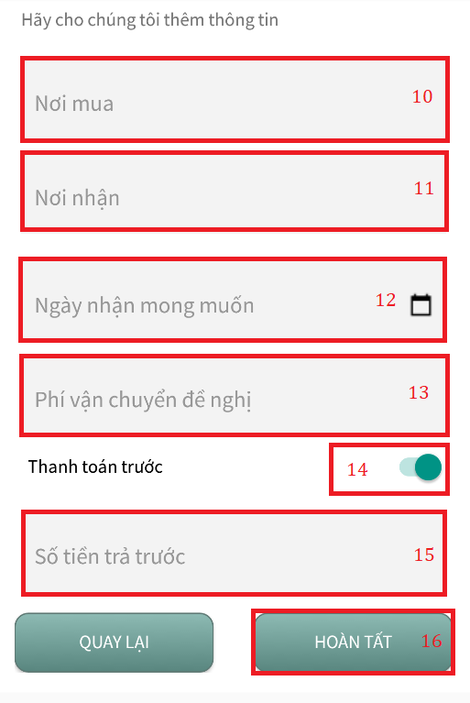

Figure 128: User manual - Create Order Interface (3)

|  |  |
| --- | --- |
| Step | Decription |
| 1 | Click on “Đơn hàng” tab |
| 2 | Click on “Đã đăng” tab |
| 3 | Click on “Thêm” button |
| 4 | Upload picture |
| 5 | Fill in field “Tên sản phẩm” |
| 6 | Fill in field “Giá sản phẩm” |
| 7 | Fill in field “Số lượng” |
| 8 | Fill in field “Mô tả thêm” |
| 9 | Click on “Kế tiếp” button |
| 10 | Fill in field “Nơi mua” |
| 11 | Fill in field “Nơi nhận” |
| 12 | Select field “Ngày nhận mong muốn” |
| 13 | Fill in field “Phí vận chuyển đề nghị” |
| 14 | Click on “Thanh toán trước” switch |
| 15 | Fill in field “Số tiền trả trước” |
| 16 | Click on “Hoàn tất” button |

Table 119: User manual - Create Order

#### 2.5.3 Create Order With Url



Figure 129: User manual - Create Order with Url Interface (1)

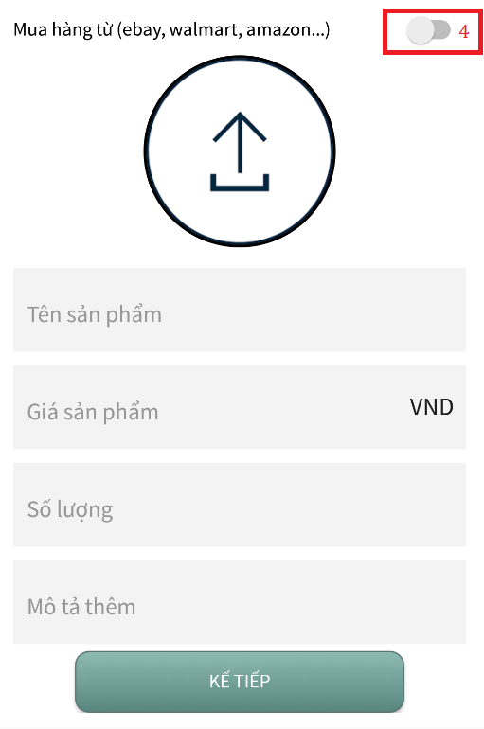

Figure 130: User manual - Create Order with Url Interface (2)

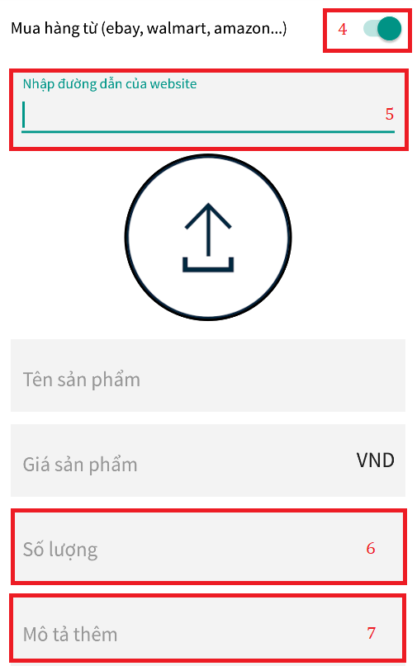

Figure 131: User manual - Create Order with Url Interface (3)

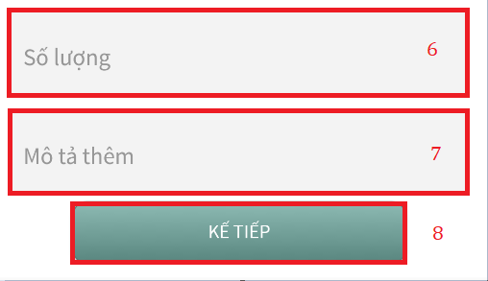

Figure 132: User manual - Create Order with Url Interface (4)

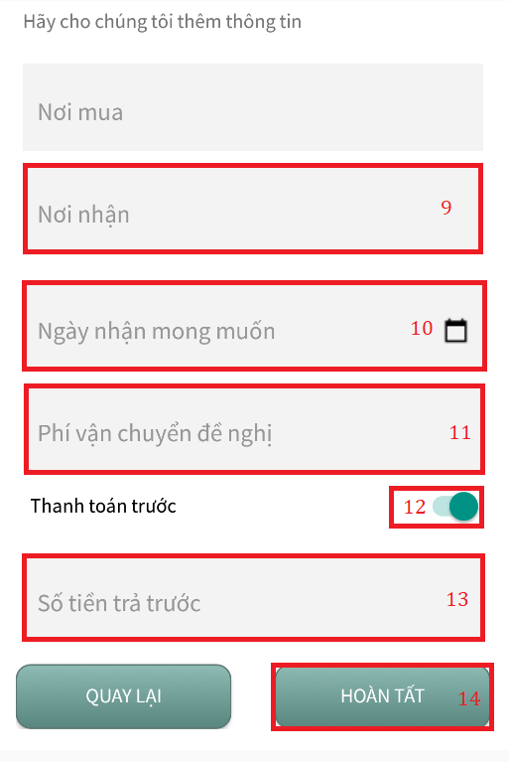

Figure 133: User manual - Create Order with Url Interface (5)

|  |  |
| --- | --- |
| Step | Decription |
| 1 | Click on “Đơn hàng” tab |
| 2 | Click on “Đã đăng” tab |
| 3 | Click on “Thêm” button |
| 4 | Click on “Mua hàng từ (ebay, walmart, amazon, …) switch |
| 5 | Paste url copy from ebay, walmart, amazon, …. to field |
| 6 | Fill in field “Số lượng” |
| 7 | Fill in field “Mô tả thêm” |
| 8 | Click on “Kế tiếp” button |
| 9 | Fill in field “Nơi nhận” |
| 10 | Select field “Ngày nhận mong muốn” |
| 11 | Fill in field “Phí vận chuyển đề nghị” |
| 12 | Click on “Thanh toán trước” switch |
| 13 | Fill in field “Số tiền trả trước” |
| 14 | Click on “Hoàn tất” button |

Table 120: User manual - Create Order with Url

#### 2.5.4 Accept Offer

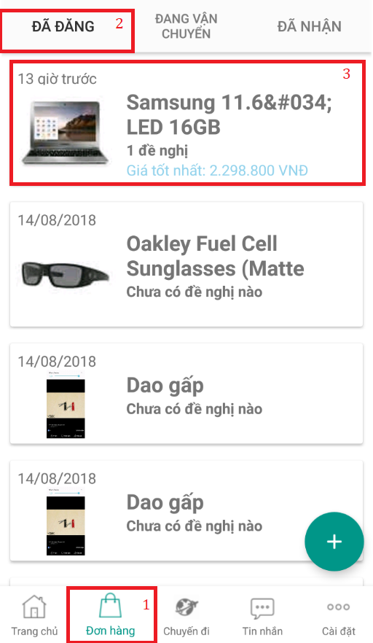

Figure 134: User manual - Accept Offer Interface (1)

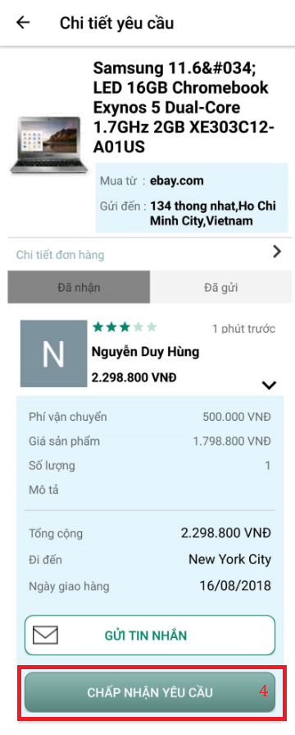

Figure 135: User manual - Accept Offer Interface (2)

|  |  |
| --- | --- |
| Step | Decription |
| 1 | Click on “Đơn hàng” tab |
| 2 | Click on “Đã đăng” tab |
| 3 | Click on certain order |
| 4 | Click on “Chấp nhận yêu cầu” button |

Table 121: User manual - Accept Offer

#### 2.5.5 Tracking Order

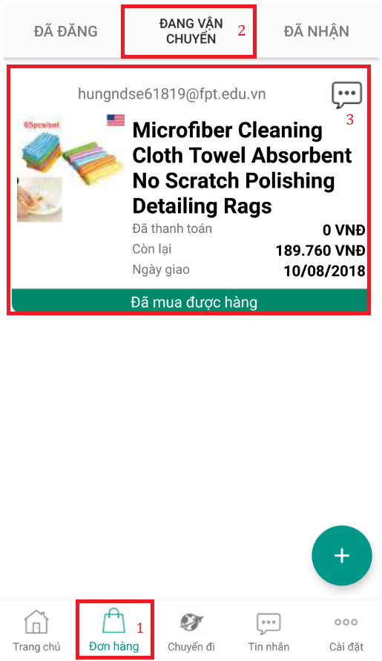

Figure 136: User manual - Tracking Order Interface (1)

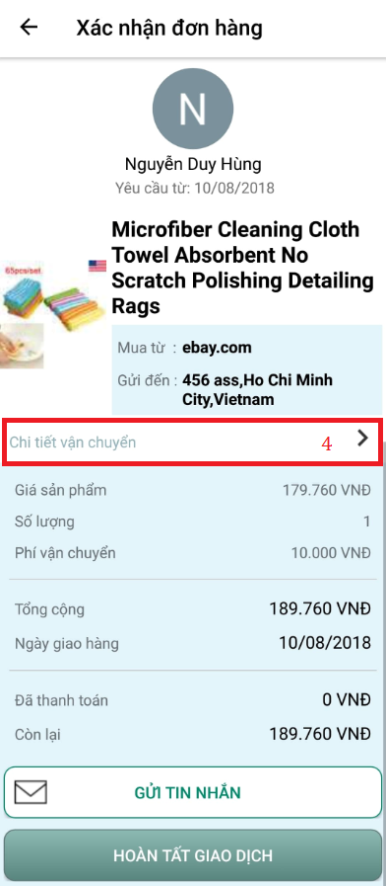

Figure 137: User manual - Tracking Order Interface (2)

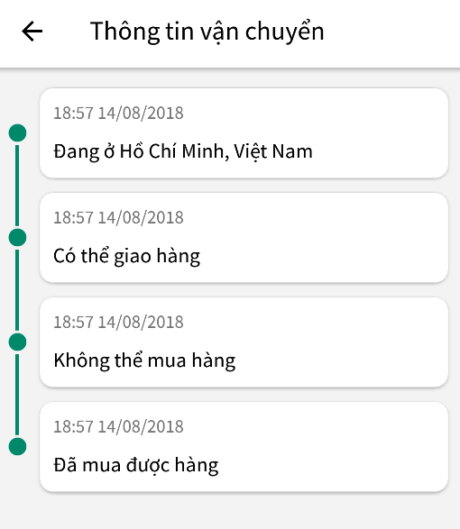

Figure 138: User manual - Tracking Order Interface (3)

|  |  |
| --- | --- |
| Step | Decription |
| 1 | Click on “Đơn hàng” tab |
| 2 | Click on “Đang vận chuyển” tab |
| 3 | Click on certain order |
| 4 | Chi tiết vận chuyển |

Table 122: User manual - Tracking Order

#### 2.5.6 Confirm Complete



Figure 139: User manual - Confirm Complete Interface (1)

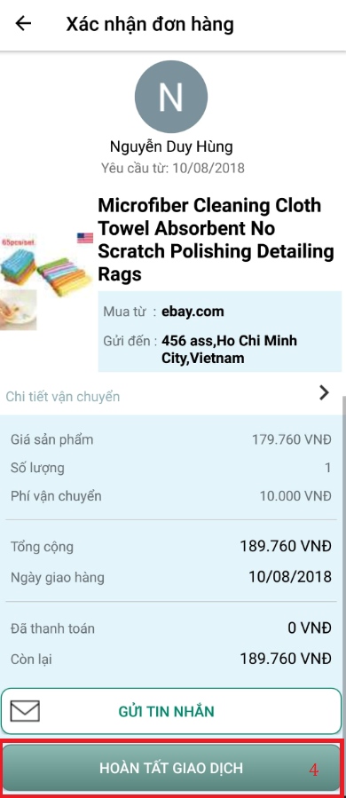

Figure 140: User manual - Confirm Complete Interface (2)

|  |  |
| --- | --- |
| Step | Decription |
| 1 | Click on “Đơn hàng” tab |
| 2 | Click on “Đang vận chuyển” tab |
| 3 | Click on certain order |
| 4 | Click on “Hoàn tất giao dịch” button |

Table 123: User manual - Confirm Complete

#### 2.5.7 Rate for Traveler

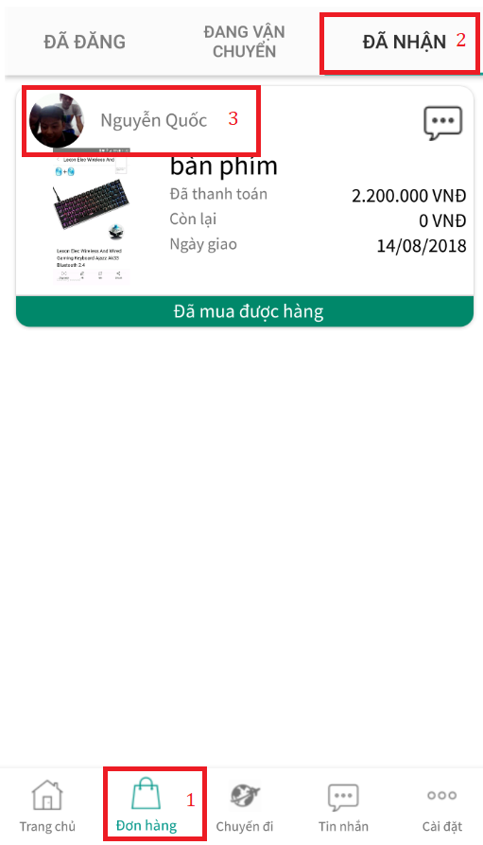

Figure 141: User manual - Rate for Traveler Interface (1)

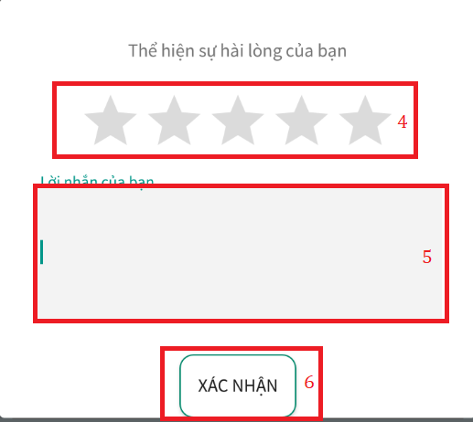

Figure 142: User manual - Rate for Traveler Interface (2)

|  |  |
| --- | --- |
| Step | Decription |
| 1 | Click on “Đơn hàng” tab |
| 2 | Click on “Đã nhận” tab |
| 3 | Click on traveler avatar |
| 4 | Choose star |
| 5 | Fill in field “Lời nhắn của bạn” |
| 6 | Click on “Xác nhận” button |

Table 124: User manual - Rate for Traveler

# G. Acknowledge

First, we would like to express our greatest gratitude to Mr. Nguyen Huy hung, our supervisor, for hí guidance, support and encouragement during this project, helped us to organize and coordinate our project especially in project requirement, project’s quality and writing this report.

We would like to send our thanks to all FPT University Lecturers for have taught and guided us with great instruction and passion throughout our years of study.

We are grateful to FPT University, which provided us with great study and motivation environment.

Last, our thanks and appreciations also go to our family and friends who encourage and help us to complete this project.

Thank you for all your support to our team.

Sincerely.

# H. Appendix

**1. Nganluong.vn** *[Online.]*

Available: <https://www.nganluong.vn/nganluong/home.html>.

Accessed on: May. 2018.

**2. Sinch Video Call Engine** *[Online.]*

Available: <https://www.sinch.com/docs/voice/>.

Accessed on: May. 2018

**3. The Unified Modeling Language** *[Online.]*

Available: <http://www.uml-diagrams.org/>.

Accessed on: May. 2018.